* abstract(simplify, hide details) and arbitrate(manage use) for the underlying hardware system.
* direct operational resources 管理资源（arbitrate）
* enforce working policies 制定规则（arbitrate）
* mitigate difficulty of complex tasks 抽象硬件实现（abstraction）
* An operating system is a layer of abstraction(simplify sth) between applications and hardware
* Manage hardware resources
* Hide details of hardware and provide abstraction to application.
* isolation

### Introduction To OS

#### Visual Metaphor

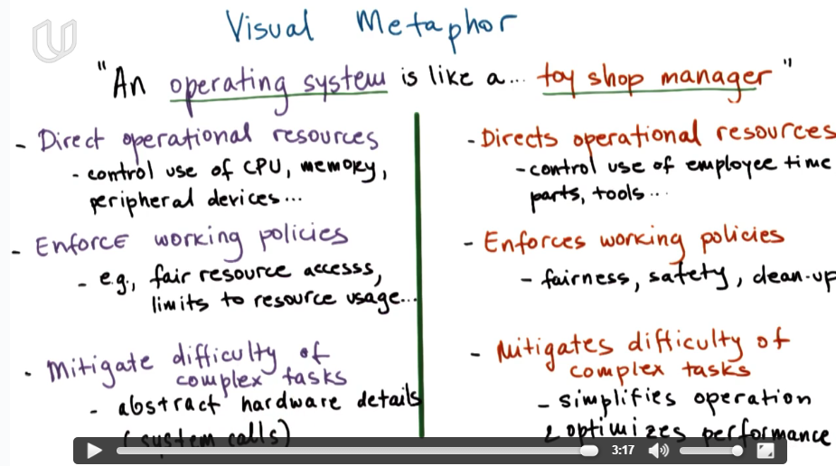

#### What Is an Operating System?

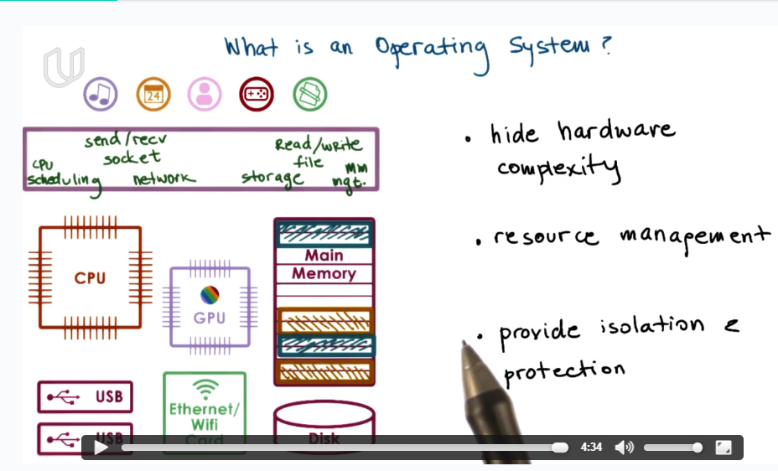

**Hide hardware complexity**: application can directly use instructions like Read/Write, Send/Recv to manipulate hardware, without knowing where the exact place he writes to and how it is been done.

**Resource management**: OS has direct access to the underlying hardware and decides how CPU and memory should be allocated to multiple applications according to predefined policy.

**Keep application protected and isolated**

#### *Operating System Definition

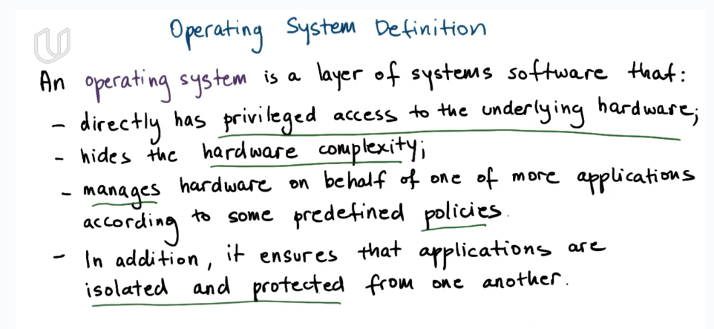

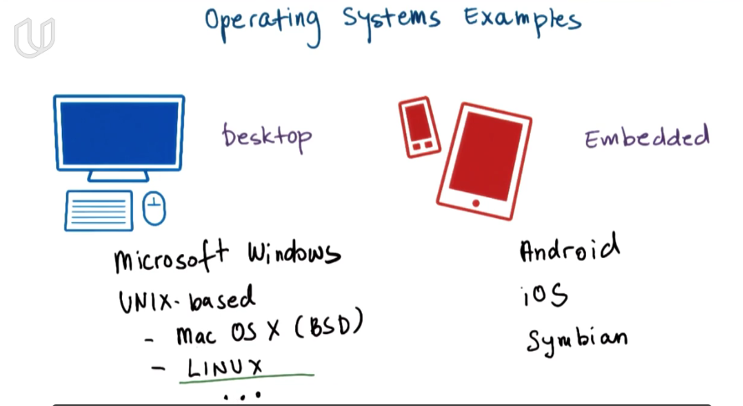

#### Operating System Elements

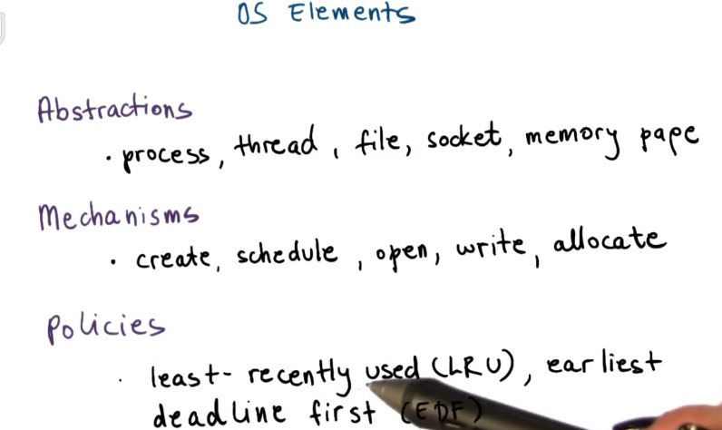

What is OS? an abstraction and arbitrate of hardware.

What OS do? manage resources; enforce polices; simplify hardware op

What OS comprise of? abstraction; mechanism; policies

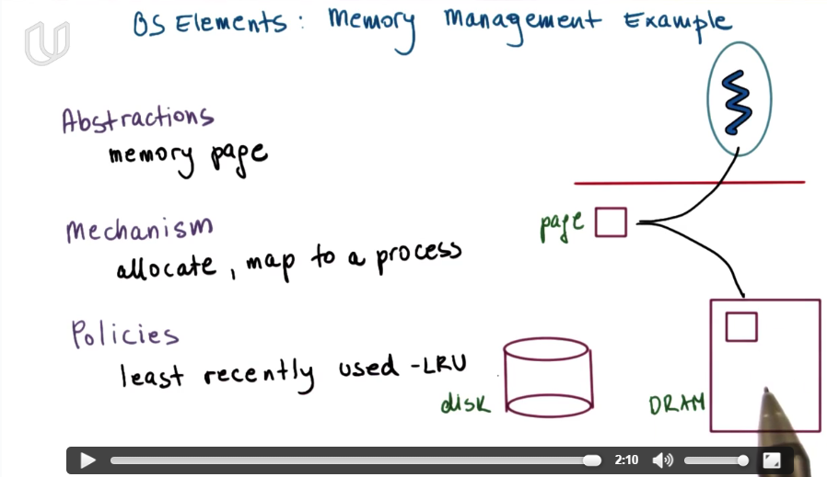

#### OS Protection Boundary

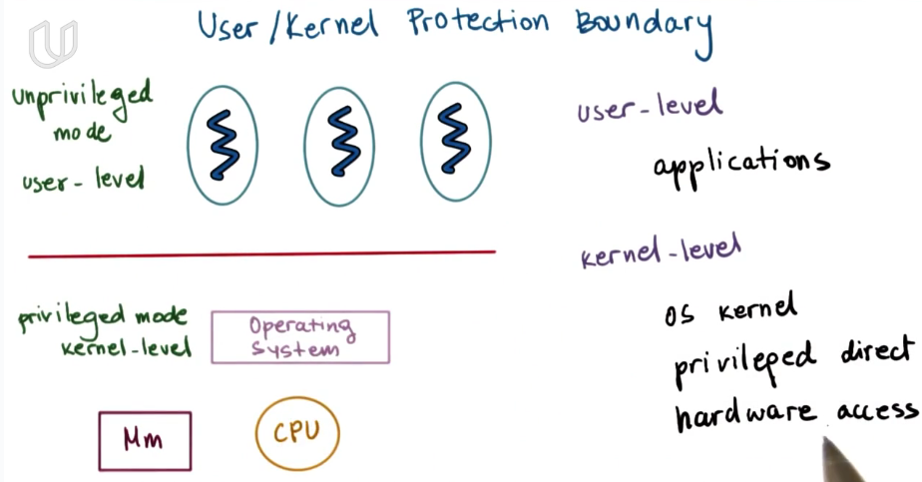

**kernal-level** have access to the hardware. While in **user-level**, it can not directly access the hardware.

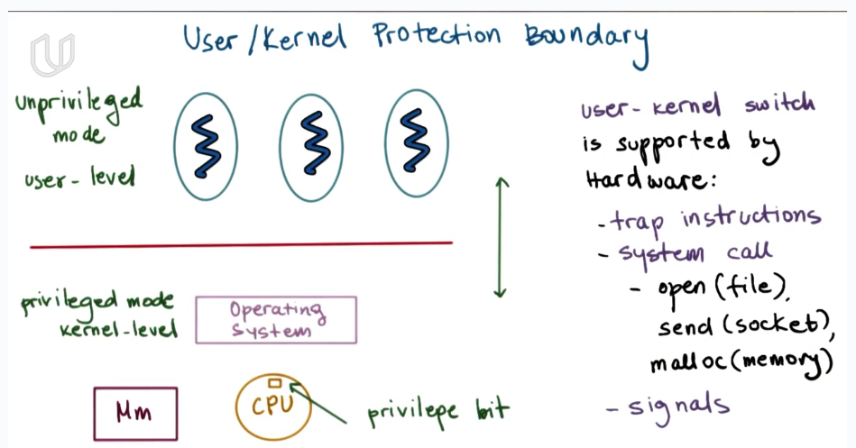

When the privilege bit in CPU is set, it means you are in kernel-level and have access to the hardware. If you need to operate on hardware in user-level, you can use system call, or it will cause a trap. In user-level, you can use system call interface to indirectly operate on hardware(through OS).

#### System Call Flowchart

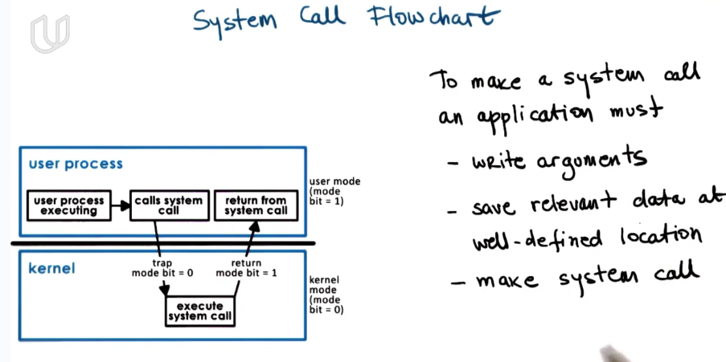

making a system call is like making a function call. you should give the control right to OS.

#### Crossing the OS Boundary

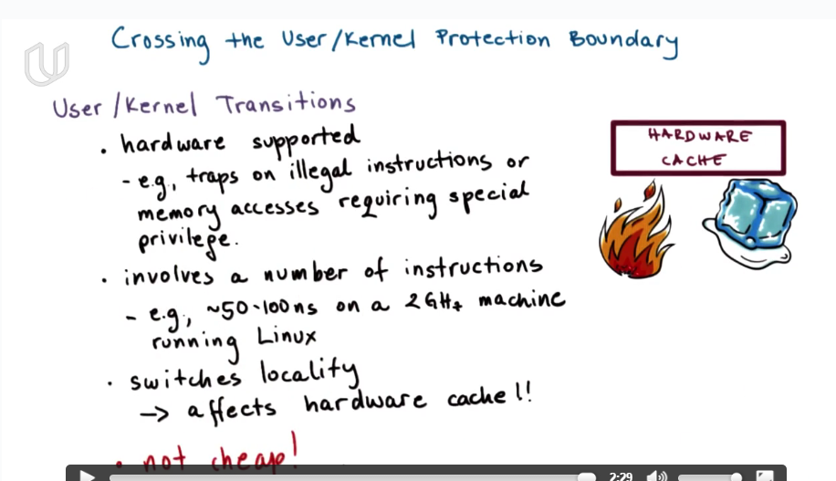

The effeciency of using the cache will affect the performance of application a lot. If trasforming from user to kernel, the OS will load what OS needs in the cache and replace the content of what the application put in the cache. So it will affect the performance of application.

#### OS services

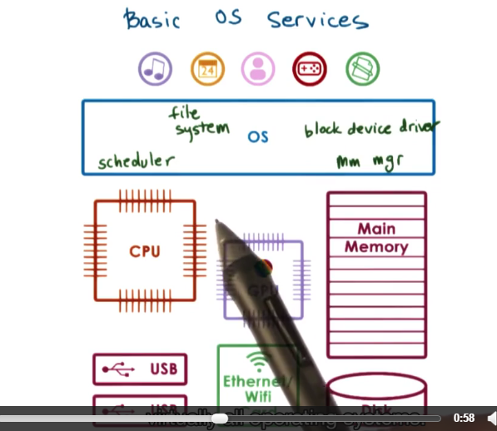

some abstractions like schedular and memory manager are directly map to the hardware, while some other higher level abstractions do not like file systems.

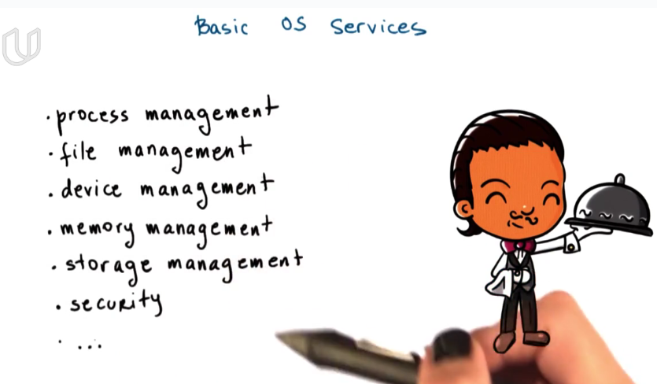

These services are provided through system calls.

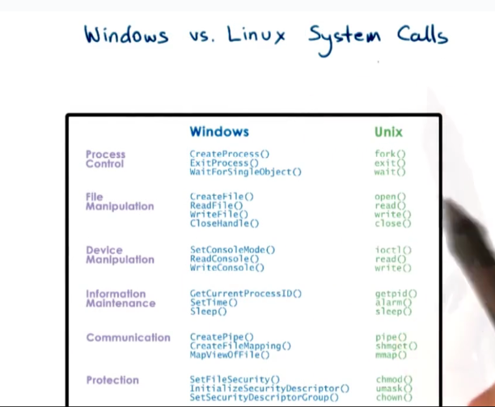

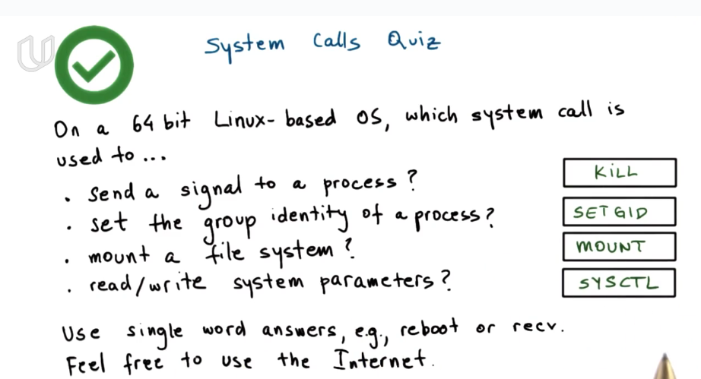

#### Monolithic OS(单片机)

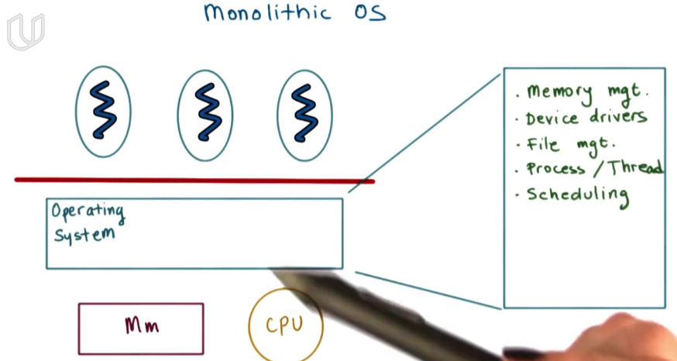

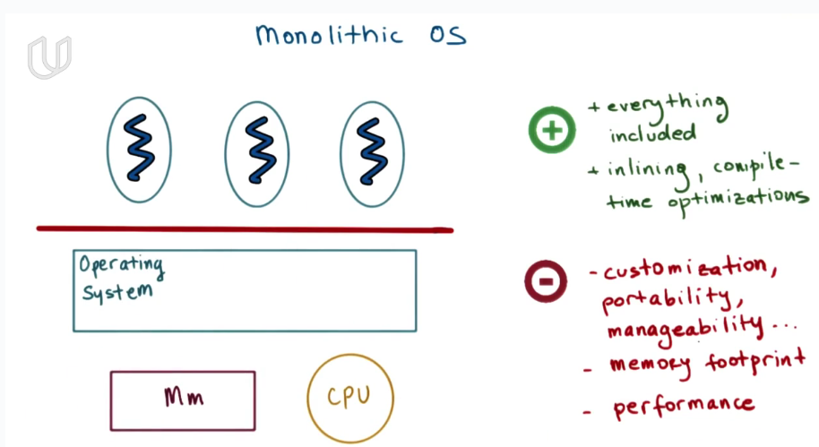

#### Modular OS

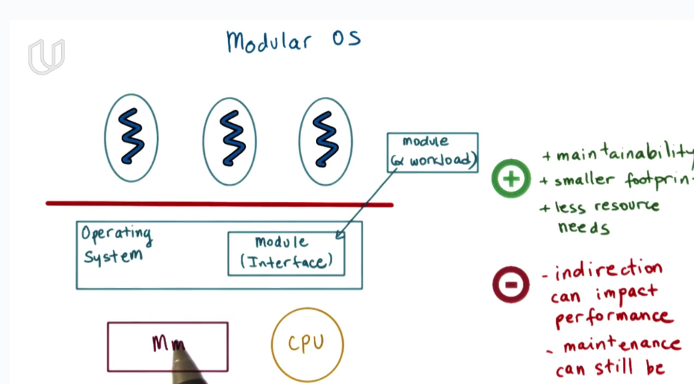

you can dynamically load a module according to your demand as long as this module implements the interface. In this way, OS can be customerized in different using situations.

#### Microkernel

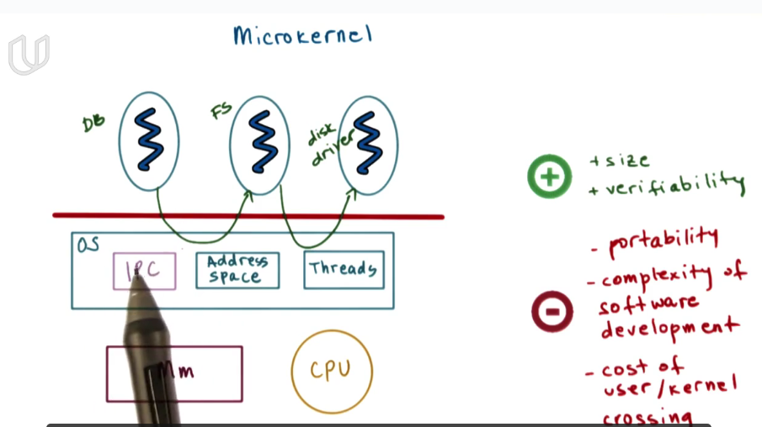

Only leave the most basic component in OS level, leave database, file system and disk drive, etc in application level. The most primitive component of OS is memory management, thread scheduling and inter-process communication.

#### Linux and Max OS Architectures

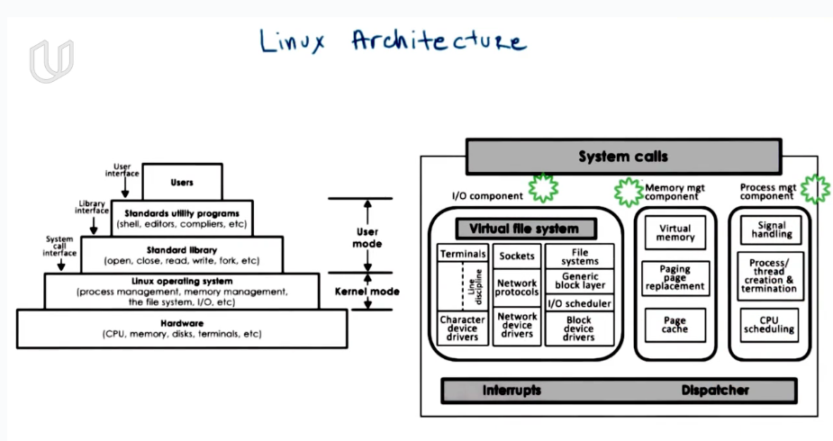

hardware🡪OS🡪standard library🡪standard ulitity program🡪users

each layer only offers interface for the adjacent layer to use. The system call interface is what OS provides for standard library. System calls have many separate components which can be maintained or replaced independently.

### Process and Process Management

#### Lesson Preview

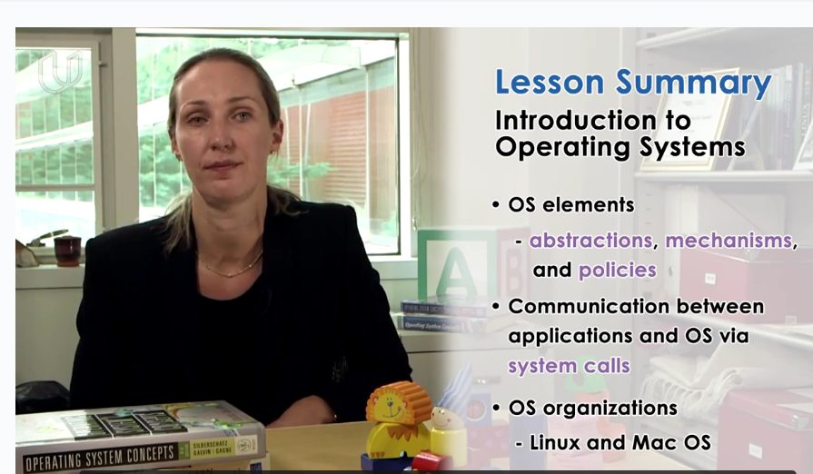

OS is an abstraction and arbitration of the underlying hardware system. In order to achieve this, OS provides a series of abstractions, mechanisms and policies. OS supports a number of system calls that allow the applications to interact with them.

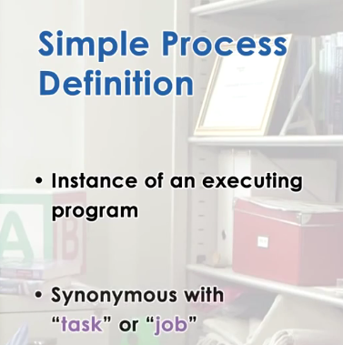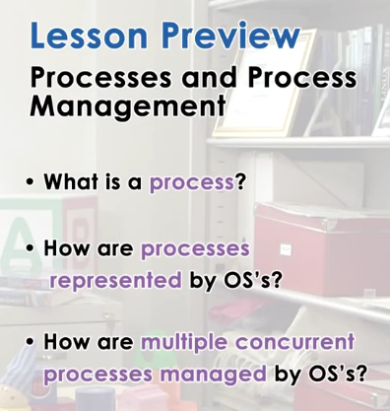

Process is one of the most important abstraction provided by OS. It’s an instance of an executing program.

#### Visual Metaphor

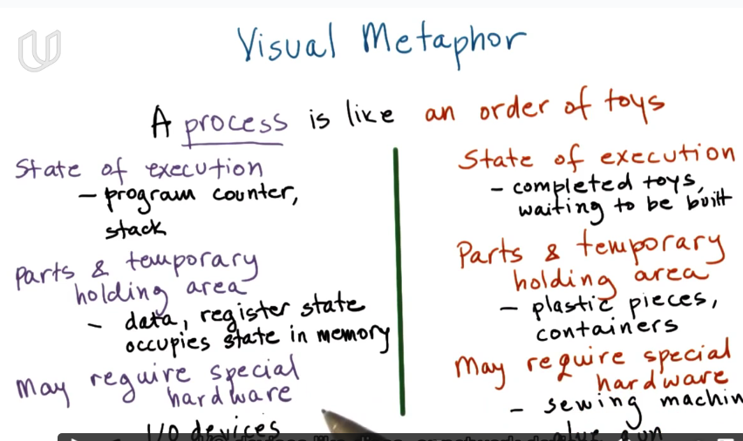

#### What is a Process?

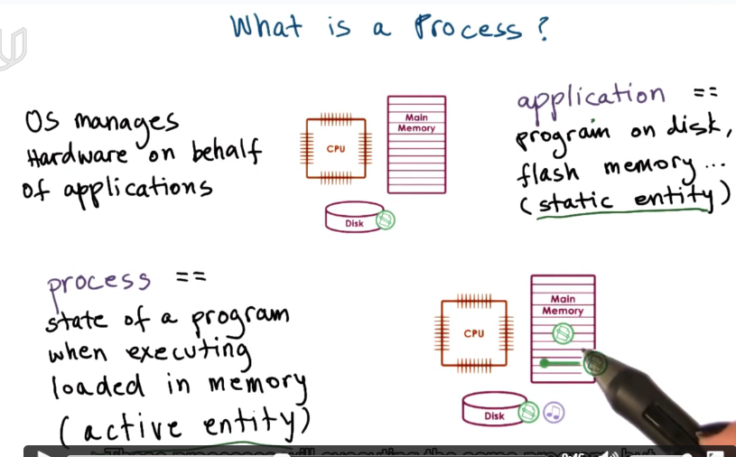

an application is stored on disk, flash memory and etc. Once it’s been launched/ executed, it becomes a process in memory. The same application may have multiple process in the memory.

#### *\*What Does a Process Look Like?*

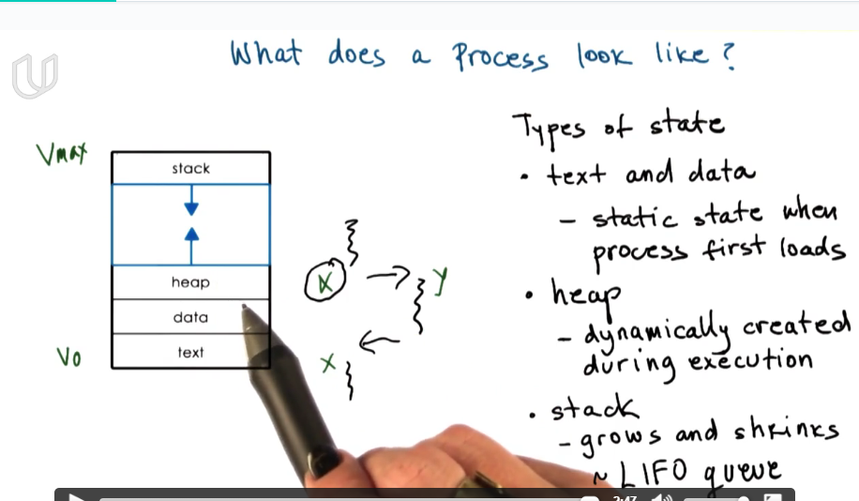

Process is represented by a virtual address space including text, data, heap and stack.

If the system is 32bits, then each process can have maximum 4GB virtual space. But it does mean all the virtual space is allocated in physical memory.

The difference between heap and stack is that heap is dynamically allocated during execution. Stack is allocated by compiler to store local variables, to support function calls, etc.

heap由程序员分配，maybe不连续存储， malloc；

stack由编译器分配，连续存储，局部变量、函数参数、函数调用等

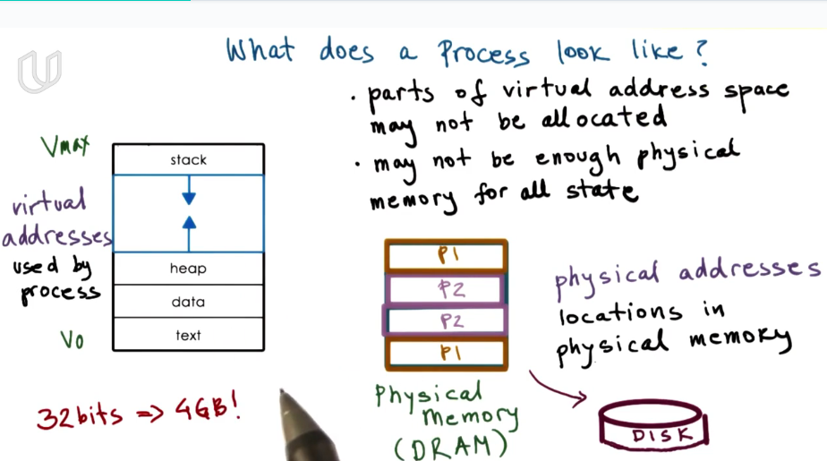

32位进程有4GB的虚拟地址空间（使每个进程看上去独享内存），但并不意味着这个进程需要这么多内存空间，只是说它可以支配这么多地址空间，并在需要时映射到physical memory 或者disk中。只有在进程实际运行时，才会分配实际的物理内存空间。内存空间不足时，需要把一部分state存储在disk中，在需要的时候再load进来。

The OS must maintain information where these virtual address really are, in memory or on disk, since it maintains the mapping between virtual address and its physial location.

将虚拟空间映射到物理空间是通过页表。

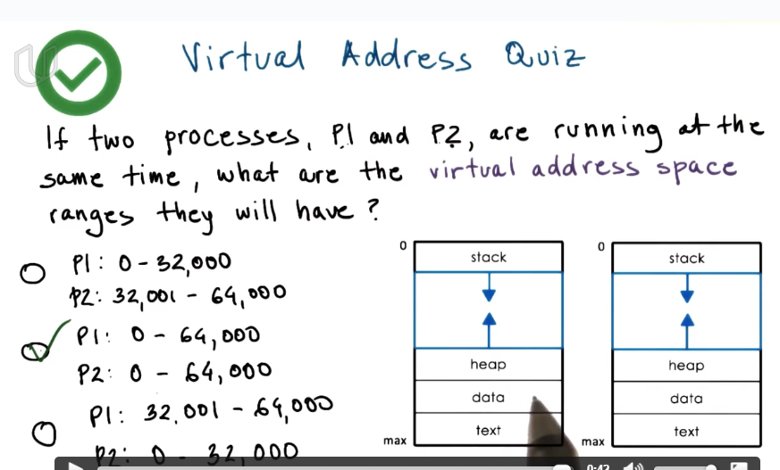

two process can have the same virtual memory. The OS will make sure they point to different physical memory.

#### Process Execution State

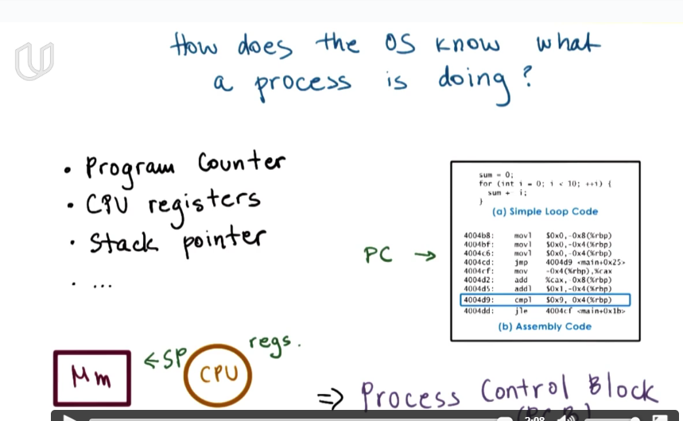

OS knows what a process is doing by PC, which is a register in CPU, and stack pointer of each process.

#### Process Control Block

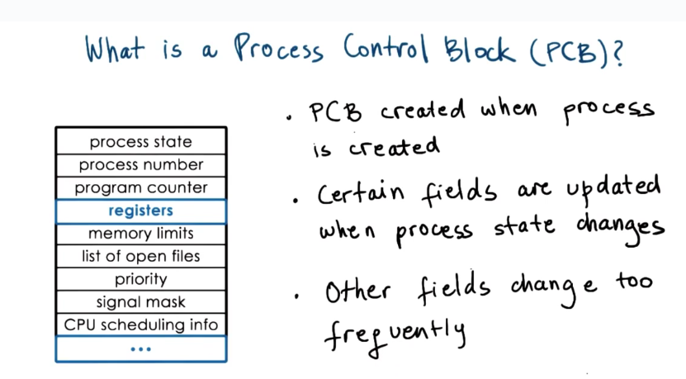

It is the OS’s job to collect and save all the information that CPU maintains for a process, to store it in PCB when the process is no longer running on the CPU. CPU will reload information from the PCB when it’s going to run the process again.

#### How is a PCB Used?

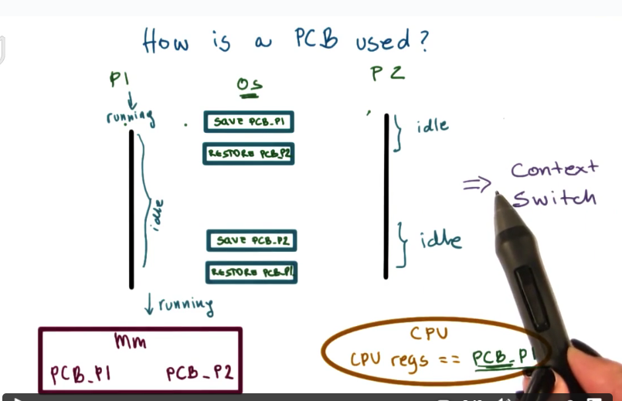

#### *Context Switch

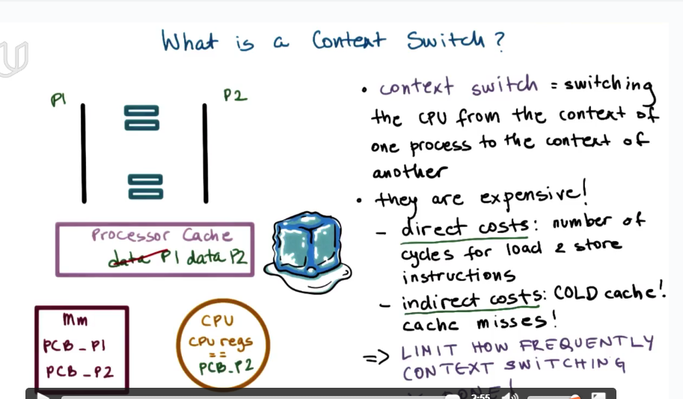

context switch is expensive for cache miss!

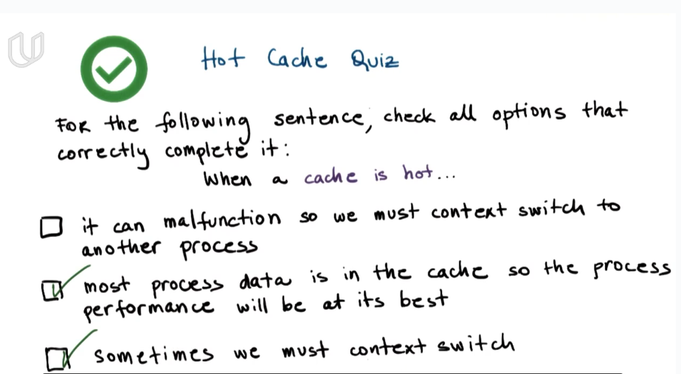

When a cache is hot, sometimes we must context switch. Maybe another process has higher priority and needs to execute. Or there is a policy about timeshare of CPU. So the time for current process expires and must be quited from CPU, and gives the CPU resources to another process.

#### *Process Life Cycle

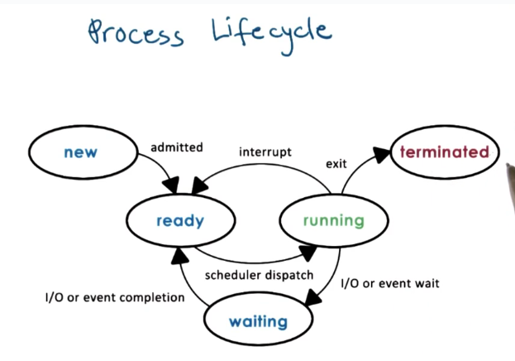

when a new process is admitted, OS will initiate a PCB for this process.

When a process is in ready state, the CPU is able to execute it. They are only waiting for the OS schedular to schedule it on the CPU

#### Process Life Cycle: Creation

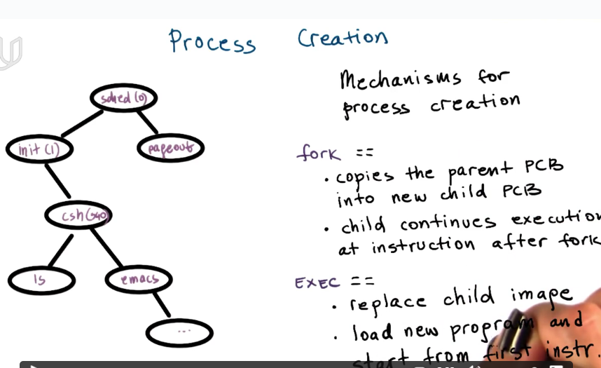

#### Role of CPU Schedular

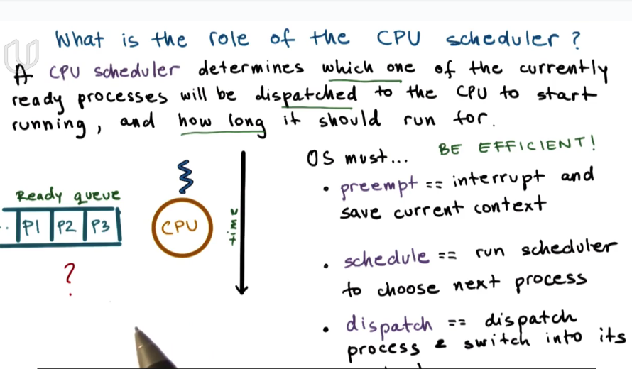

OS must have efficient scheduling policy. It depends on the efficiency of scheduling alogrithm and also the data structure used to present the ready queue.

In order to achieve high efficiency of CPU, it needs process scheduling and context switch,

#### What about I/O

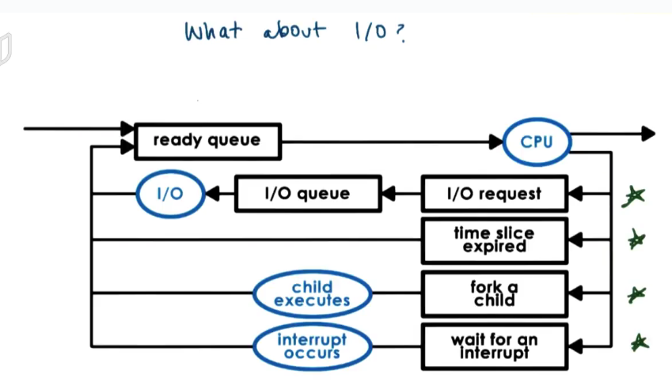

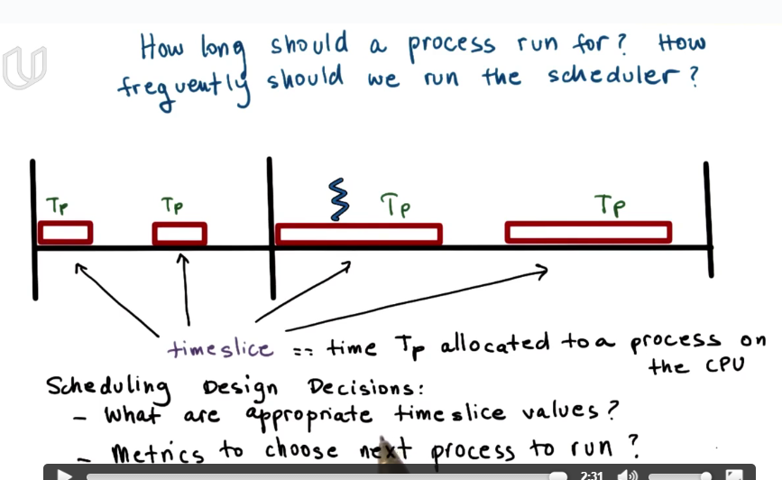

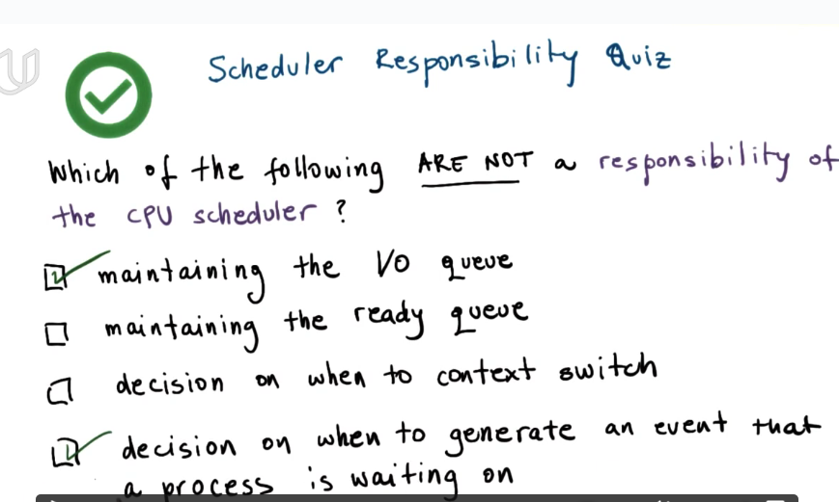

a CPU scheduler has no control over external event.

#### *Inter Process Communication

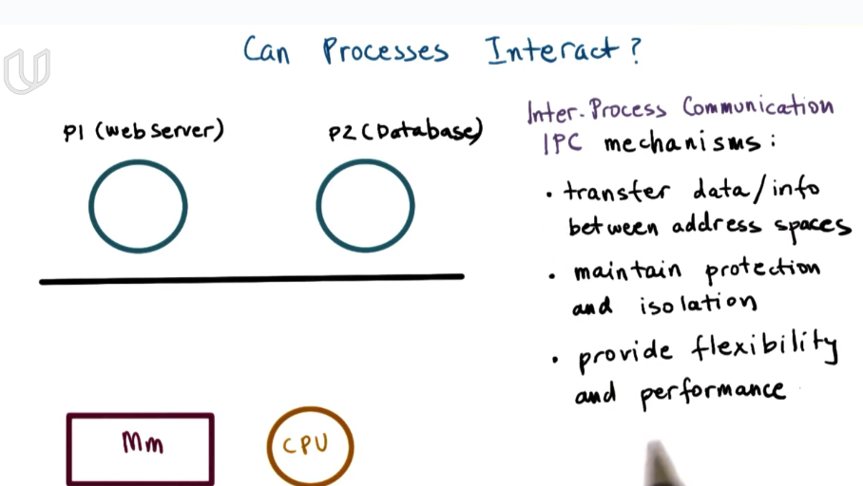

many applications include multiple processes. They may need to communicate sometimes.

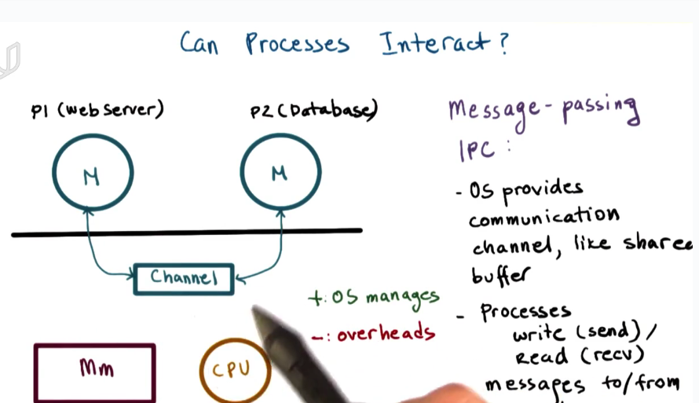

It’s messge-passing because every process has to put the information that it wants to send to the other process, explicitly in a message and send it to the delicated communication channel. OS will provide well-defined API for this usage.

requires OS but can avoid conflict to rd/wr the same address.

message passing is implemented by system call.

memory share is faster but may cause conflict.

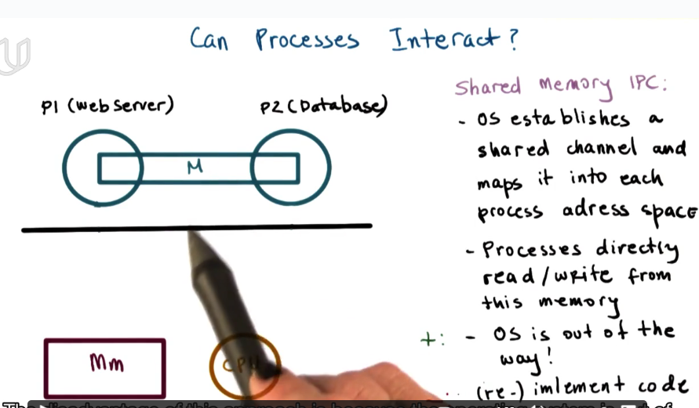

#### Lesson Summary

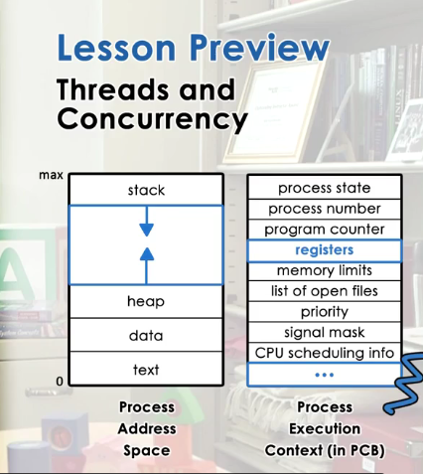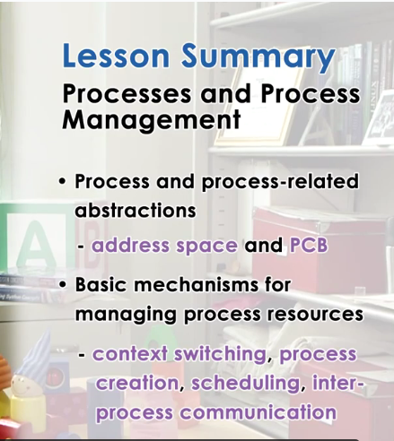

what is process: an instance of executing application.

what a process looks like? address space.

How OS manage process? PCB

Key Words: Virtual Address Space; PCB; Context Switch; Process Life Cycle; CPU Schedular; Inter-process Communication

### Thread and Concurrency

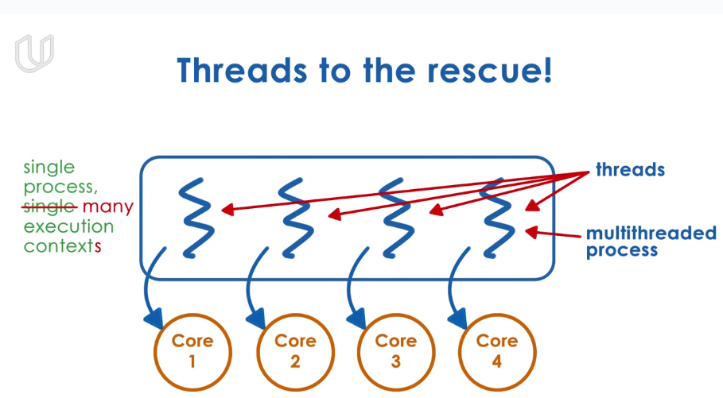

#### *Process vs. Thread

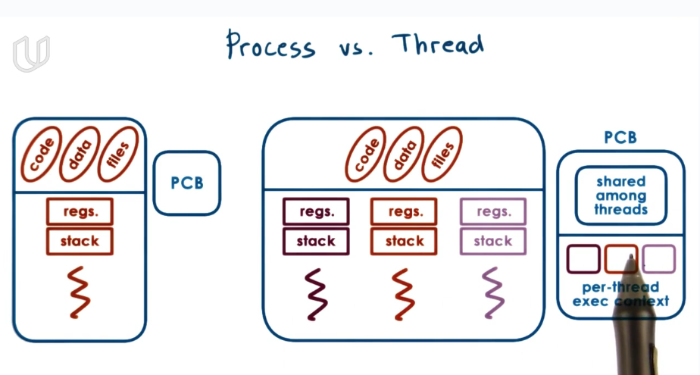

**a single thread process is represented by its address space. The address space wiil contain all of the virtual to physical mapping for the process, for its code, its data. Keep section files for everything. The process is also represented by its execution context that contains the information abou the values for CPU’s registers, the stack pointer, program counter. The OS represents all these information in a PCB.**

**Thread contains multiple, independent execuation context. They are part of the same virtual address space, which means they will share the same virtual to physical memory mapping. They will share all the same data, code, and files. However, they will potentially execute different instructions, address different portions of address space, operate on different portion of input. Each thread has different program counter, stack pointer**

#### Benefits of Multithreading

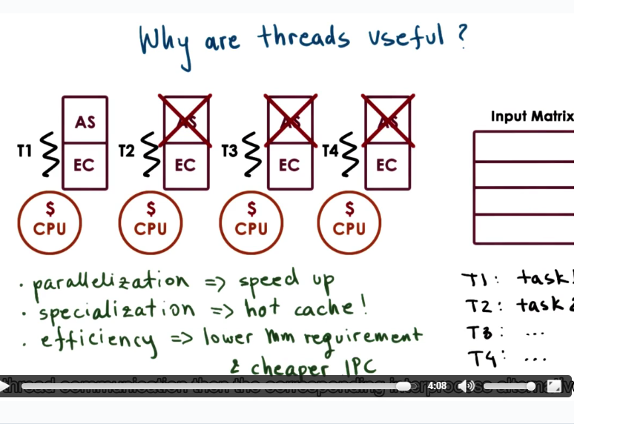

**Different thread of the same process may deal with different portion of input. They share the same code and data, but different execuation context.**

By sepcializing different thread to run different task or different portion of program, more state of application can be loaded in cache.

**Multi-process VS Multi-thread: each process have its own adderess space but threads can share the same address space. Besides, communication between threads is cheaper than process.**

#### Benefit of Multithreading: Single CPU

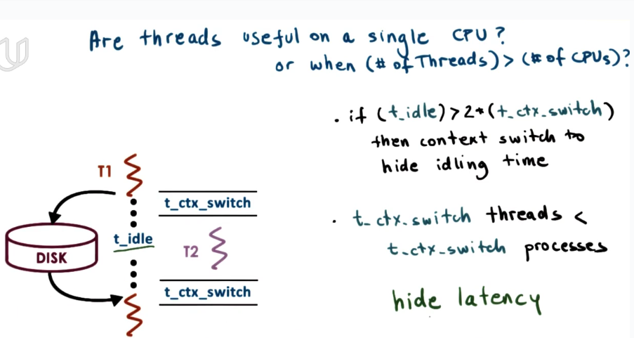

Context switch between threads is cheaper than process, because thread context switch does not need to create new virtual to physical memory mapping(because they share the same address space.)

Multi-thread is useful because t_ctx_switch is shorter, so we can make use of more t_idle and hide latency associated with I/O operations. This is useful even in single CPU.

#### Benefit of Multithreading: Apps and OS

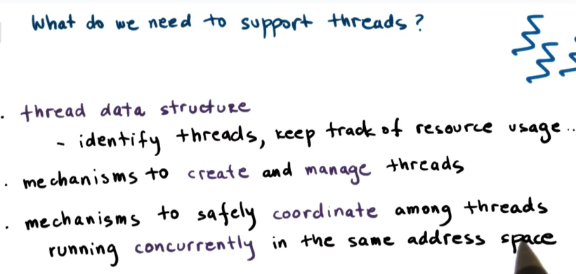

#### Basic Thread Mechanisms

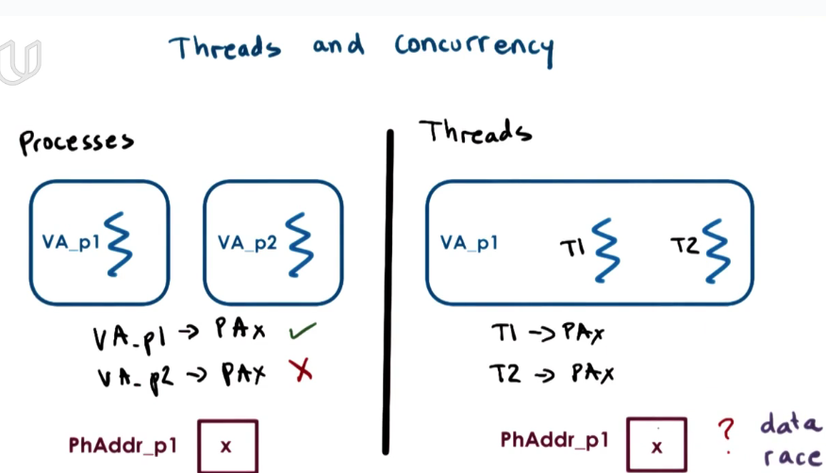

threads of single process have access to the same virutal memory space, which may result in data race. There should be mechanisms to ensure concurrency and coordination.

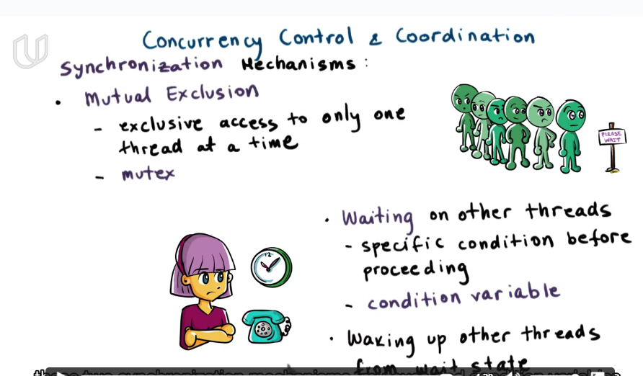

**多线程的优点：并发性， 提高响应， 高效使用CPU，cheaper communication， memory friendly**

**问题： concurrency**

#### Thread Creation

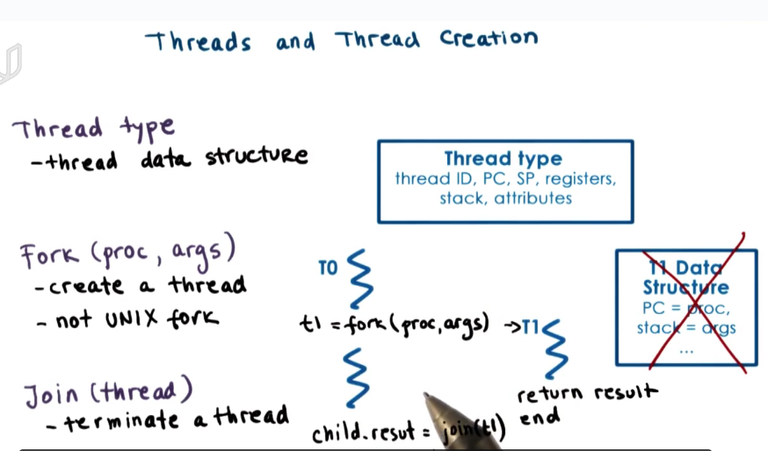

When T0 creates a child thread T1, T1 will execute the first instruction in proc with args.

Join: T1 will return its results to T0 and then is killed.

#### Thread Creation Example

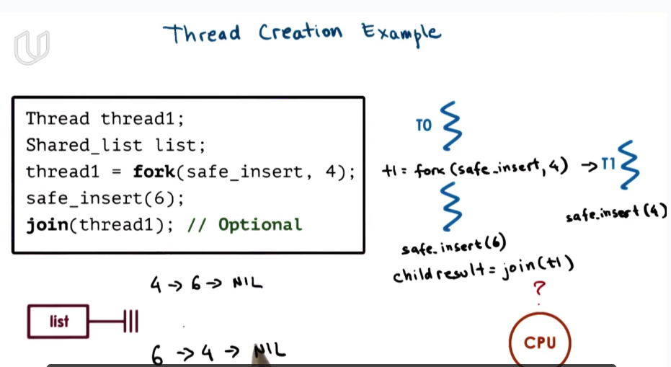

when T0 creates T1, T0 and T1 will constantly be switched when executing on the CPU. so the order of the safe_insert operation of parent and child thread is not clear.

When T0 calls join, if T1 is already completed, it will return immediately. Otherwise, T0 will be blocked and wait until T1 finished.

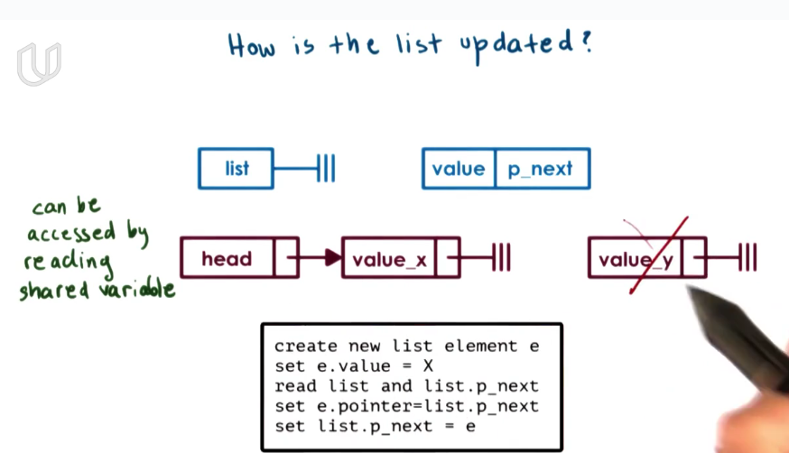

if **two thread on two CPUs** try to update the list at the same time. They will both first create a new list node, set next to head.next. But head.next can only be set to one of them. the other will be lost.

#### *Mutex

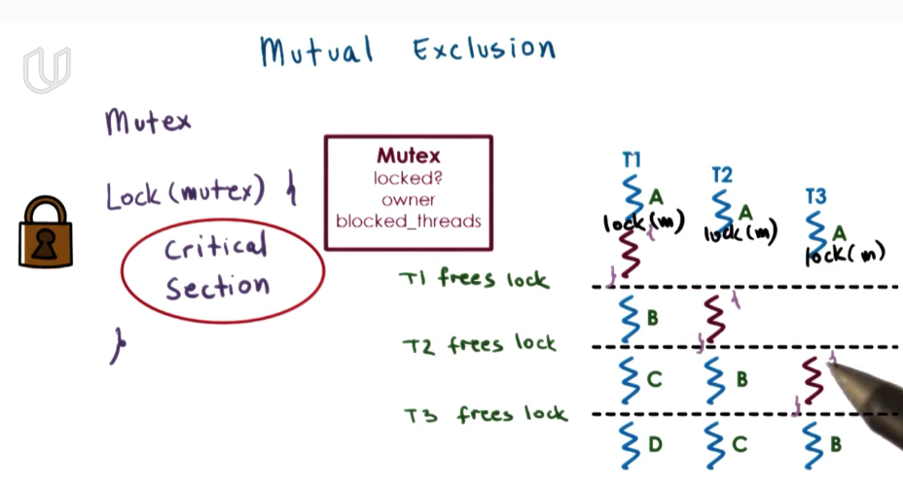

**Mutex is a lock to protect critical section.**

You can only access the data when you get the lock. The lock can only be held by one thread at a time. After you quit the critical section, you should release the lock.

#### Mutex Exclusion

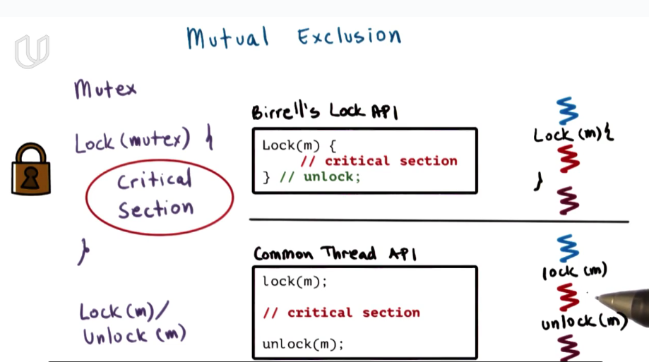

#### *Producer and Consumer Example

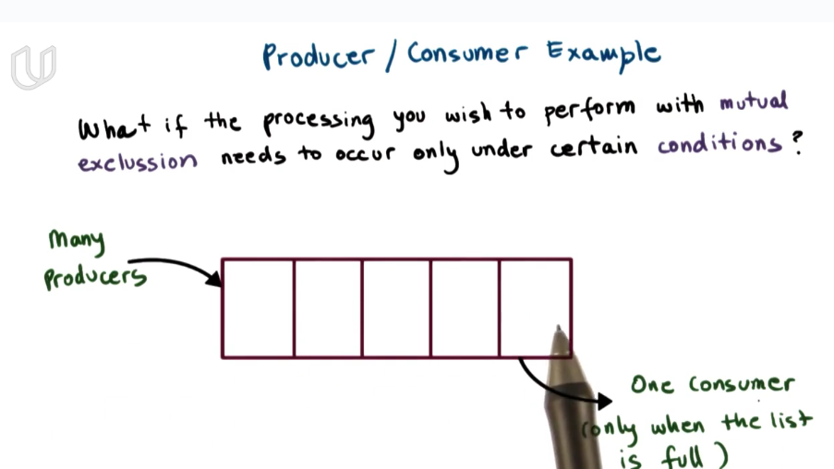

生产者消费者问题：两个线程同时对一块共享内存读写，生产者不能向已满区域写，消费者不能从空区域读。

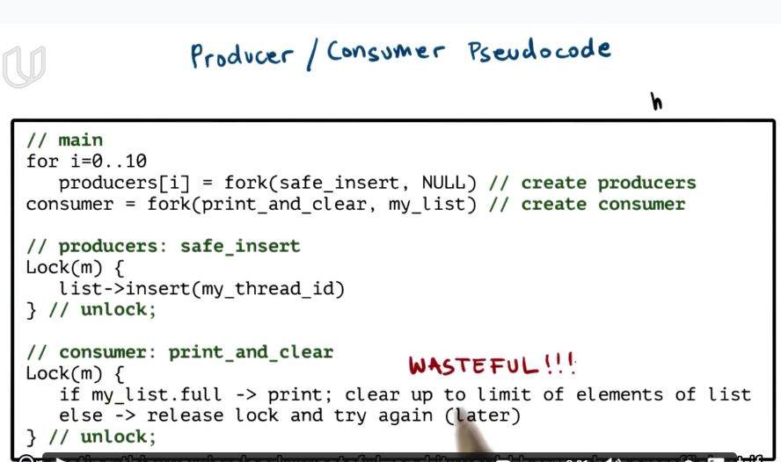

wasteful because consumer needs to query all the time.

#### *Condition Variable

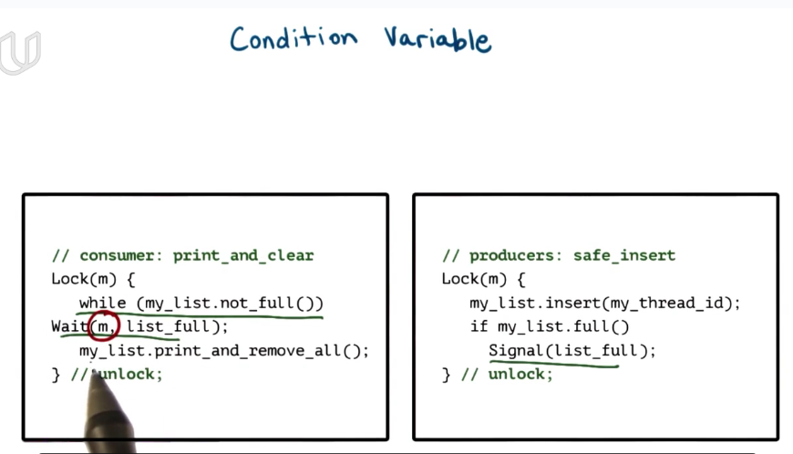

the lock must be automatically released when coming into the wait statement, and automatically acquired when stepping out of the wail statement.

When the list is full, producers will send a signal. Consumer receives the signal, acquires lock and read the list, and release the lock.

Mutex is a basic conception to solve multi-thread concurrency. But if one thread can only acquire the mutex under certain conditions(producer-consumer, writer-reader, etc), then conditional varaibles are helpful.

#### Condition Variable API

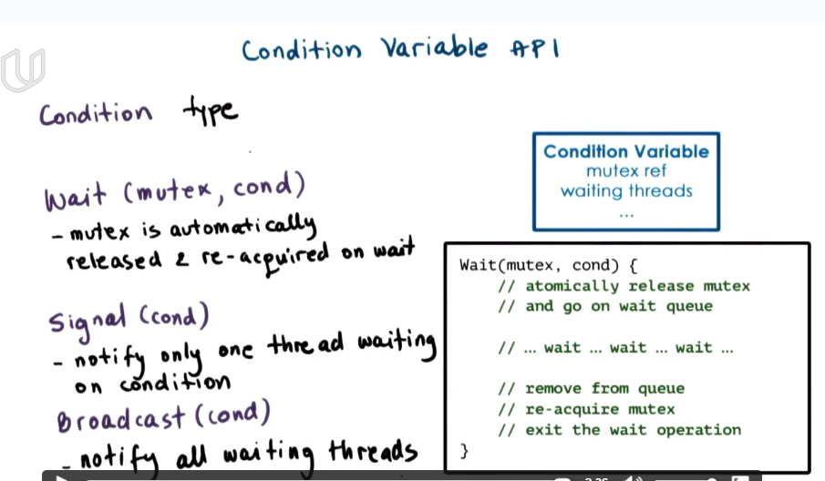

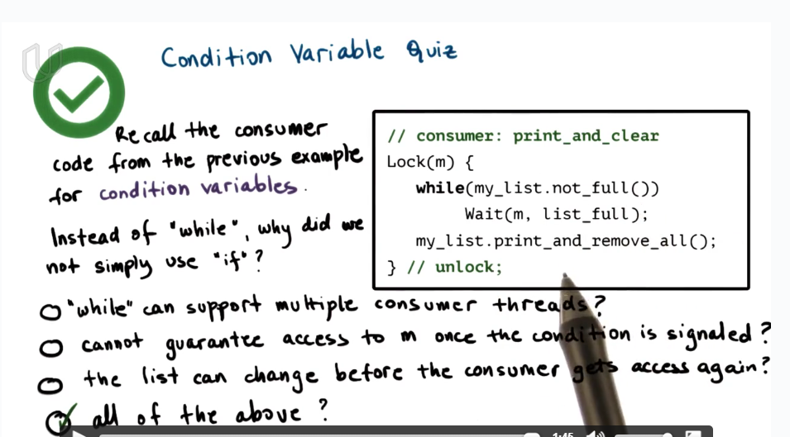

#### *Read and Writer Problem

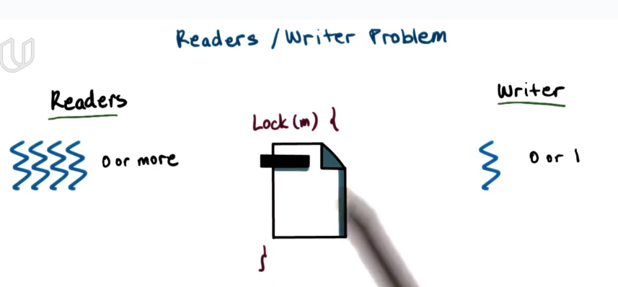

a single mutex/lock is not ok because we should allow mutiple readers at the same time.

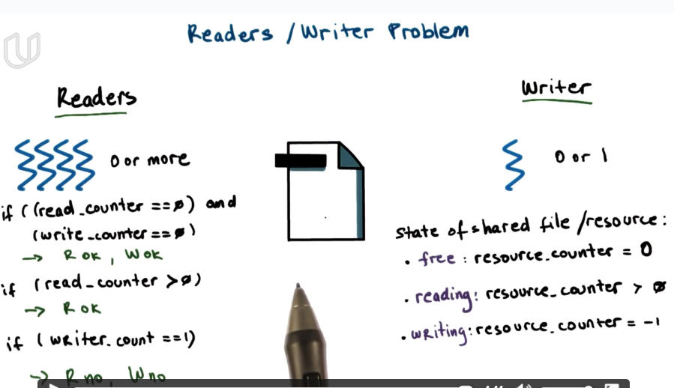

The actual read/write process is not protected by the mutex/lock, but only one thread has access to the resource.counter at a time.

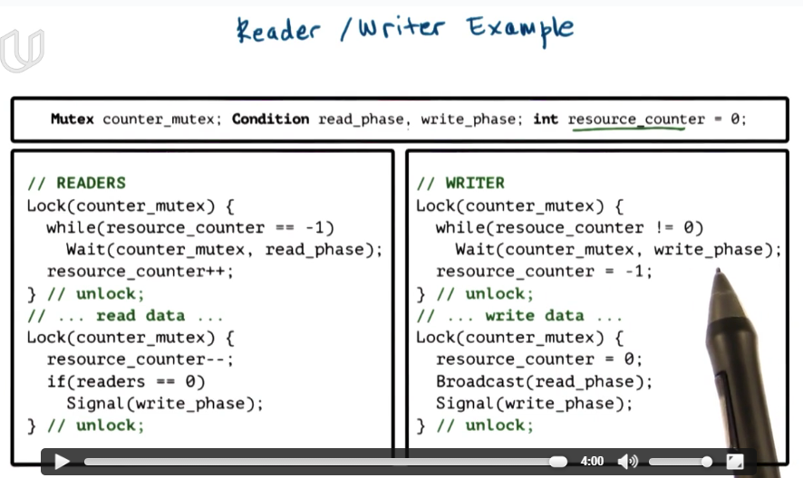

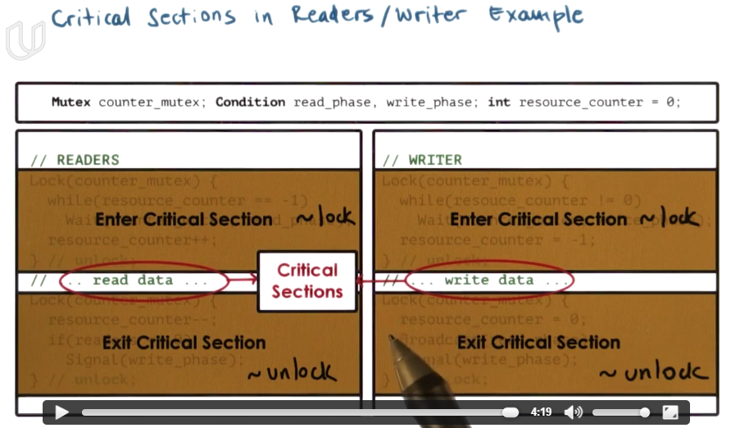

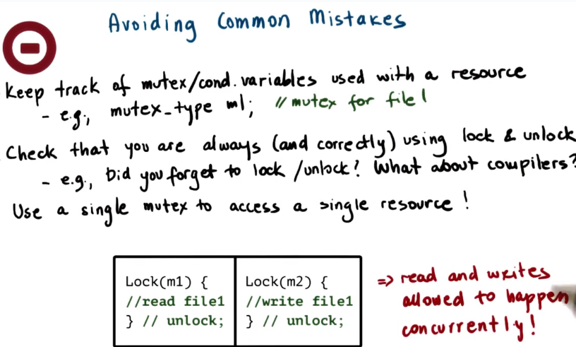

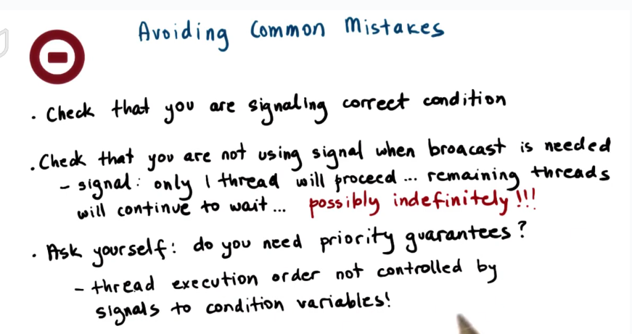

#### Spurious Wake Ups

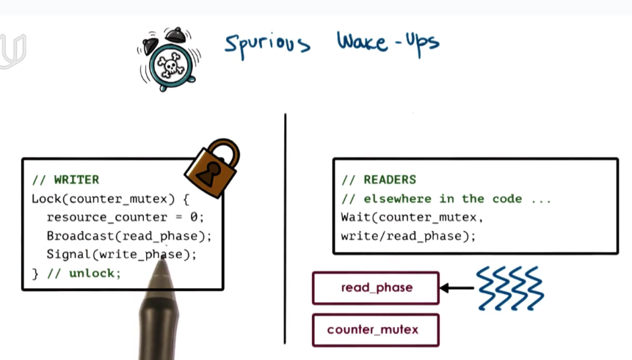

writer broadcast the read_phase and then release the lock. So it may be possible that threads waiting for the read_phase signal wake up and acquires the lock before writer release the lock. In this way, they will fail and wait in the queue for lock instead.

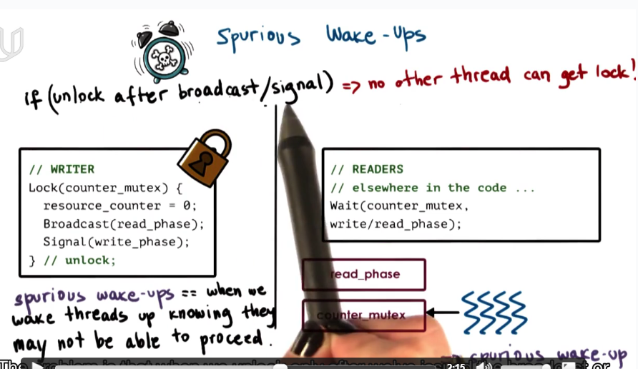

spurious wake-up is unnecessary wake-up. It does not affect correctness, but affect performance.

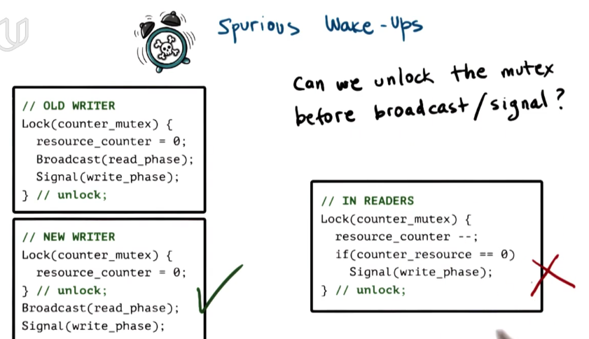

#### *Deadlock

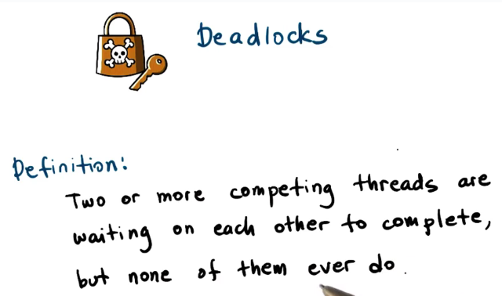

多个线程相互请求对方手中的资源， 形成一个闭环

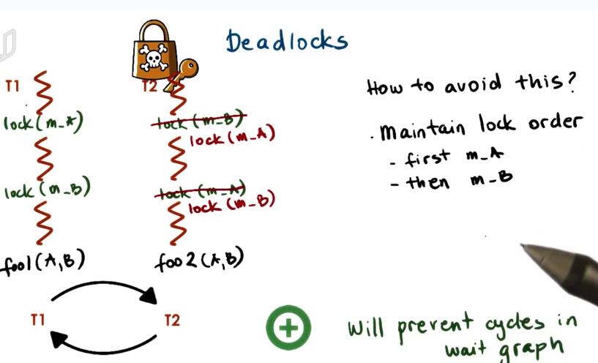

**解决死锁：确保资源获取有一定的顺序。**

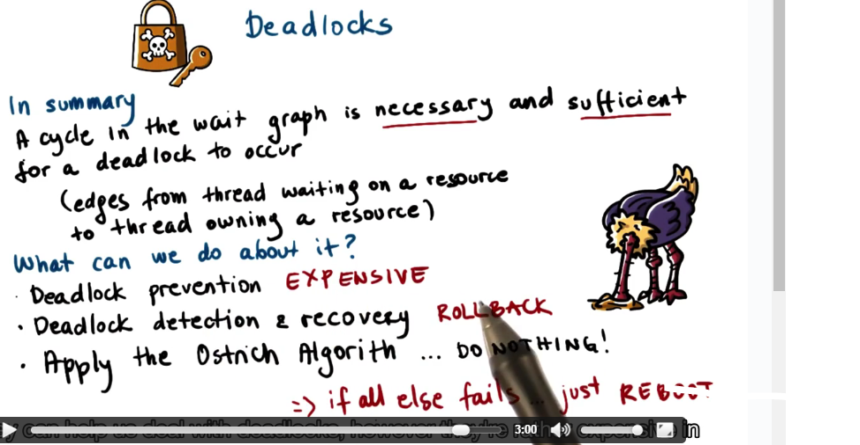

deadlock prevention: first to detect if a thread would possibly cause a deadlock. If it does, delay it and operate it afterwards.

#### *Kernel vs. User-Level Threads

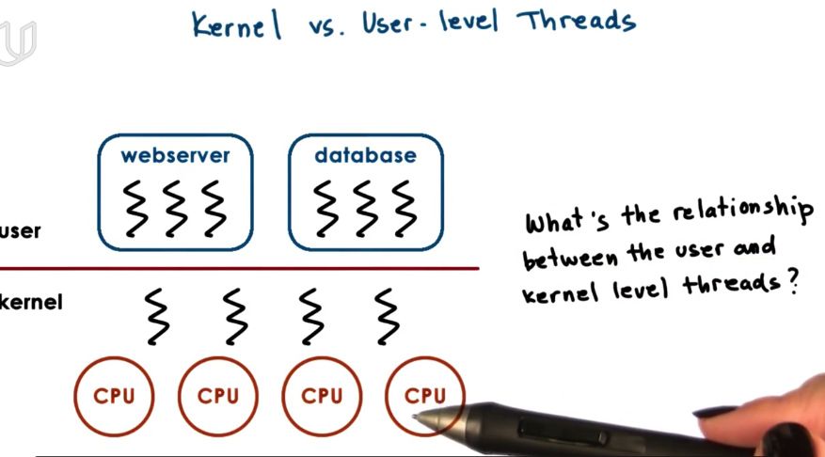

Threads can exist both in user level and kernel level.

Kernel threads are visible to the kernel and are managed by kernel level component such as OS schdeluar. The OS schedular will decide how these threads will be mapped onto the underlying CPUs and which one of them will be executed at some point of time.

Some kernel threads are to support and execute user-level threads. Some may run OS-level services.

For a user-level thread to actually execute, first they must be associated with a kernel thread.

#### *Multithreading Models

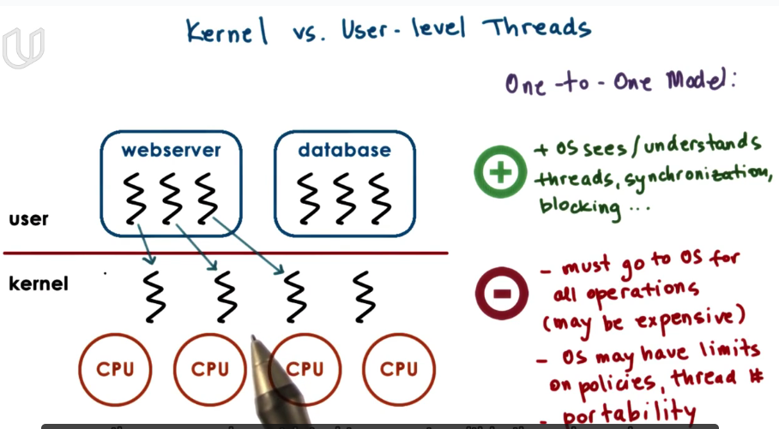

If all the user-level threads are associated with kernel-level thread, OS is responsible for thread scheduling, synchronization, blocking and so on. They must obey the OS policy. For example, if the user process acquires a specific scheduling policy , it may not be supported by OS.

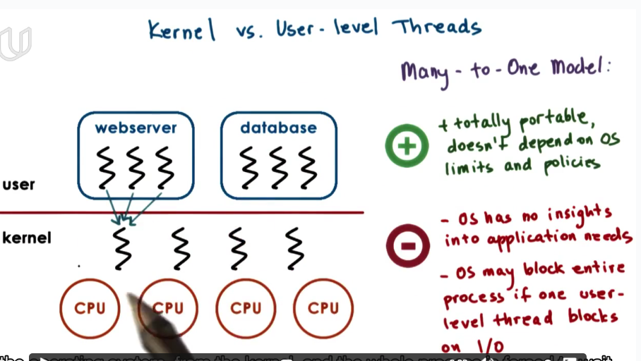

all the aspects about thread scheduling, synchronization, blocking, etc will be decide by user process. Totally portable to any OS. But this kind of model may easily be blocked.

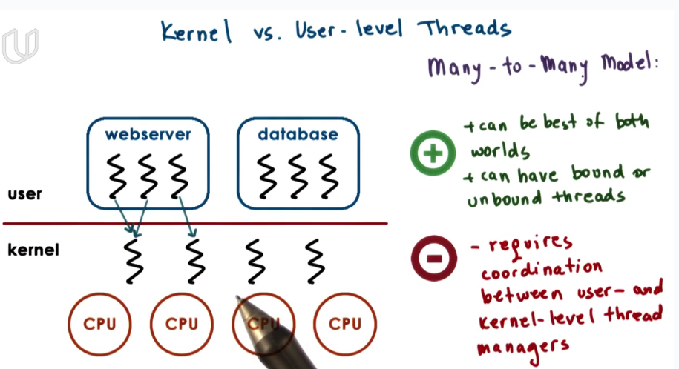

#### Scope of Multithreading

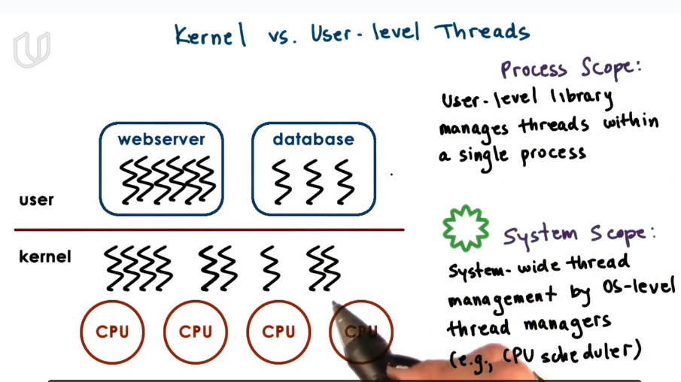

threads are supported both by the user-level library and system-wide thread manager.

OS-level thread manager will look at the entire platform and decide how to allocate resources among threads.

user-level library associated to a process and manages the threads within a single process.

#### Multithreding Patterns

Three patterns for multithreading patterns:

boss-worker

pipeline

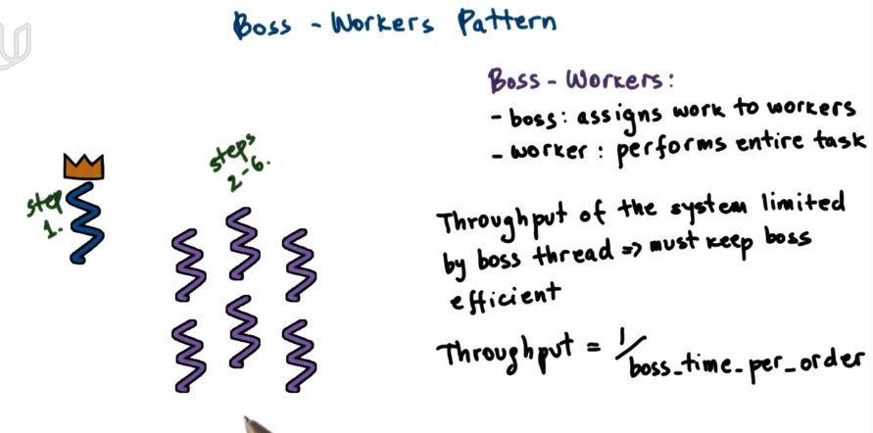

boss-worker pattern is that the boss thread will allocate each task to a worker thread. and the worker thread will be responsible to complete the entire task.

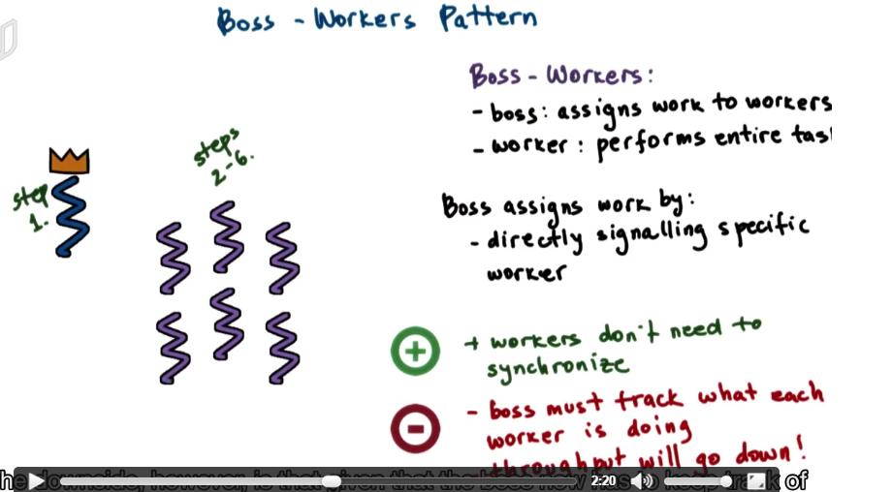

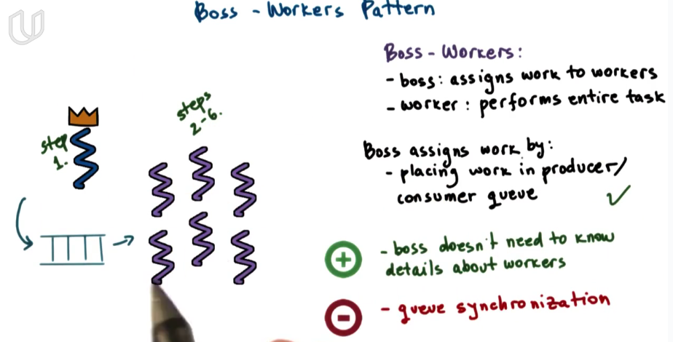

different works have access to the head of the queue. So there is concurrency problem.

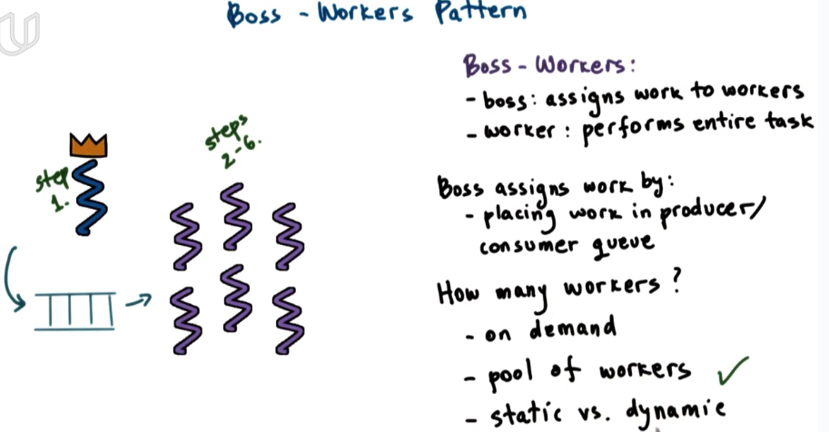

动态管理线程池

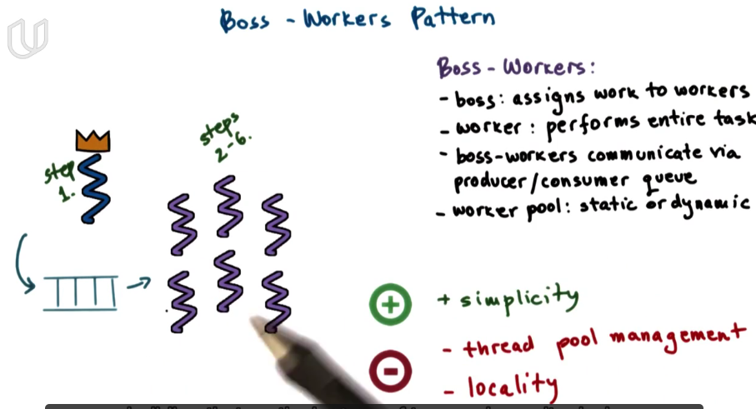

locality: a worker will perform better on similar work but the boss keeps no track of what a work did in the past.

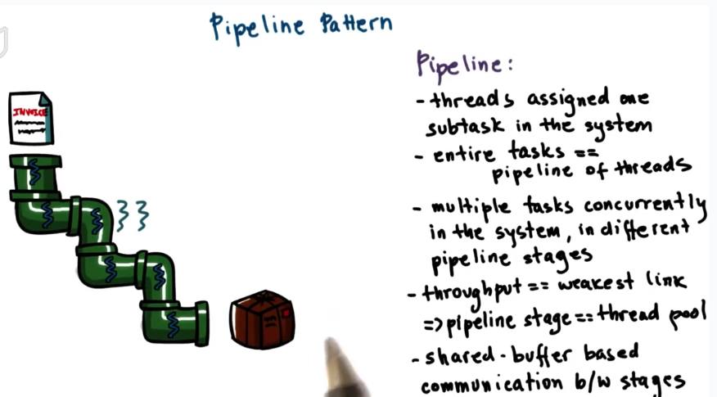

a pipeline pattern is that each worker thread only responsible for part of the task.

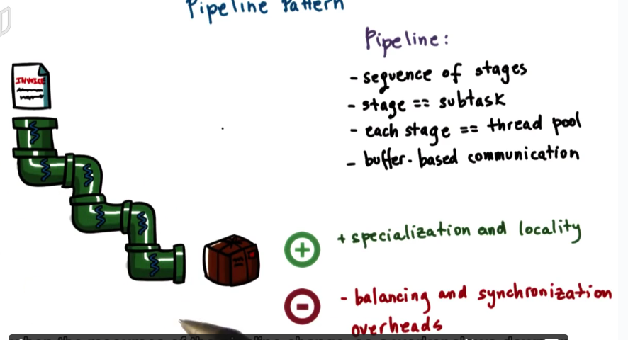

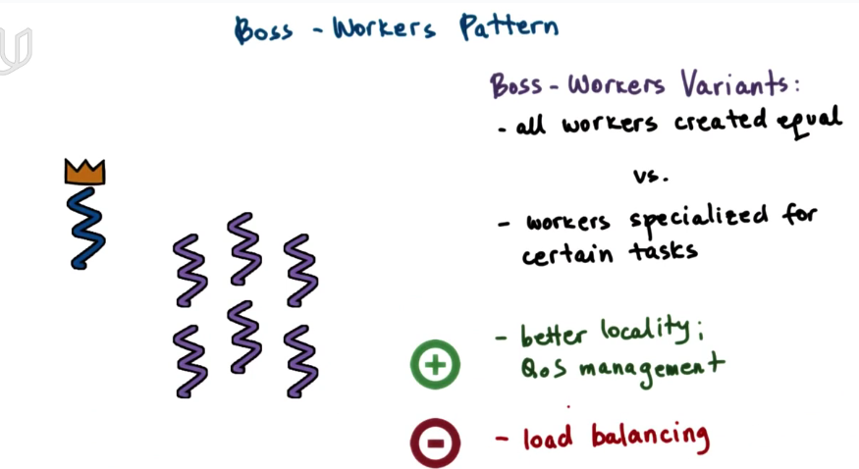

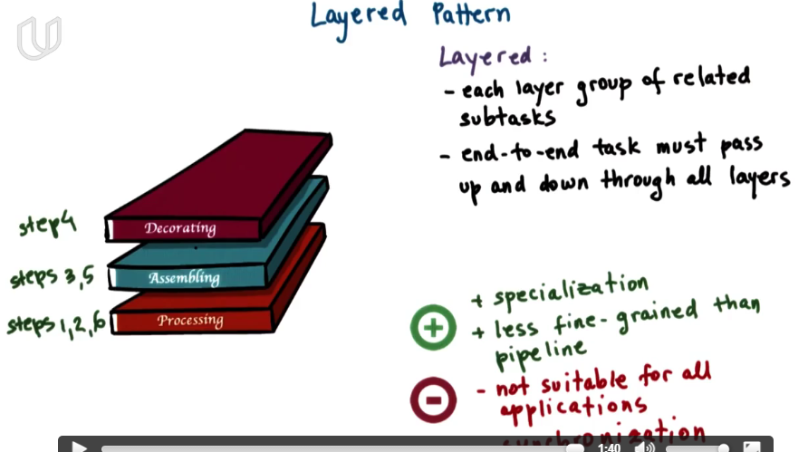



Keywords: Thread(benefit, how to represent); concurrency; mutex; condition variable; Reader-Writer Problem; Producer-Consumer Problem; Deadlock; user-level vs. kernel-level thread.

#### Thread Design Consideration

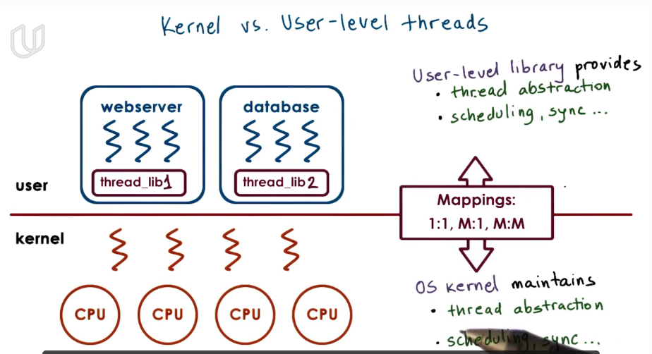

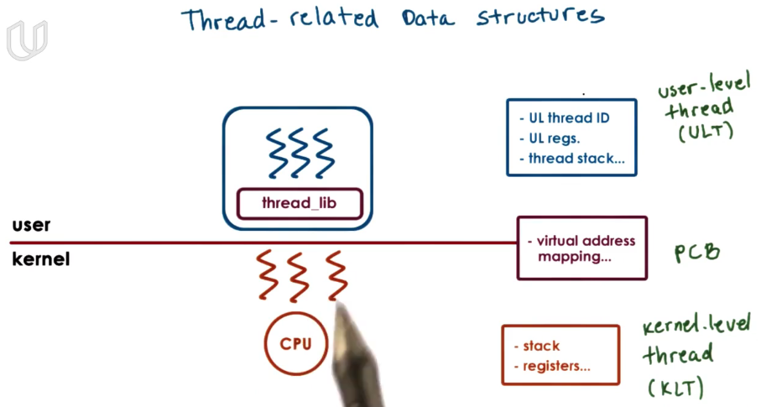

Multi-thread process will still maintain a PCB about its virtual address mapping information, but each thread will share a PCB and maintain its own stack and register.

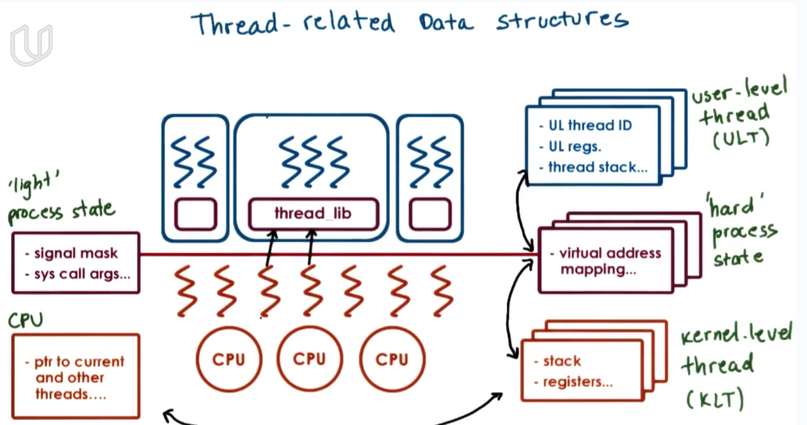

From process to multi-thread, a single large PCB is divided into a number of different data structure.

‘light’ process state is associated with a portion of user-level threads that are linked to the same kernel-level thread.

we do so for memory because different user-level or kernel-level may share information. So we do not need to maintain a PCB for each thread.

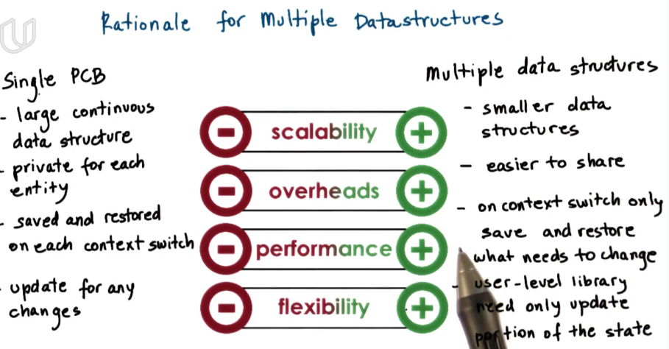

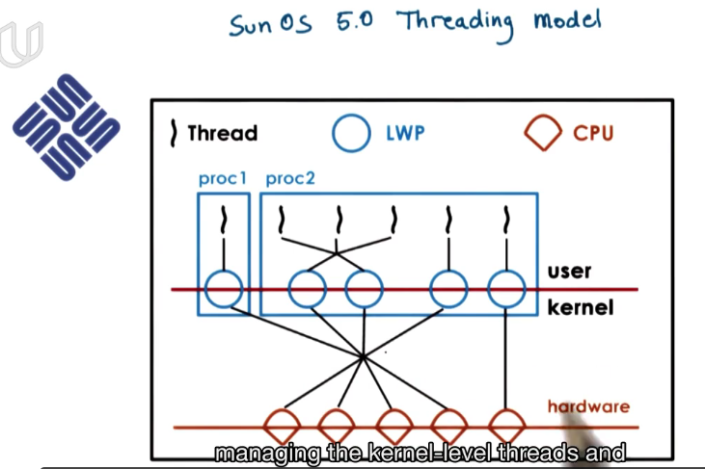

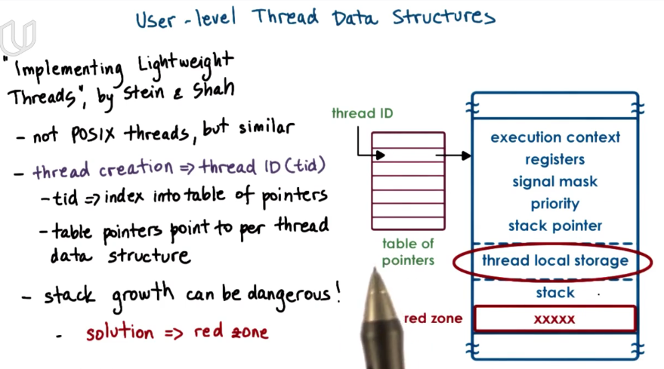

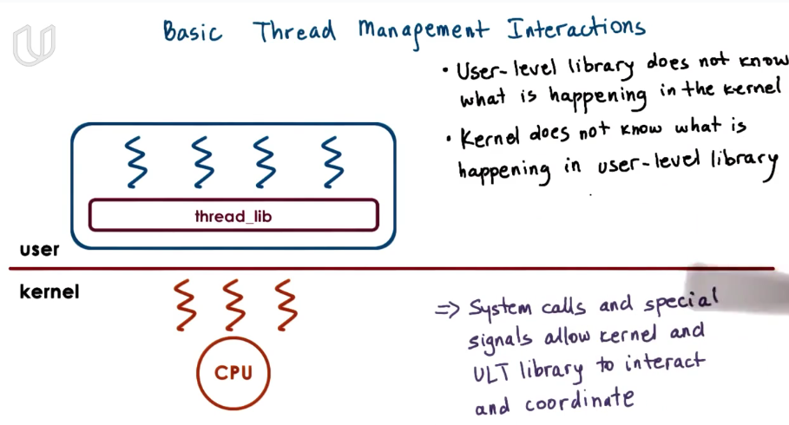

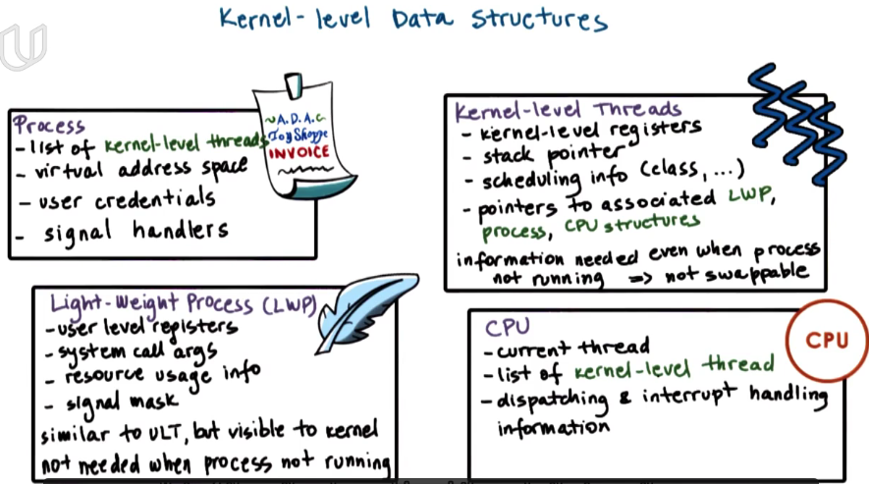

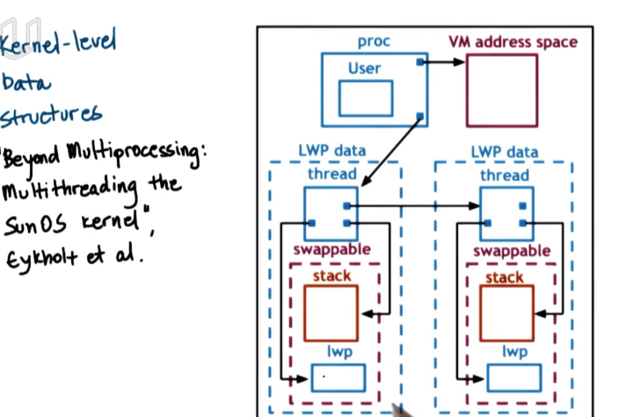

#### Interrupt and Signal

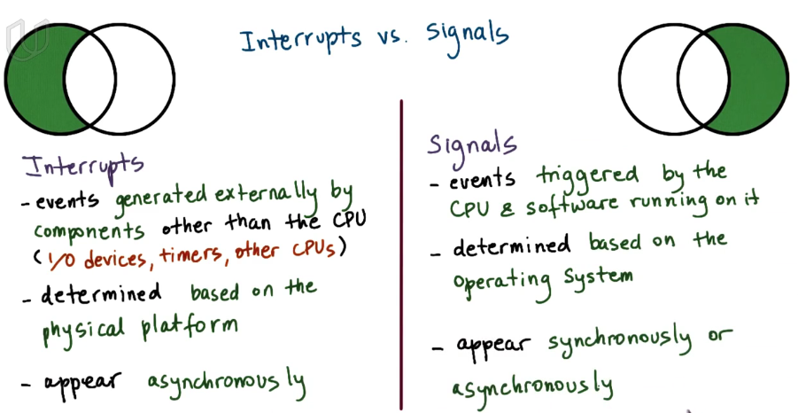

interrupt is generalized outside CPU. interrupt is delivered to CPU and notify to CPU that some specific thing happens.

signal is passing throung process.

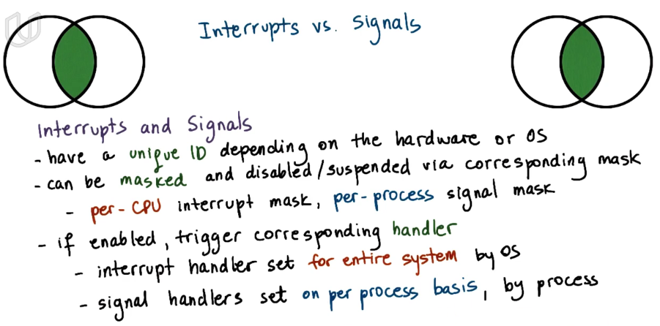

how to handle an interrupt is decided by OS, is set for the entire system,

how to handle a signal is decided by each process.

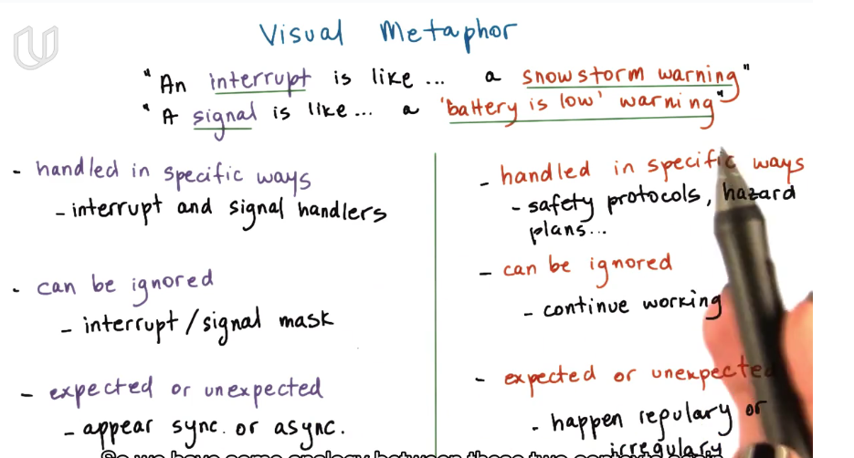

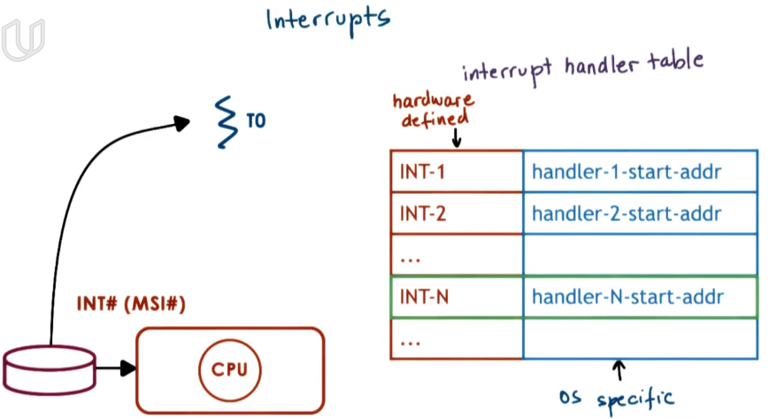

中断号 for each interrupt. There is an interrupt handler table specifying what CPU is going to do when receiving an interrupt.

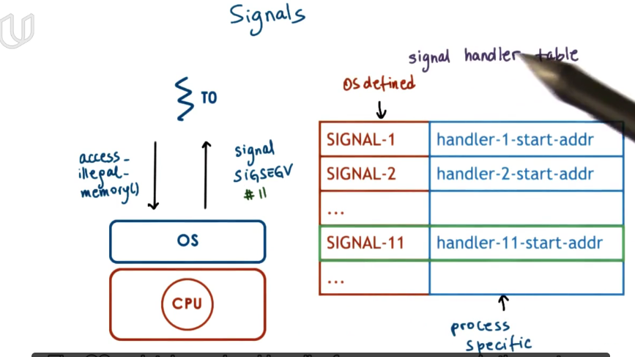

OS has default handler for each possible signal but process can specify their own signal handler.

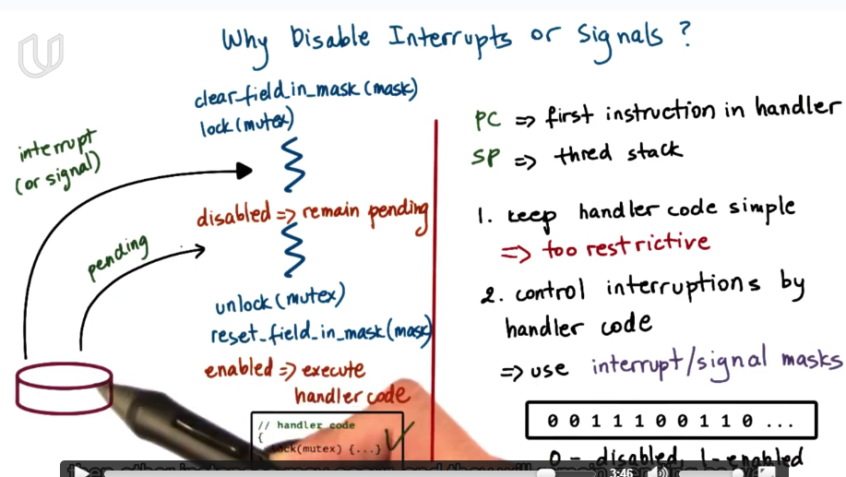

sometimes we need to disable interrupt or signal.

When an interrupt or signal comes, PC will point to the first instruction in handler and SP will still be thread task. If directly execute the handler, then there may cause a deadlock(if handler is asker for a mutex which already was acquired by the thread, the thread cannot release the mutex unless handler operation is done, and handler operation cannot continue unless it gets the mutex).

So when an interrupt or signal comes, first check the intterupt or signal mask to see if we enable this intterup/signal. If disable, then the original thread will continue, until at some point of time the mask shows enable(say the thread release the mutex so the handler can be executed.)

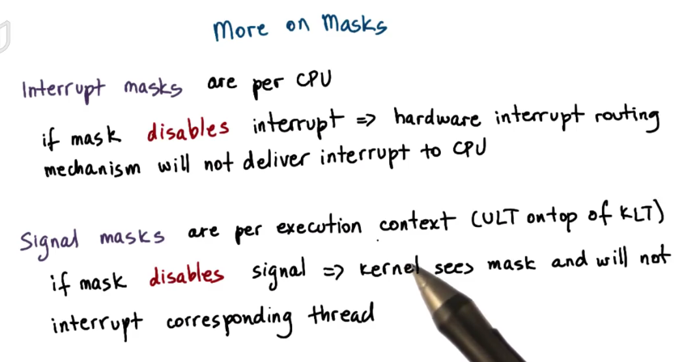

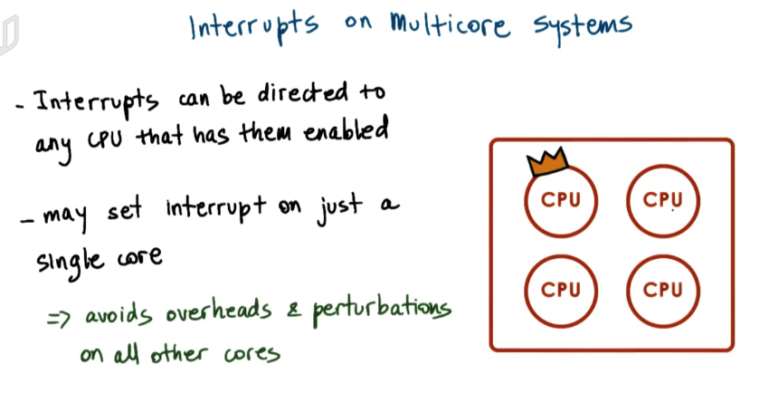

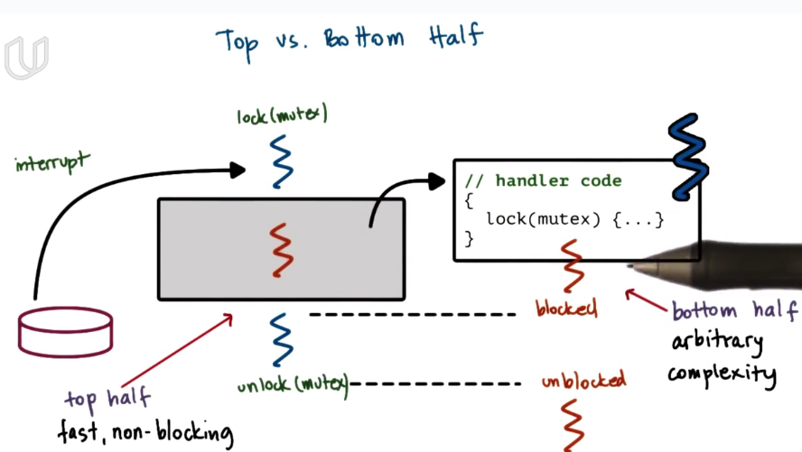

another way to avoid dead lock in interrupt handler is to create a new thread for interrupt handler, which is separate from the original thread.

##### Thread Performance

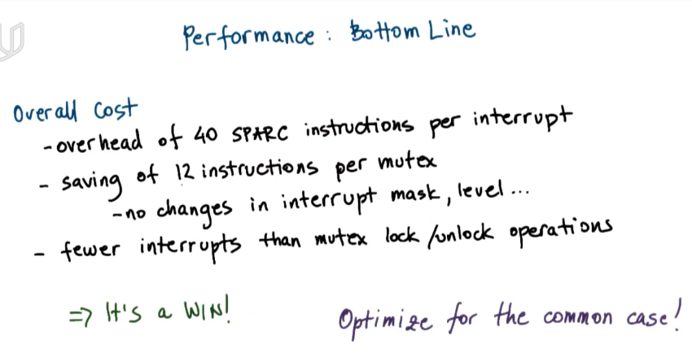

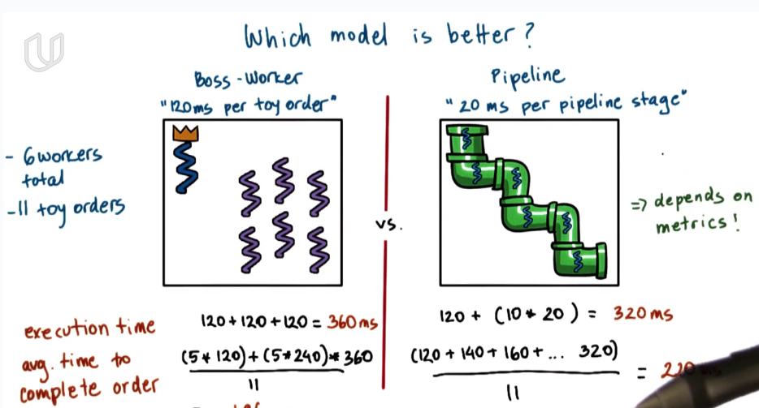

When comparing different model, the answer depends on what metrics used to evaluate.

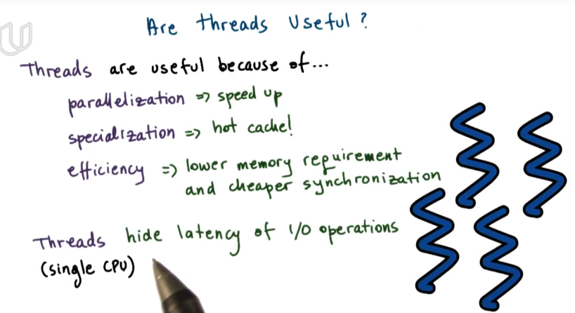

thread的好处：并行化，专用化，高效（节约内存，更便于同步），多处理器系统

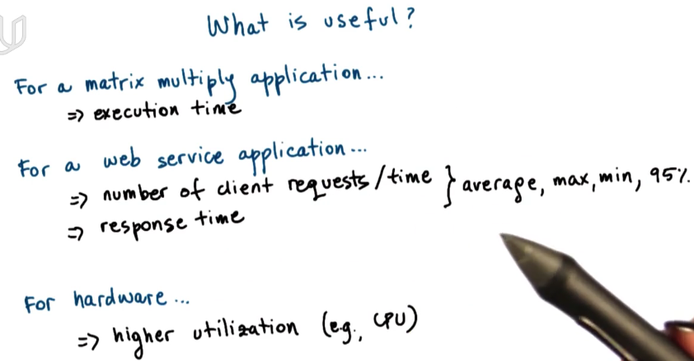

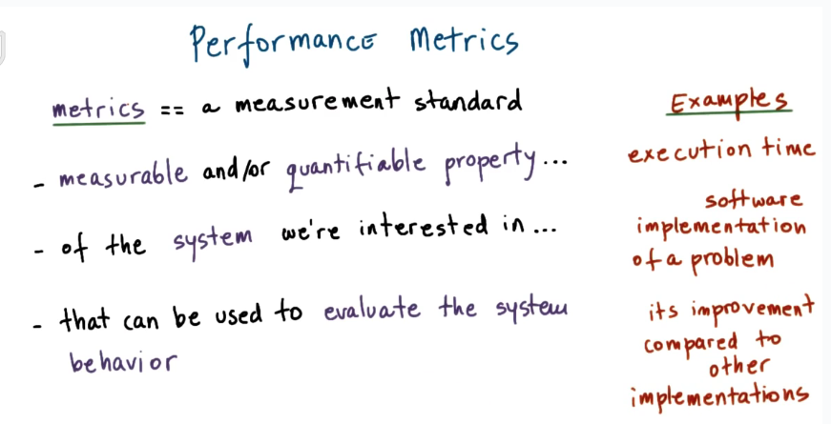

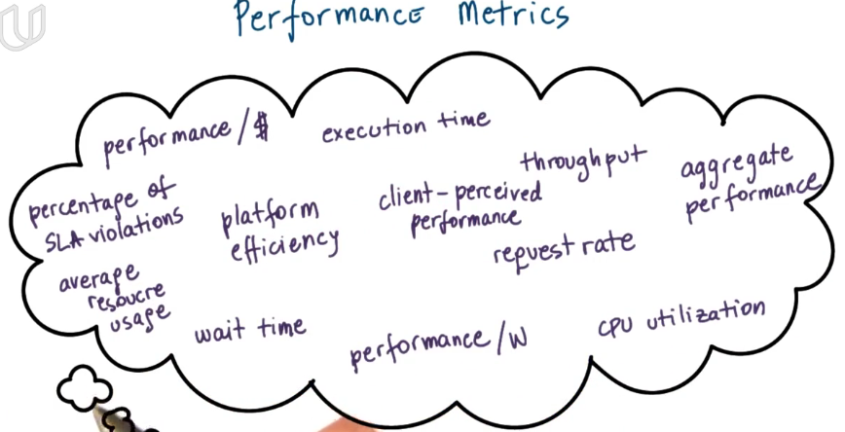

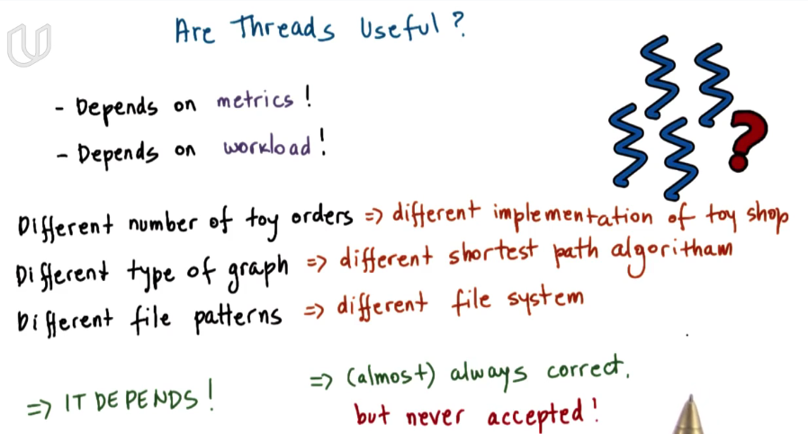

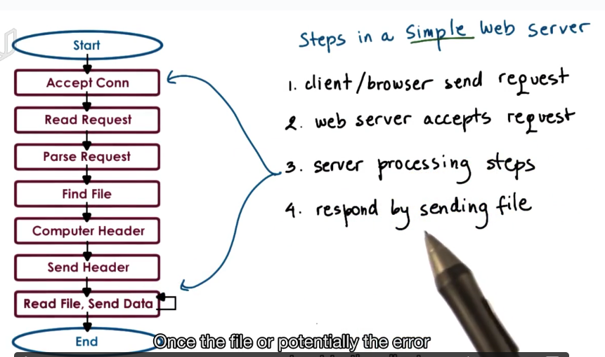

Compare the multi-thread with multi-process model using a simple web server.

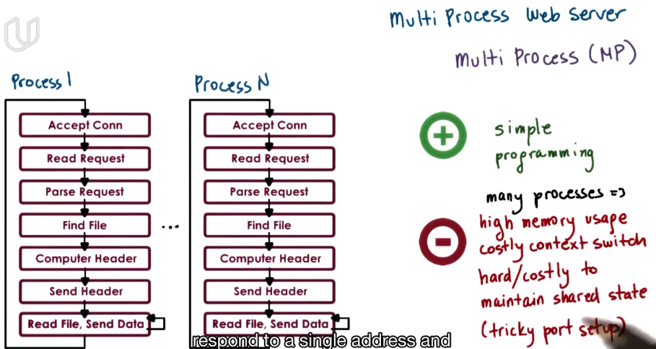

Dowsides about running multi-process on a platform:

1\ have to allocate memory for each process, put high load for memory and hurt performance.

2\costly context switch.

3\ it’s expensive to maintain shared state among process because the communication mechanism and sychronization mechanism that are availble over processes are high overload(because OS will defaultly disable a process access to another process’s address space.)

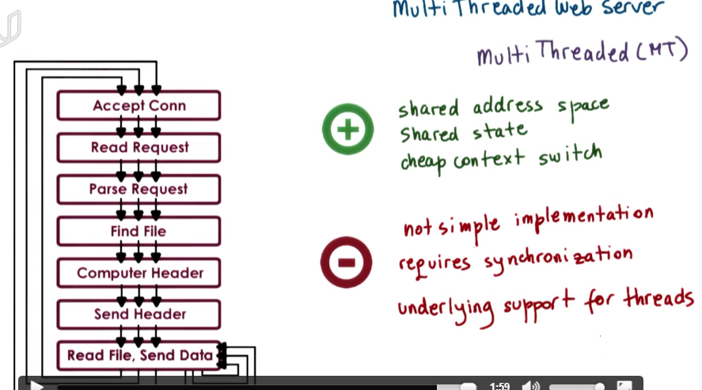

multithread share the address space, share the state, has cheap context switch. But because they have access to the same memory address, there needs synchronization policy to ensure working correctly.

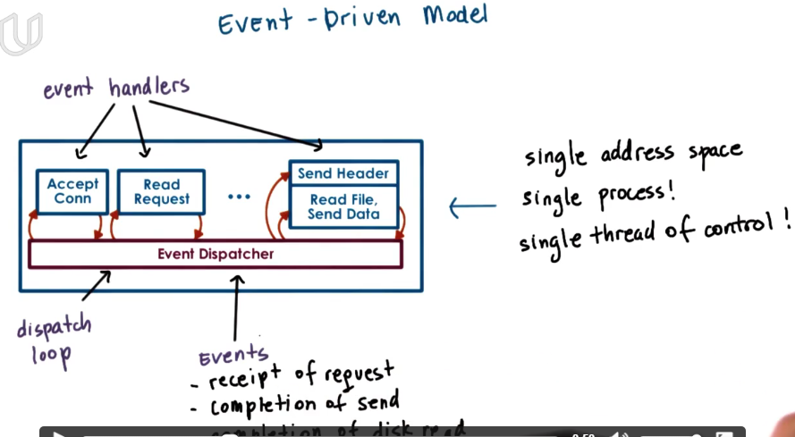

The main part of this model is event dispatcher that continuously in a loop that looks for incoming event and based on the event invokes one or more register handler.

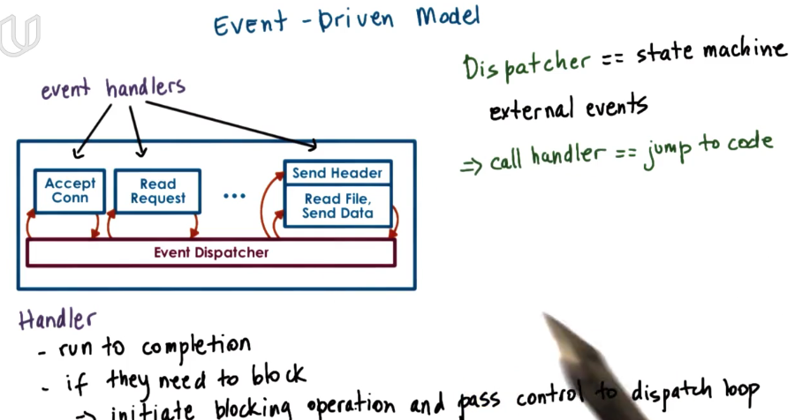

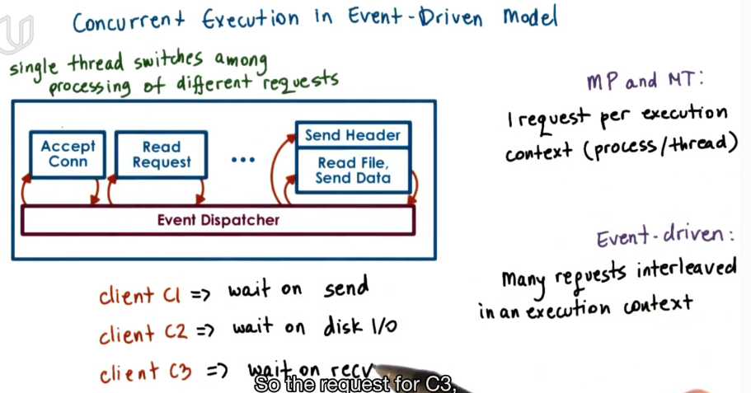

single thread switches among processing of different requests.

many requests interleaved in an execution context.

why use single execution context for different request? why not assign each request to different context, different thread or even different process?

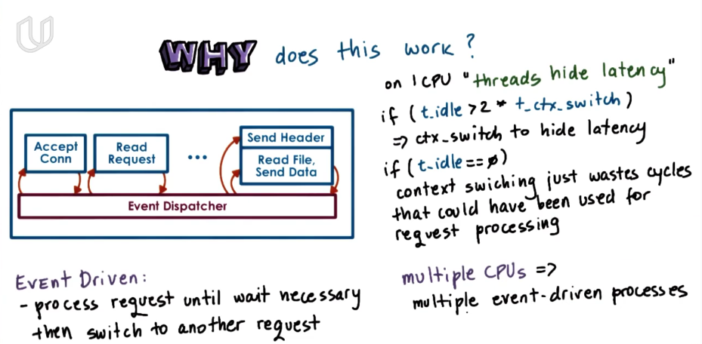

event driven model非抢占式调度。 a request will be not be switched by CPU until it terminates or has to wait.

### CPU Scheduling

#### Visual Metaphor

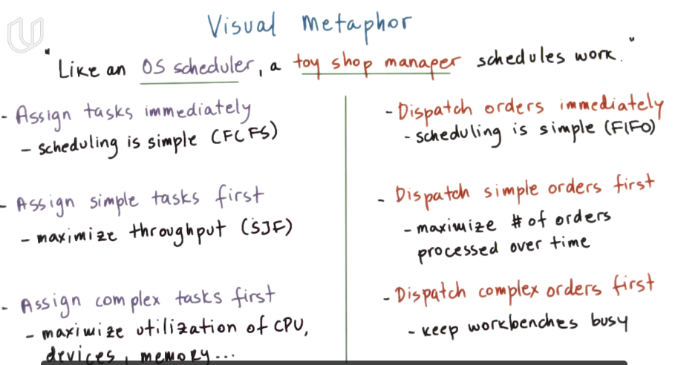

First come first serve: simple implementation, less overhead on schedular.

Simple job first: max throughput

complex job first: max utilization of resources

#### *Scheduing Overview

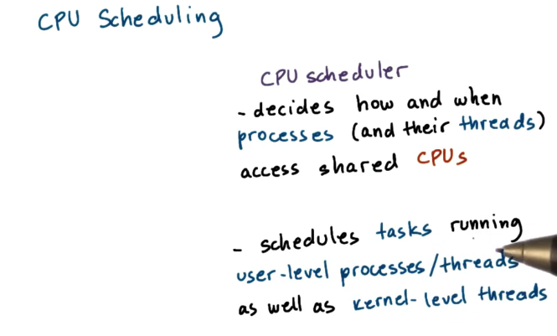

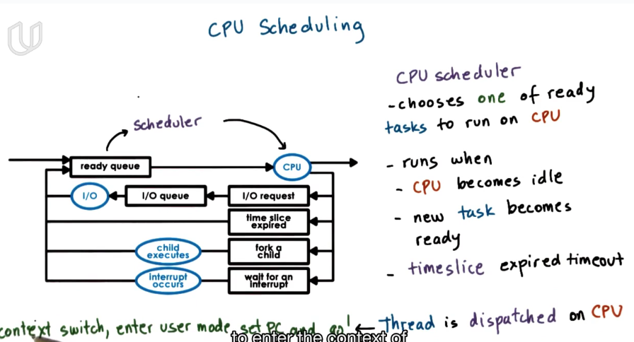

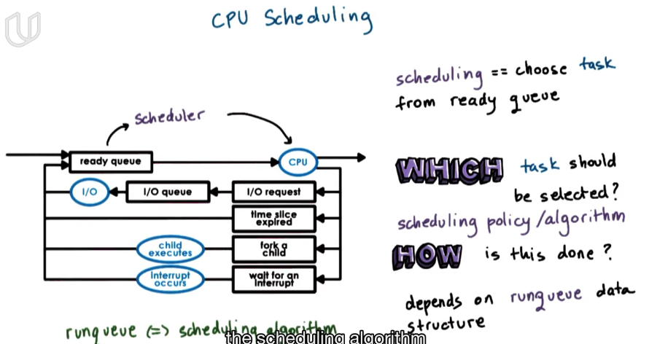

**the data structure of ready queue is tightly coupled with the scheduling algorithms. It can decide which kind of algorithms can be effeciently supported.**

#### Run To Completion Scheduling

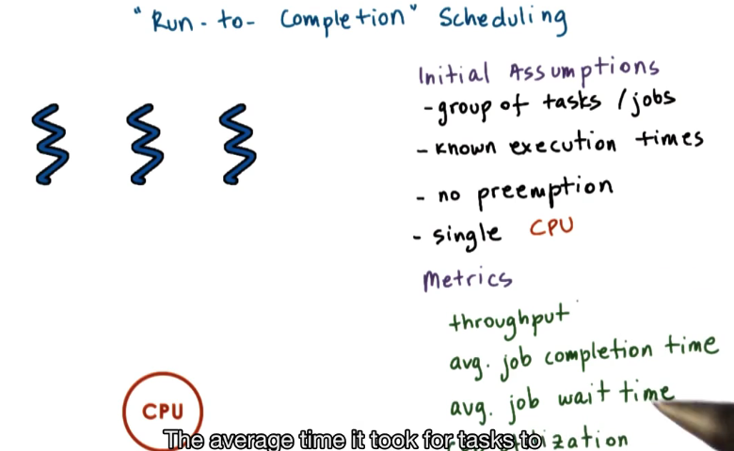

no-preemption

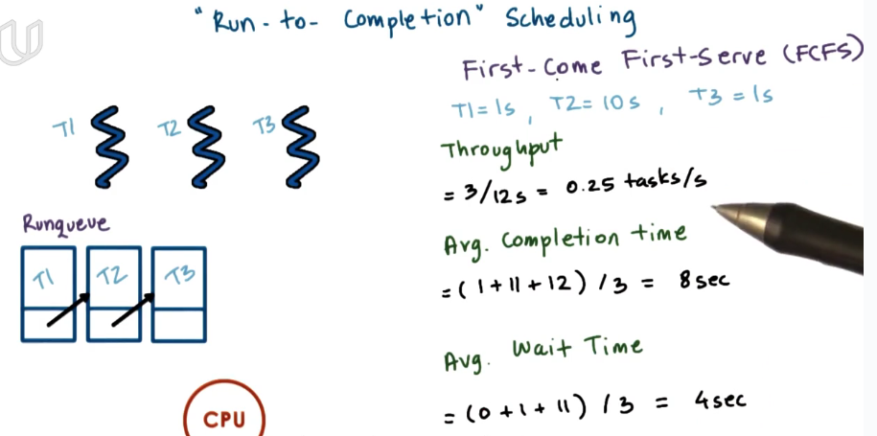

runqueue = FIFO queue

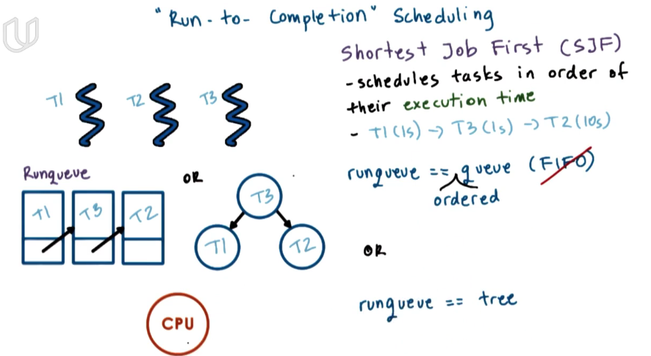

dequeue from the runqueue in an order: ordered queue or tree.

#### Preemptive Scheduling: SJF + Preempt

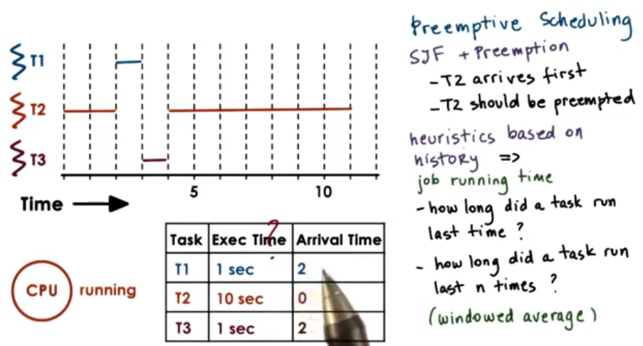

when new tasks come in, schedular will start to work and decide whether to switch task depending on the policy(simple job first here)

#### Preemptive Scheduling:Priority

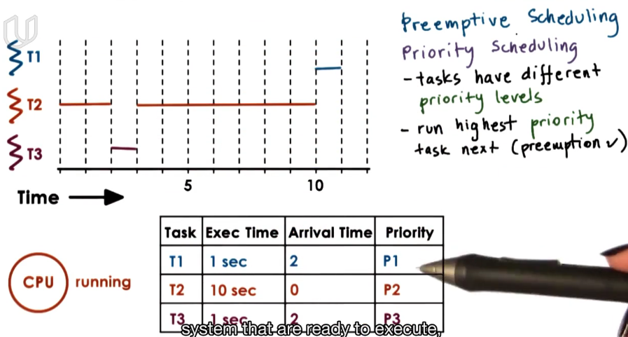

preemptive scheduling based on priority.

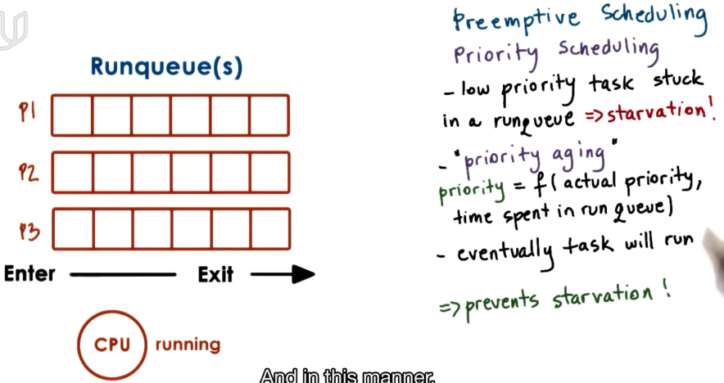

prevent starvation of low priority task

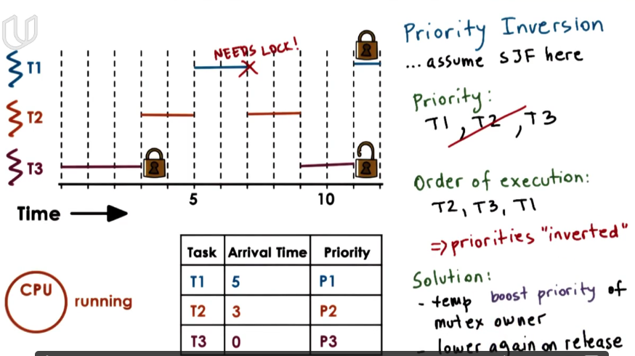

if high priority task requires a lock held by a low priority task. Then this low priority task should be executed first(assume T3 has the same priority level as T1).

#### Round Robin Scheduling

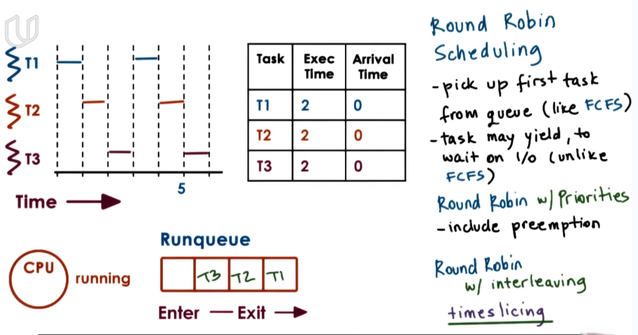

轮询调度

#### Timesharing and Timeslice

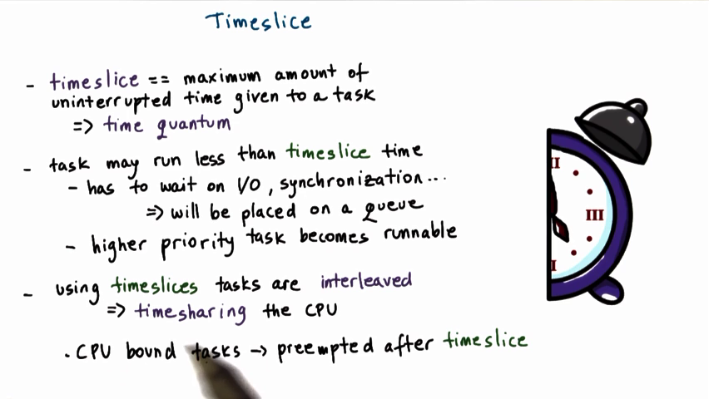

timeslice: 时间片

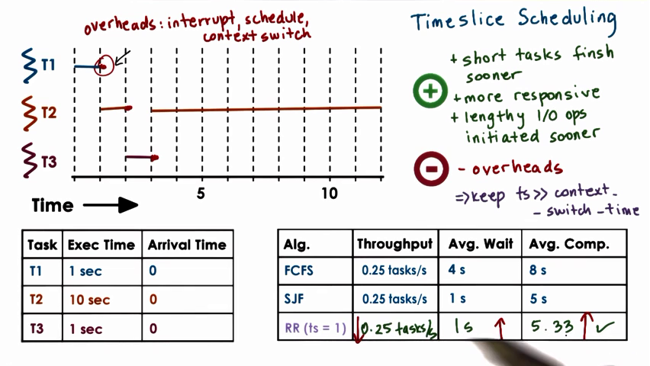

if timeslice is shorter, then short task can finish sooner, and it can be more responsive, any I/O oeperation can be executed sooner. but bad side is the overhead because of context switch.

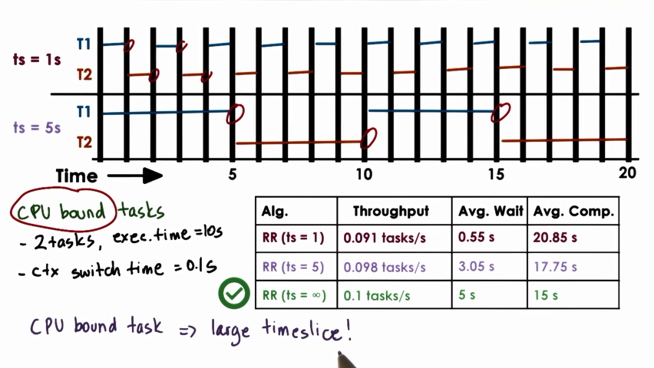

CPU bound task prefers large timeslice.

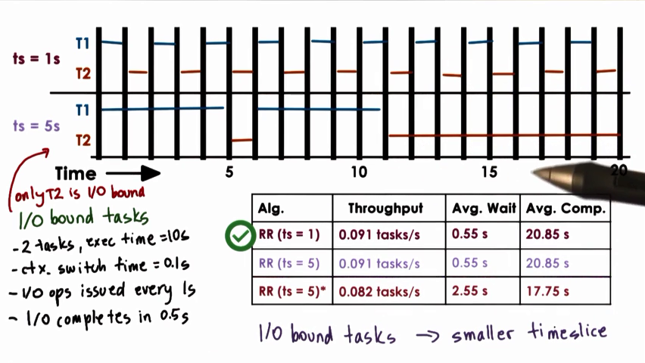

#### How Long Should a Timeslice be?

#### Runqueue Data Structure

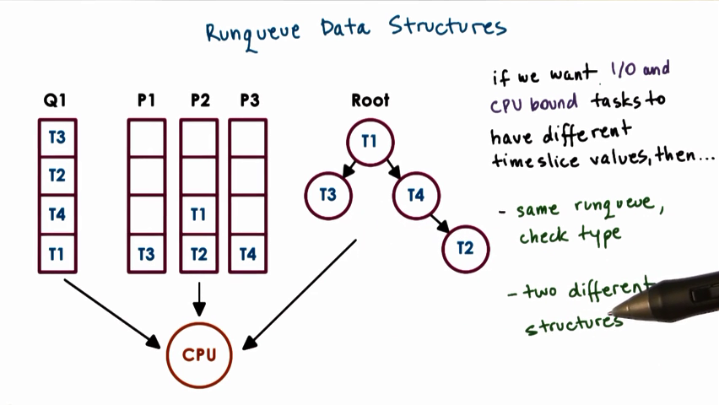

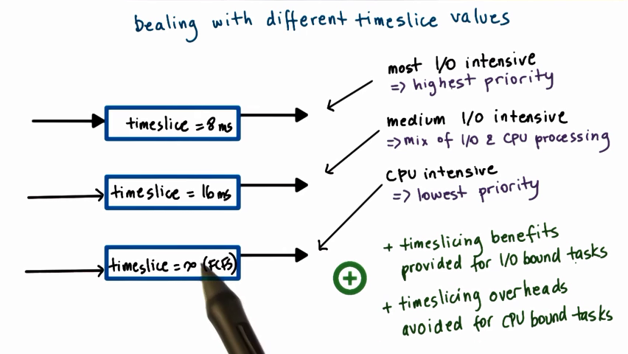

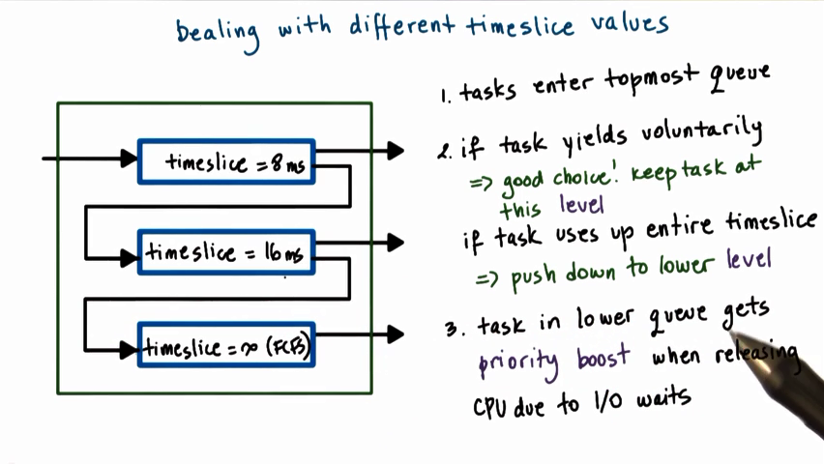

there should be different timeslice for I/O and CPU bound task. Adjust a task to different timeslice according to the feedback.

#### Scheduling on Multiprocess

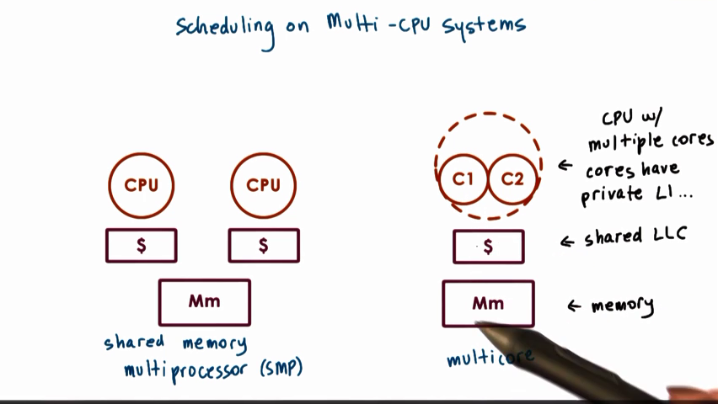

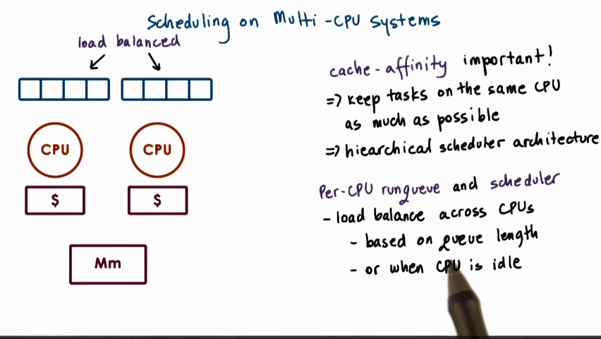

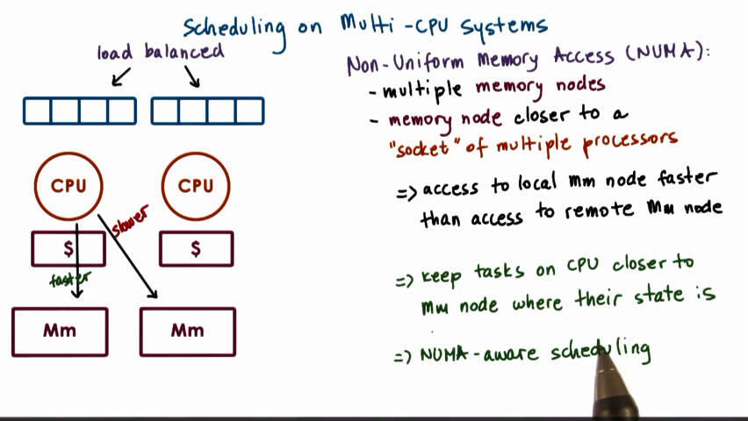

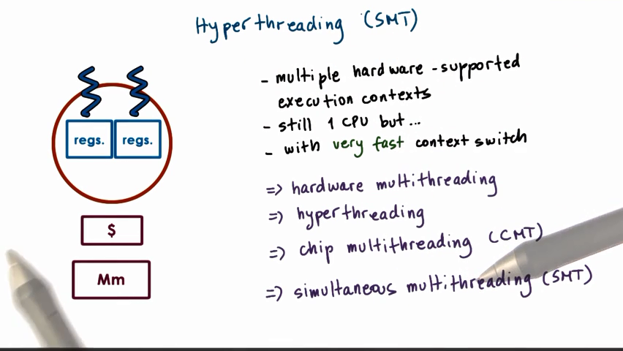

hyper-thread: multiple hardware support in a single CPU. Different set of registers store different context of different thread.

The context switch is very must because you do not need to save and reload PCB every time. You just need to switch from one set of register to another.

#### *Review

There are preempt and un-preempty scheduling. Un-preempty scheduling won’t switch a task until it completes. Preempty scheduling will switch a task before it completes because of I/O, sharing CPU, etc.

There are different kinds of scheduling policy. Different policy is chosen based on different usage and different metrics. For example, first-come-first-serve(FCFS), shortest-job-first(SJF), round-robin-scheduling, timeslice scheduling, priority scheduling, etc.

### Memory Management

#### Memory Management Goals

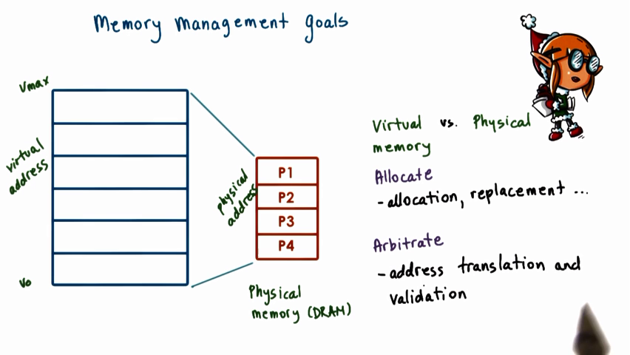

virtural address is much larger than memory. So some of the virtual address may be projected to the second storage like disk.

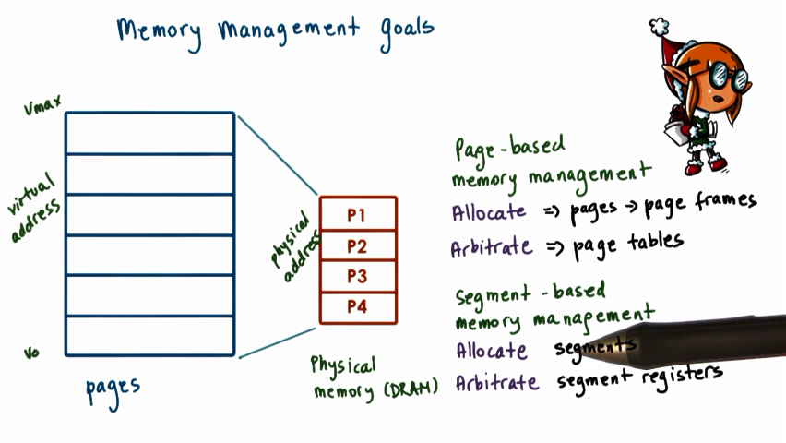

the virtual address is subdivided into fixed size segments called pages, so is the physical memory of the same size.

segment-based memory management model: flexible-sized segment.

#### Memory Mangement Hardware Support

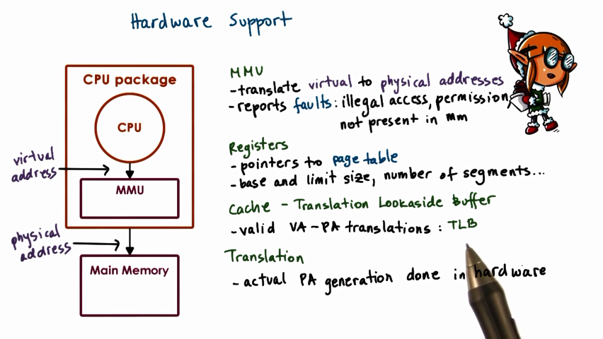

Every CPU package is equipped with a memory management unit.

Use registers in the process of address translation.

the translation process is done by hardware

#### *Page Tables

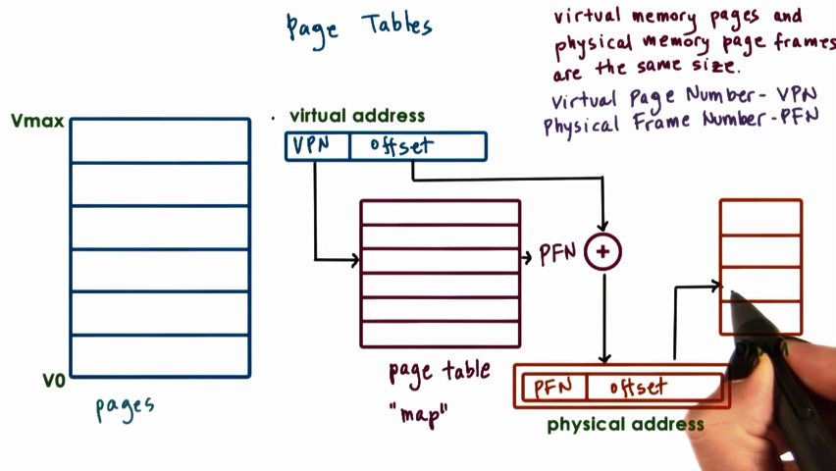

**Because the pages size are the same, we only need to translate the first virtual address in a page to the first virtual address in a page frame in physical memory.** The remaining address will map to the corresponding offset.

**Only the first portion of virtual address is used to find the page table entry.**

VPN:virtual page number

PFN: physical frame number.

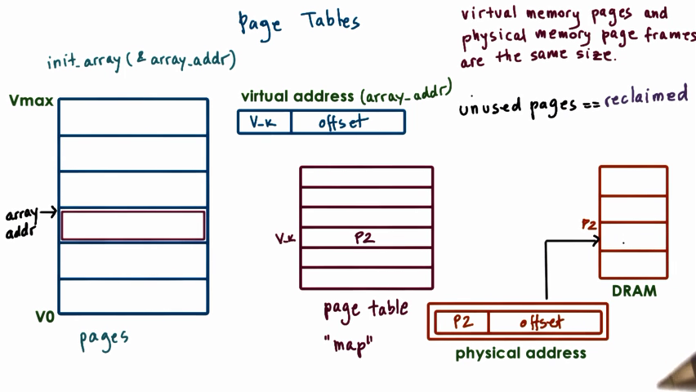

When we first access an array item, the OS will allocate the physical memory for it and establish a page entry. The physical memory will allocated only when we access it.

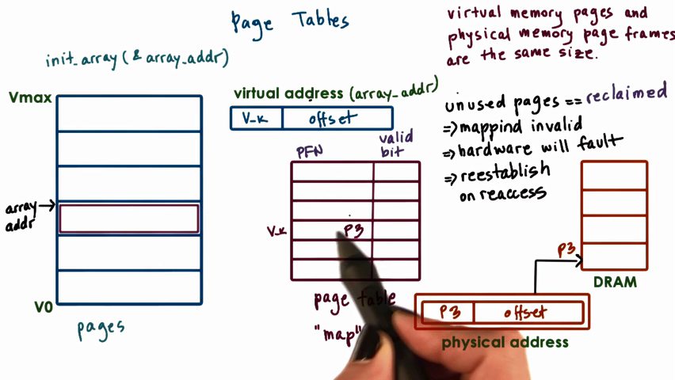

if the page is put in disk, the OS will bring it back to memory and reestablish the page table entry. It probably projects to a new memory address.

For every process, the OS will create a page table.

#### *Page Table Entry

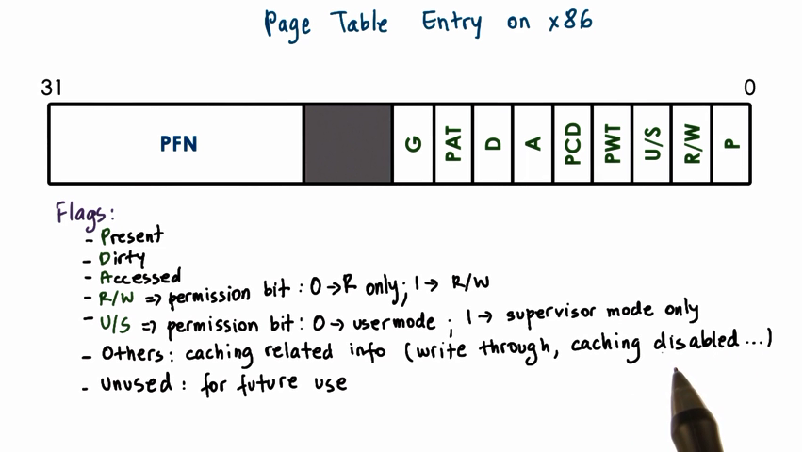

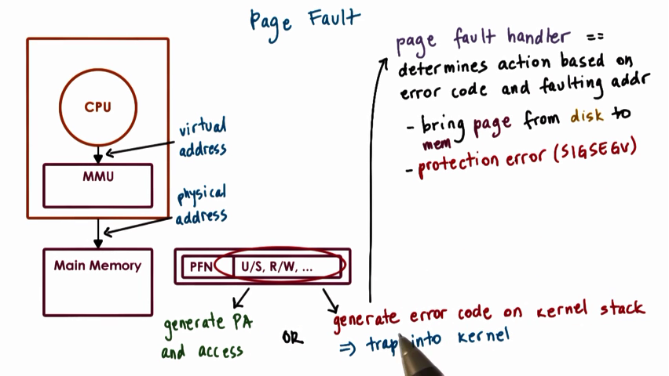

when the flag is invalid, an error code will be reported to OS.

#### Page Table Size

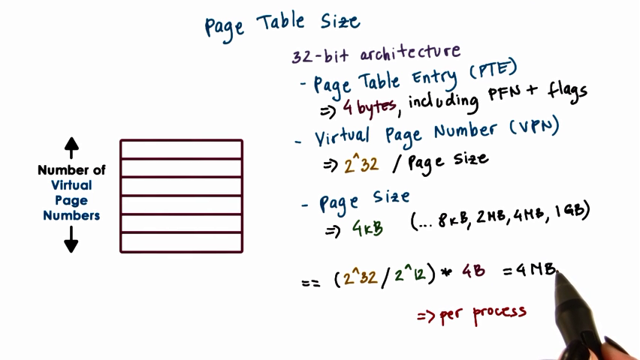

for 32-bit system, if the virtual address space is 32 bits and page size is 4kb. Then 1MB page entrys . Each page entry is 4 Bytes, then the page table size will be 4Mb.

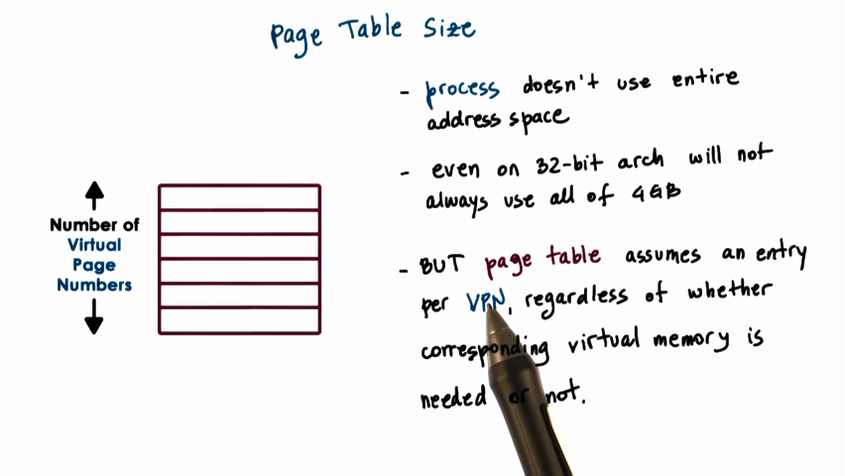

#### *Multiple Level Page Table

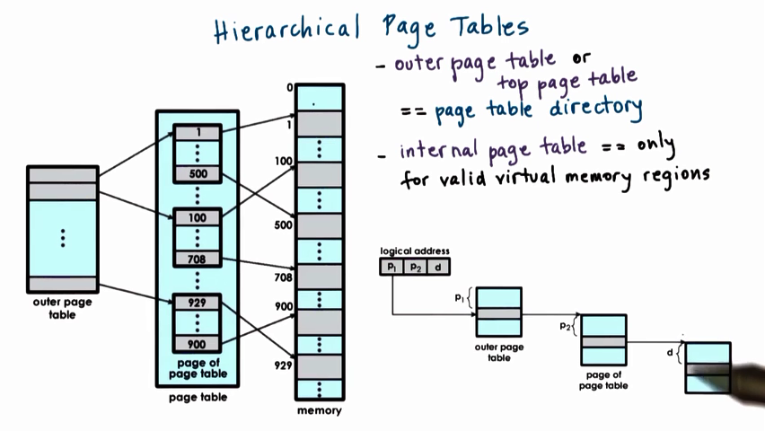

The virtural page number is divided into several levels and used to direct the way through hierarchical page tables.

Inner page table only for valid memory regions.

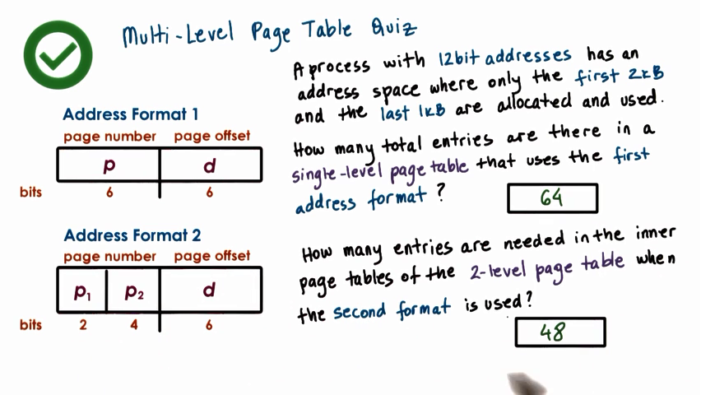

There are 4 outer page table entry. Only 3 of them will be projected to inner page table. Each outer page table entry is an inner page table. Each inner page table has 16 enties.

2 bit p1 is for out page table. It means for each 1kb of virtual address, they will be projected to the same page table entry. Each page table entry is another page table. The next 4 bit is to locate the inner page table. the offset is used for locating inside the inner page table entry.

#### Speeding Up Translation-TLB

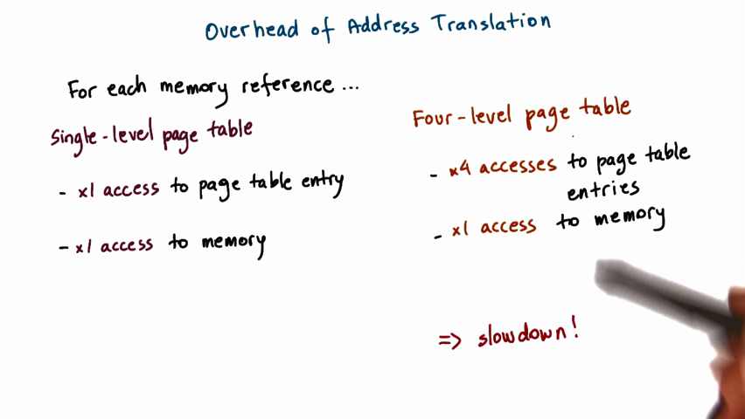

Access to page table entry is to decide the physical page frame number

The offset is to decide the actual position inside a page frame.

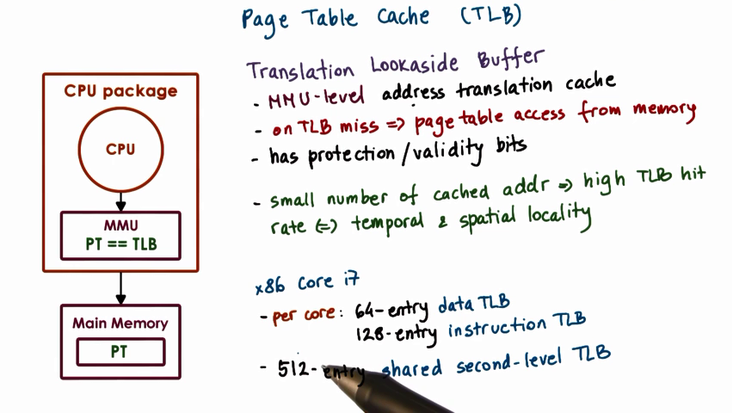

There are address translation cache in CPU called TLB.

#### Page Size(means page entry size)

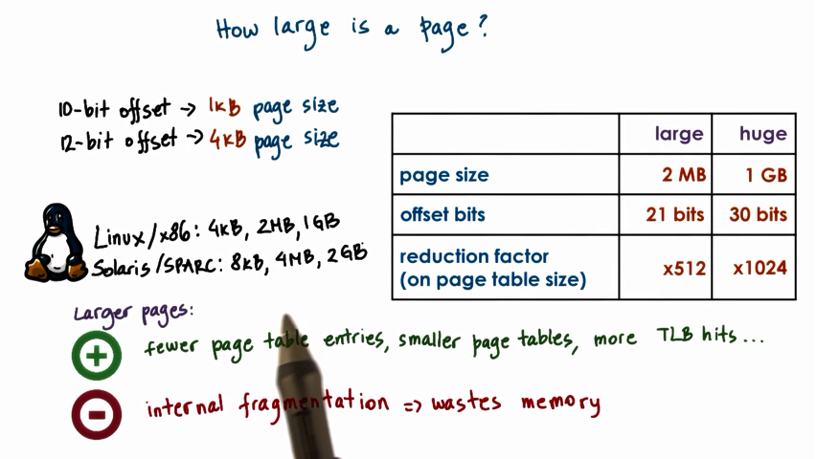

Page size means the size of each page table entry.

For large pages, if the large virtual memory page is not densely populated, there will be a lot of gaps inside the entry.

#### Memory Allocation

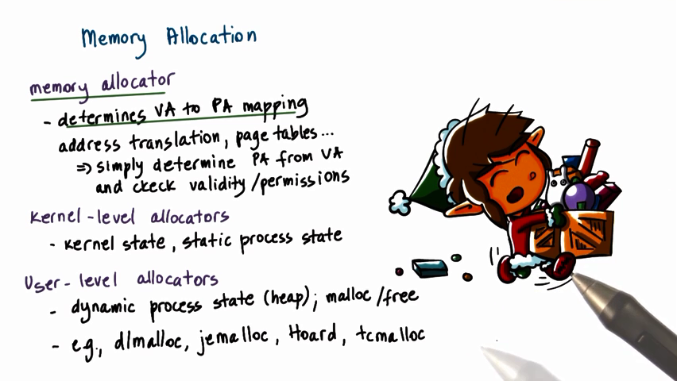

Memory allocation is about how OS decides how to allocate a particular portion of the memory to a process

#### Memory Allocation Challenges

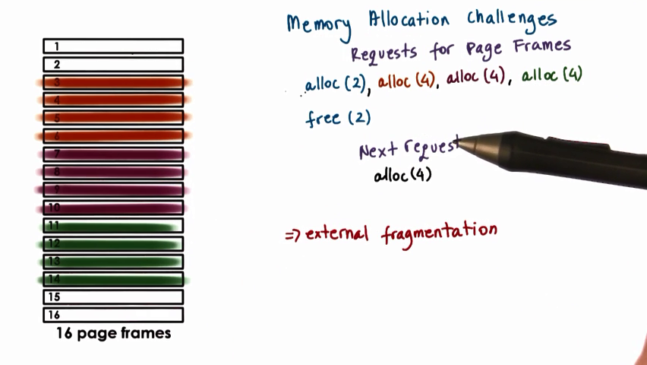

#### Linux Kernel Allocator

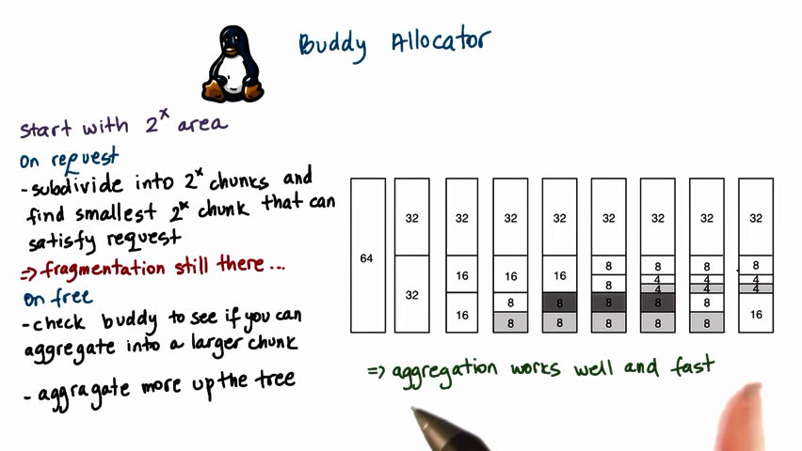

#### Demand Paging

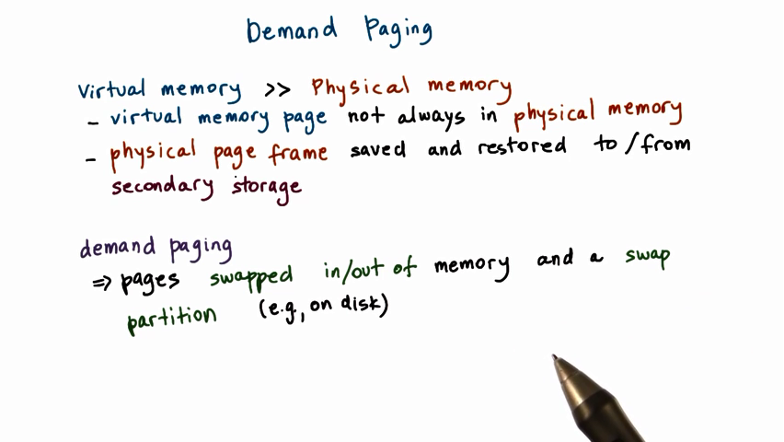

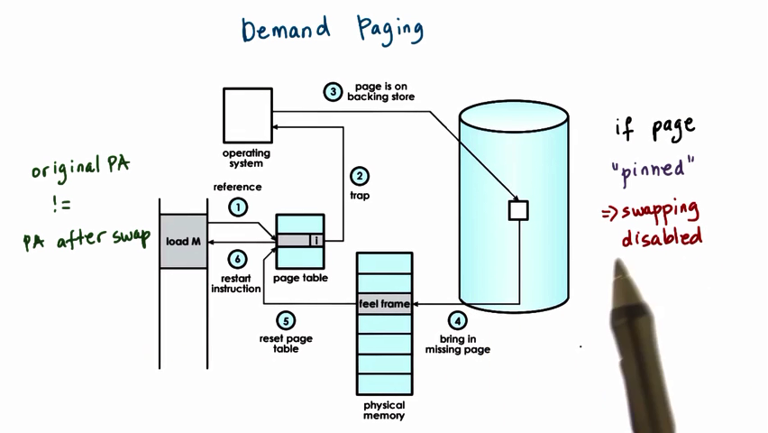

When a process tries to access an address, the page table will tell whether the corresponding physical address is valid in memory. If not, it will cause a trap. Then OS will be able to determine that the actural physical page frame is stored in disk. OS will load it into memory, then updates the page table. Then the process will try access the address again and this time it successes.

#### *Page Replacement





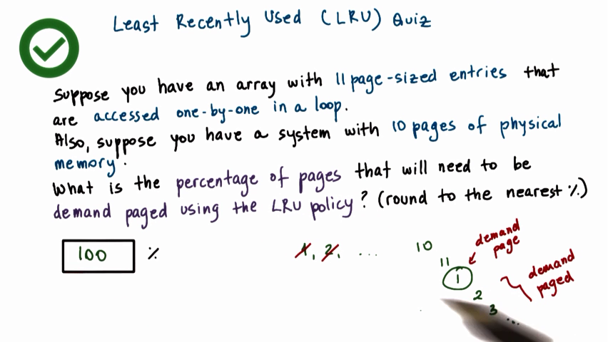

If you visit array element one-by-one in a loop, the next visited element will be the least recently used one and is removed from memory.

#### Copy-on-Write

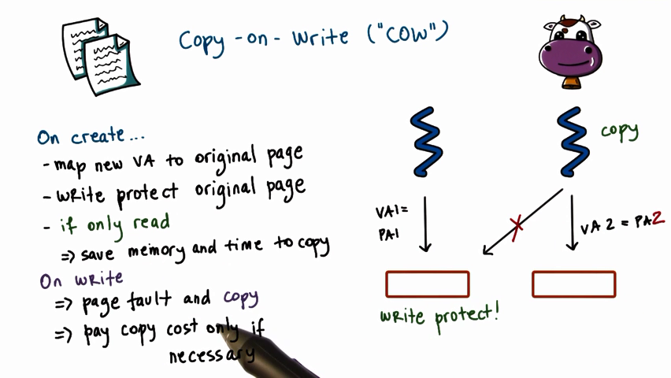

Traditionally, when a new process is created, it will inherit virtual address space from its parent. If only read, there is no need to maintain two same copy, they will share one in the first. Only those pages needed for write will get a separate copy then.

#### Check Point

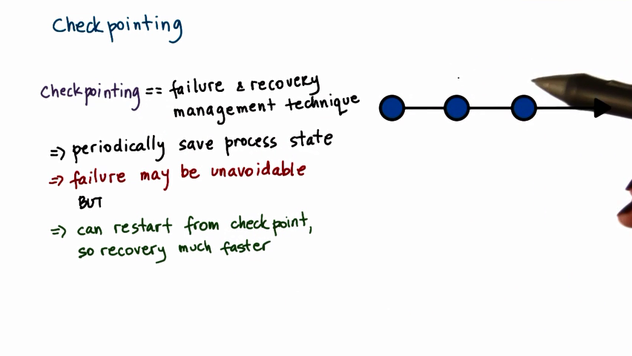

复原点

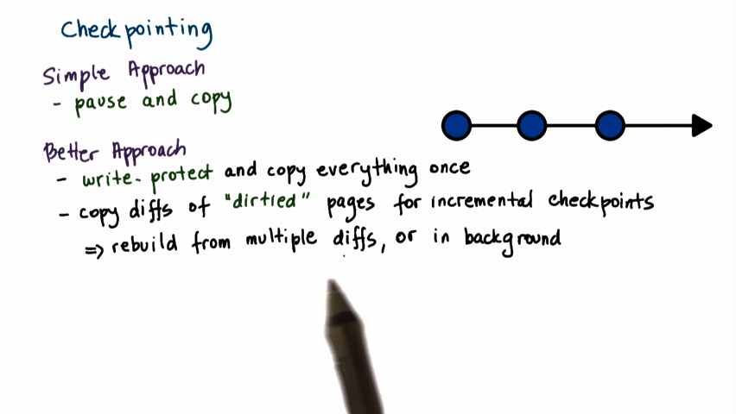

Everytime a checkpoint created, we only need to copy the modified content of the dirtied pages.

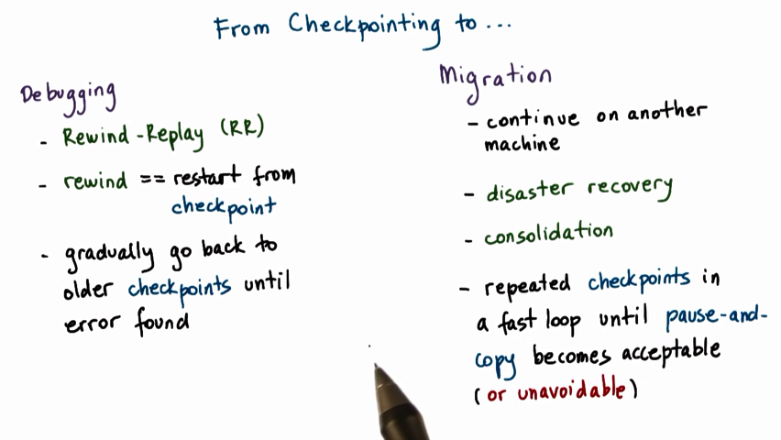



#### Lesson Summary

Keywords: pages and segmentation, address translation, page allocation, page replacement algorithms

### Inter-Process Communication

#### Visual Metaphor

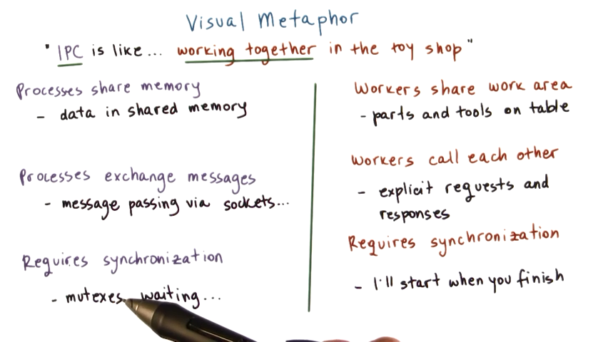

#### *Inter-Process Communication(IPC)

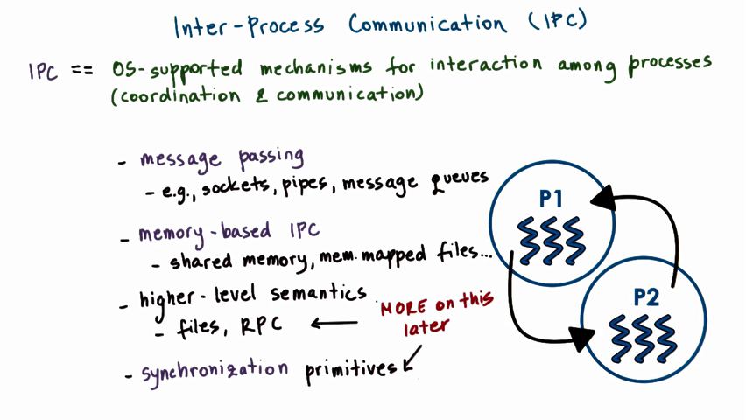

Processes interact with each other through message passing or shared memory. **The former one is supported by OS and process only need to use the well-defined APIs.** The later one they access to the same memory space and may cause **synchronization or concurrency problem**.

#### *Forms of Message Passing

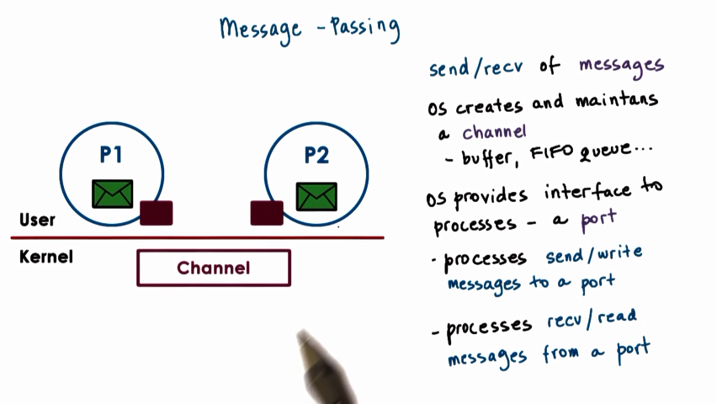

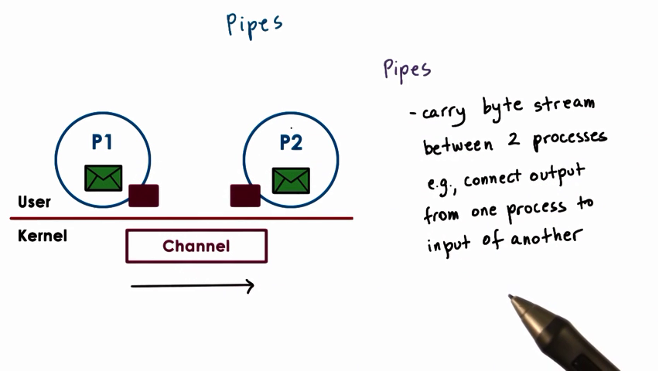

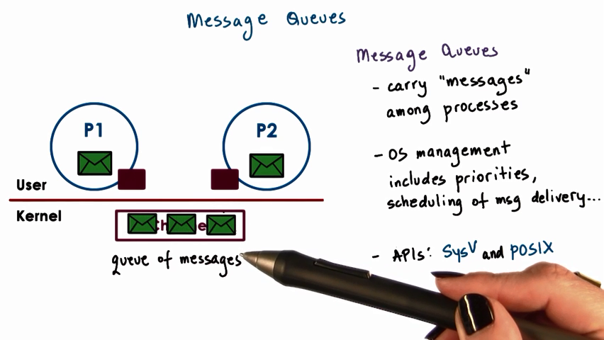

**There are mainly three types of message passing communication: pipes(2 processes), message queue(multi-processes) and socket(every process should hold its socket to communication with others.)**

There exists a lot copy operation in message passing API. For pipe method, a single write/read iteraction need 4 times copies and 2 times system calls.

#### *Shared Memory IPC

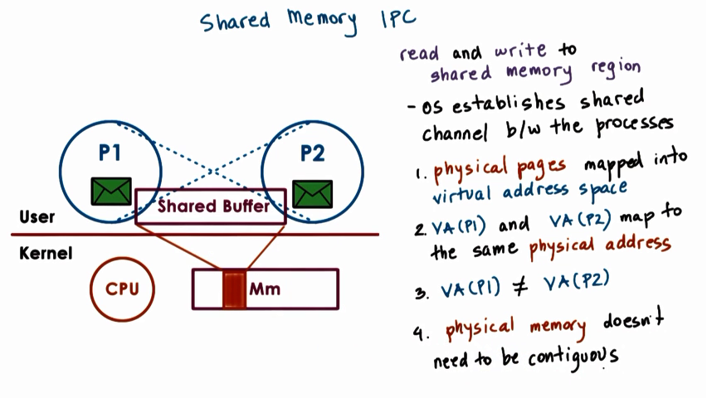

**OS will map part of virtual address space of the two processes to the same physical memory space.**

**OS only is needed for set up the projection.**

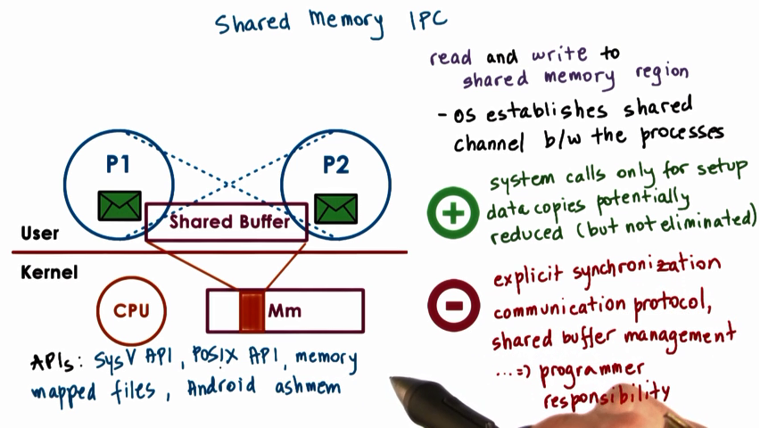

Any shared data should be placed in the shared space. If not the case, it has to be copied in and out of the shared memory region.

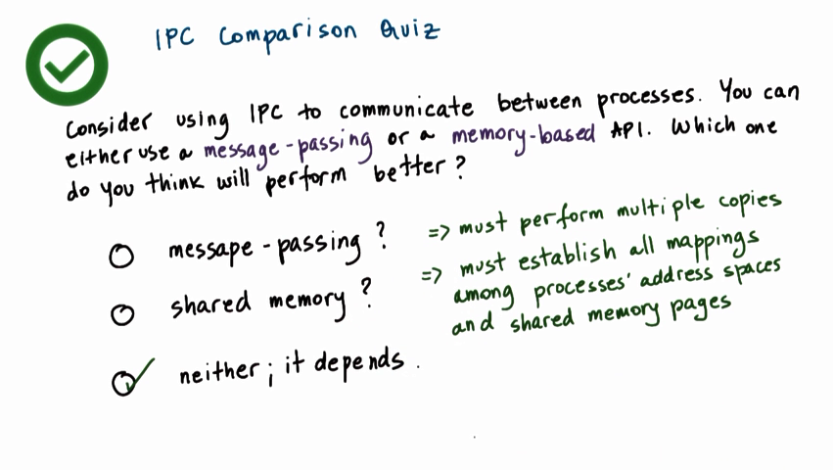

I think it is decided by your demand. Message-passing is safer because API is well-defined by OS, no problem about concurrency and sychronization. Shared memory is faster but less safe.

#### Copy vs. Map

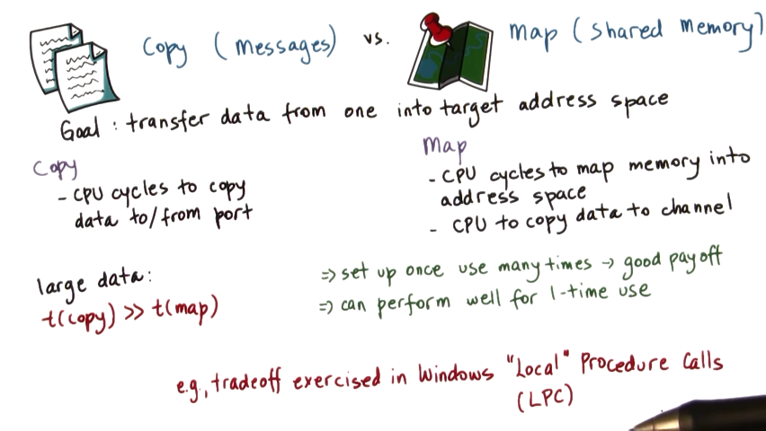

In fact, interaction between processes is about passing data from one virtual address space to another. If the amount of data is below a threshold, copy method is likely to be used. Otherwise, choose map method.

#### SysV Shared Memory

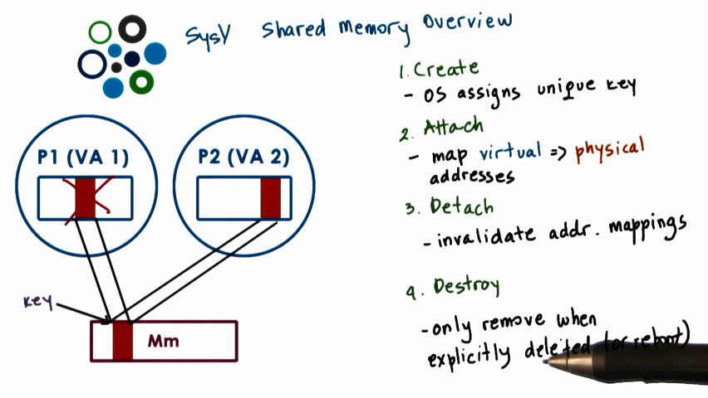

The properties of the shared physical memory.

When a process requires a shared memory segment, the OS allocates the required amount of physical memory and assigns a unique key to it. Other process holding the key can have access to the segment.

You can invalidate the share segment but it’s still there and won’t be removed until explicity request.

#### SysV Shared Memory API

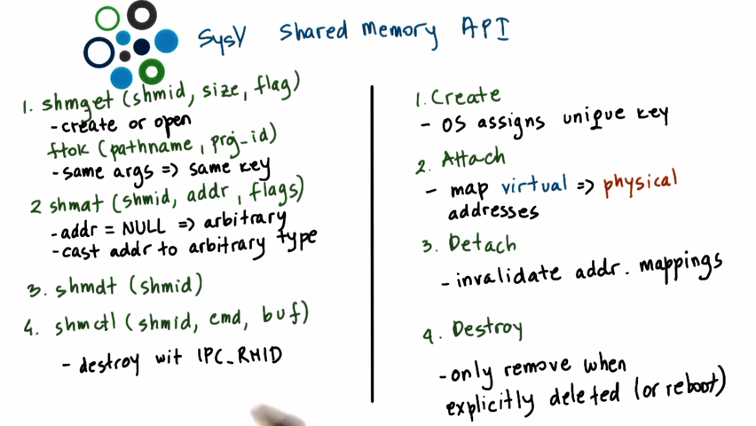

#### Posix Shared Memory API

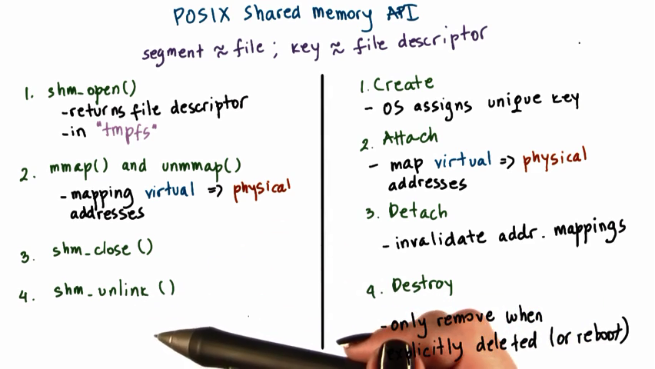

#### Shared Memory and Synchronization

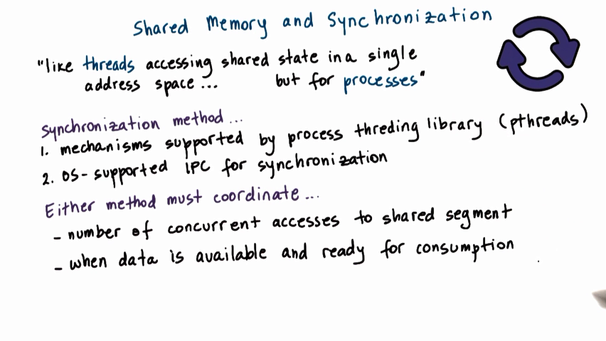

#### Pthreads Sync for IPC

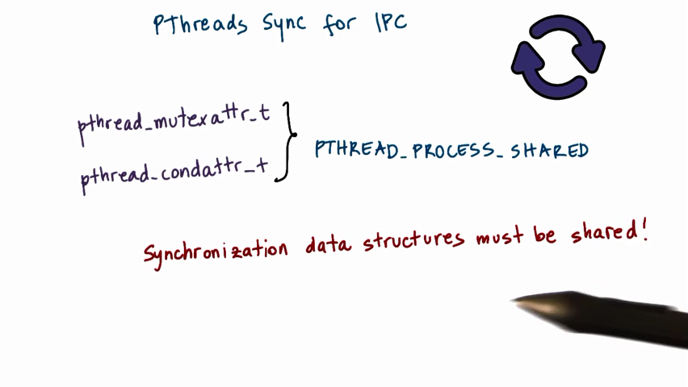

The mutexes and condition variables should be global and visible to all processes. So it should be allocated from the shared memory region that’s visible to both processes.

#### Other IPC Sync

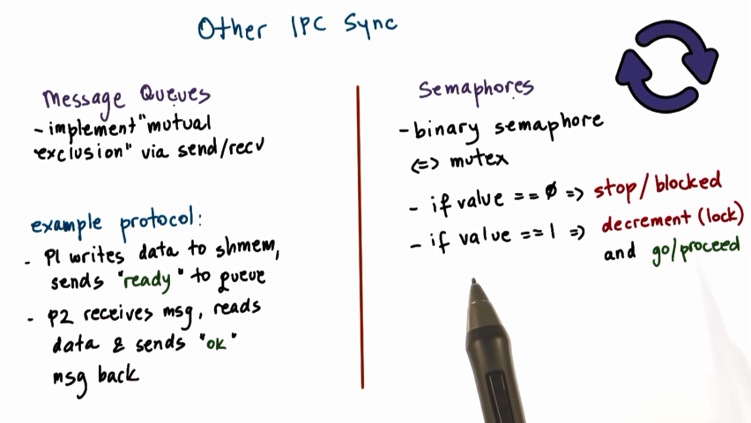

#### Lesson Summary

Keywords: shared memory vs. message passing; pipe, message queue & socket; shared-memory concurrency:mutex and condition variable.

### I/O Mangement

#### I/O Devices Feature

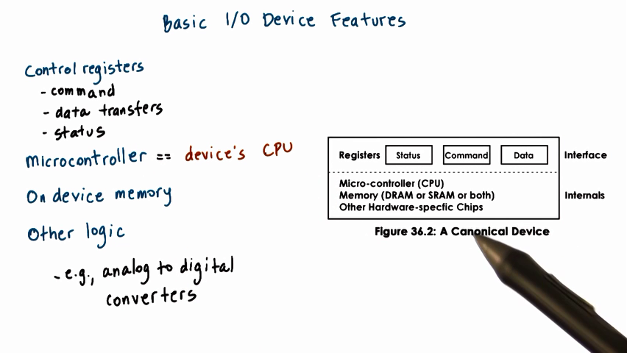

Inside an I/O device, there are a set of control registers that can be accessed by the CPU and permit iteraction with CPU. Command registers is used by CPU to control what exactly the device will be doing. Data registers is used to control the data transfers in and out of the device. Status registers is used by the CPU to find out what happening on the device.

#### CPU-Device Interconnect

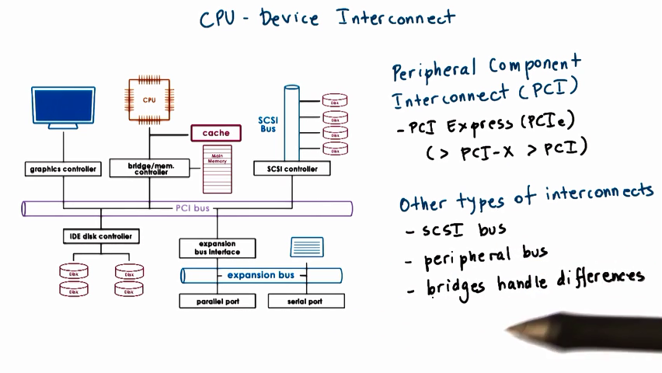

#### Device Driver

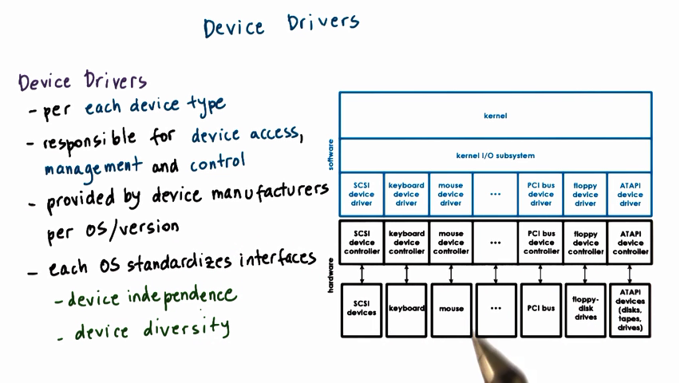

For each device type, OS will install the corresponding device driver to manage those devices.

#### Types of Devices

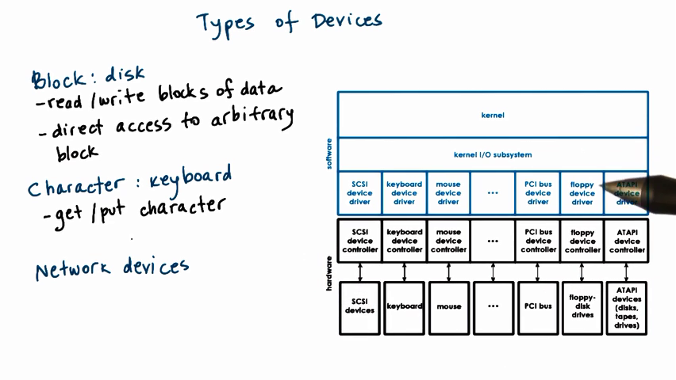

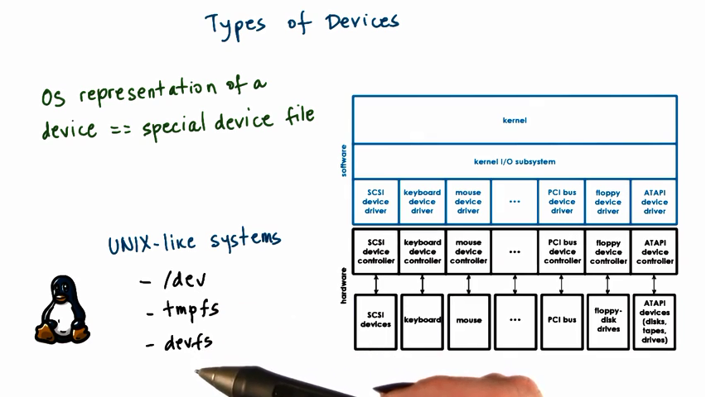

OS represents each device as a special kind of file. So OS can make use of some existing mechnism about file to manipulate I/O devices.

#### CPU-Device Iteraction

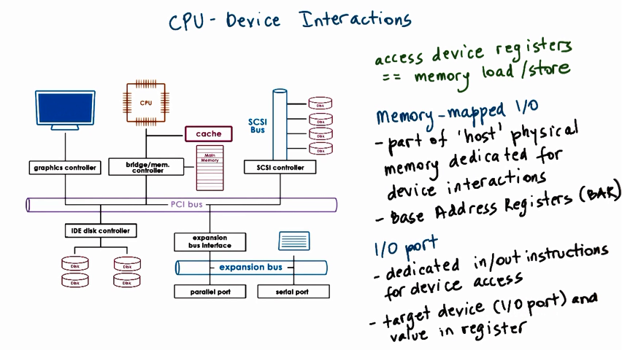

CPU accesses devices in a way similar to access physical memory. The PCI controller will translate this access as an acess to specified I/O device.

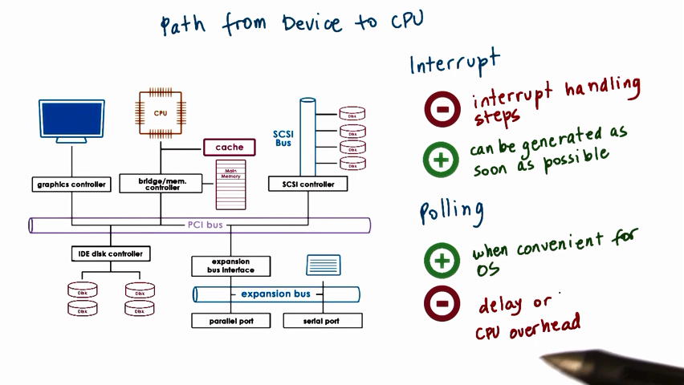

Devices iteracts with CPU via interruption or waiting for CPU polling.

#### Device Access PIO

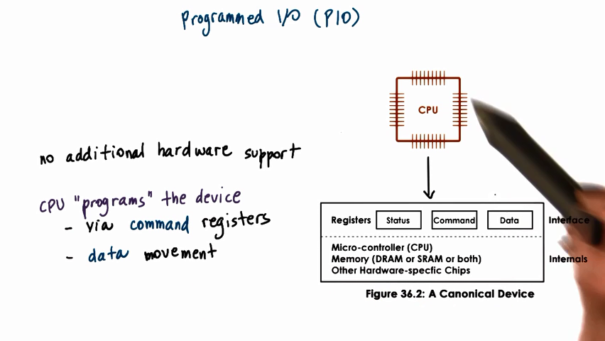

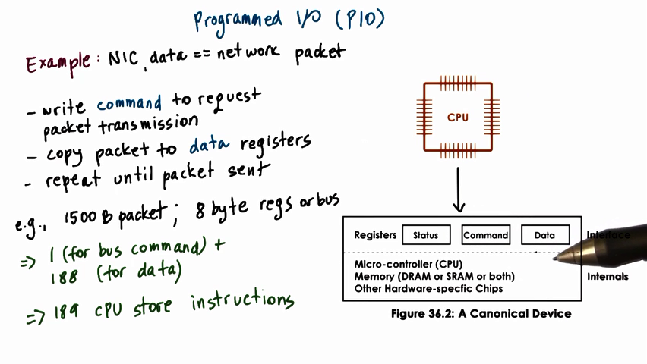

Moving data from memory to devices can be implemented by CPU. CPU programs and manages the device through some kind of instruction.

#### Device Access DMA

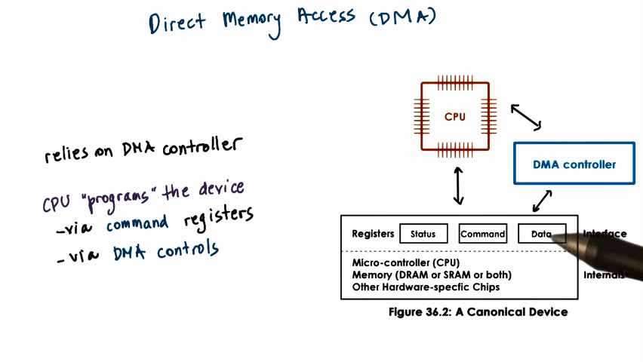

The data movement will be controlled by configuring the DMA controller which data to be moved from CPU memory into the device

Once DMA is configured, it can only read and write data to and from the physical memory without involvement of CPU.

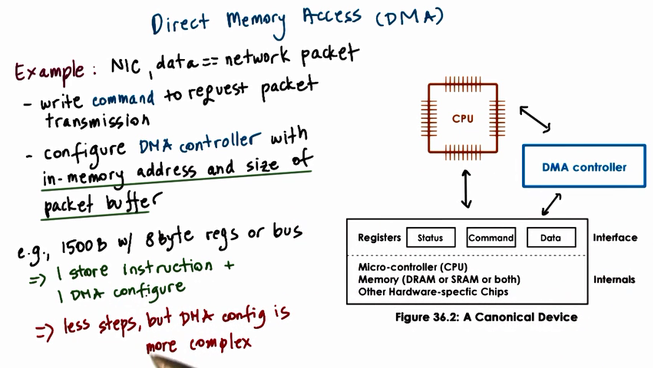

When the amount of data is small, it’s better to use PIO because configuing the DMA is complex.

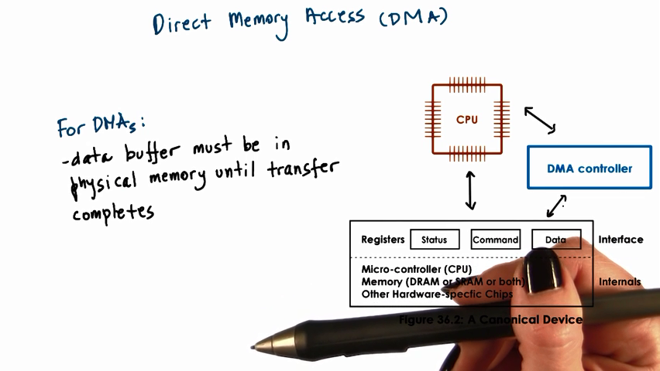

DMA can only access memory, cannot access disk. So the data to be transferred must be in memory.

#### Typical Device Access

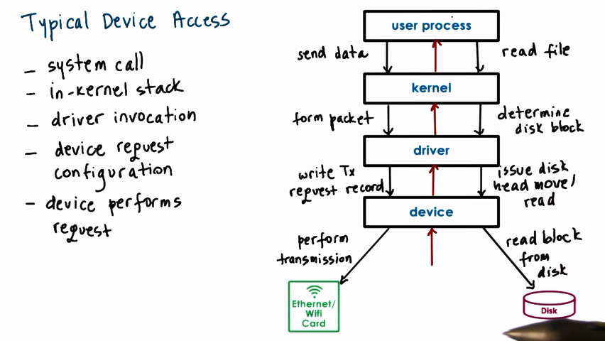

Before OS sends request to device driver, OS should generate the correct packet of data liske TCP/IP packet for network transmission.

The drive manages the device through PIO or DMA

#### CPU Bypass

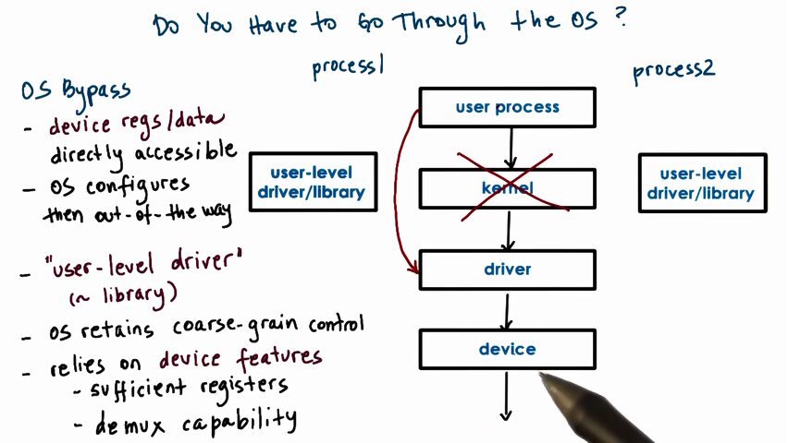

#### Syn vs. Asyn Access

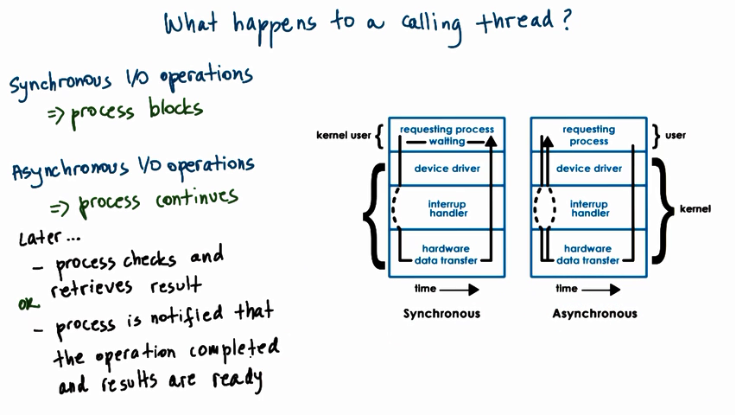

When an I/O call is made by the user process, synchronous operations will block the process and the process waits until the result is returned. Otherwise, asynchronous operation will continue to execute.

#### Block Device Stack

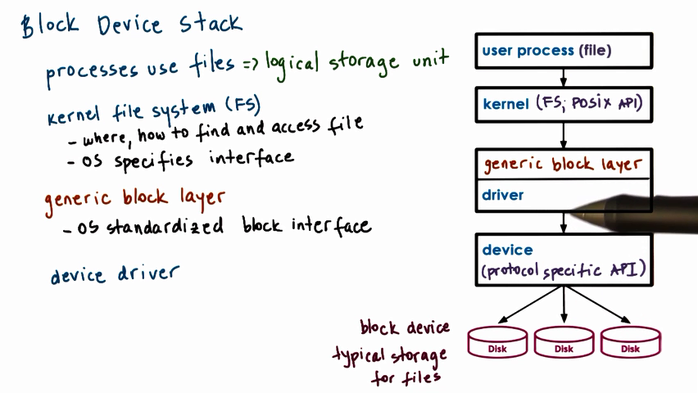

block devices like disk are typically used for storage. The typical block storage abstraction used by applications is a FILE.

On top level, user process does not think about how disk works. They only request operations to be performed on files.

Below the file interface used by the applications, is the file system. The file system will have information about how to interpret those read/write request, where to find the file, how to access it, etc.

The generic block layer knows how to interact the particular driver and hides details at lower level from kernel level.

#### *Virtual File System Abstractions

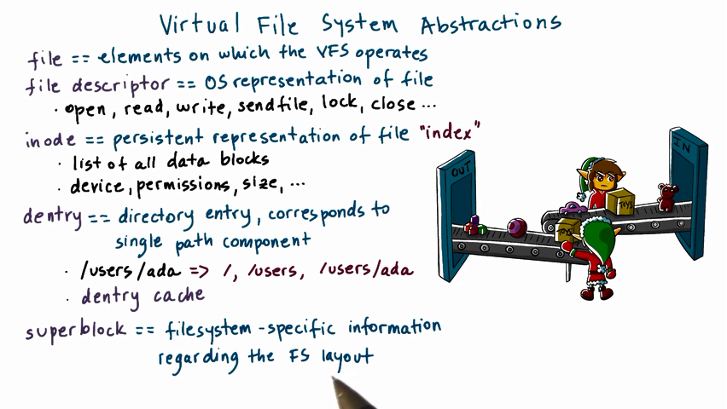

OS may support several kinds of file system, and the virtual file system is used to hide the difference and provide a unified API.

inode: inode refers to index node, list of all data blocks for a file. a file may not save contigous in memory so it’s important to keep the index.(目录)

#### VFS on Disk

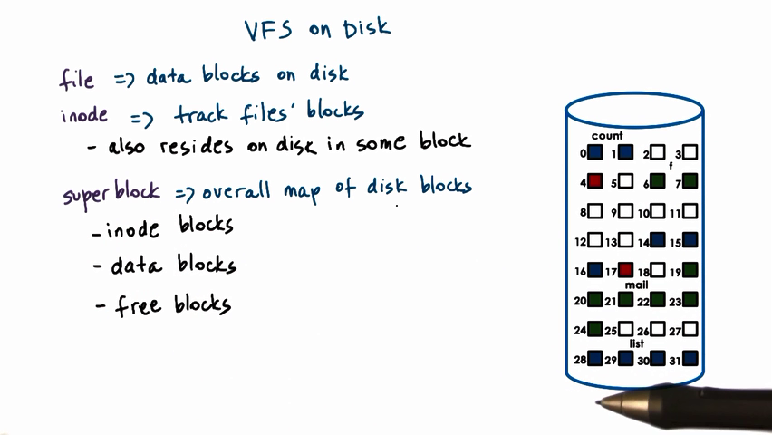

A file is noncontinous blocks on disk. An inode tracks all blocks corresponding to a file.

Superblock can be used for allocation, when we need to find some free blocks to allocate to a new file creation request or file write request. and also used for lookup when we need to find the particular portion of a particular file.

#### Ext2-Second Extended File System

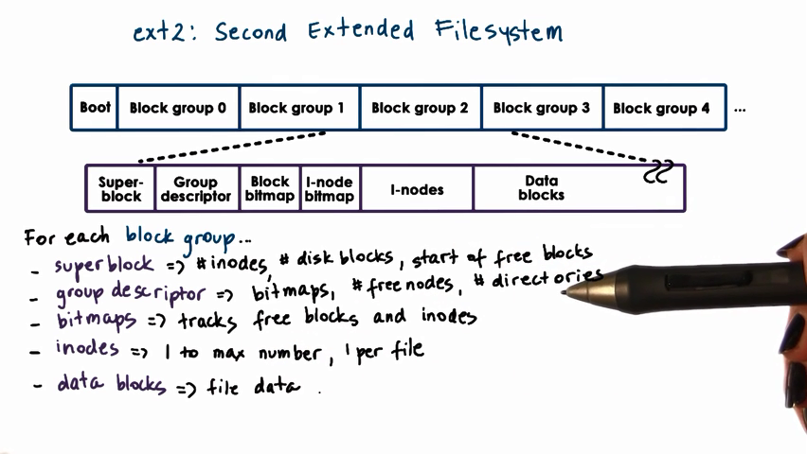

#### *Inodes

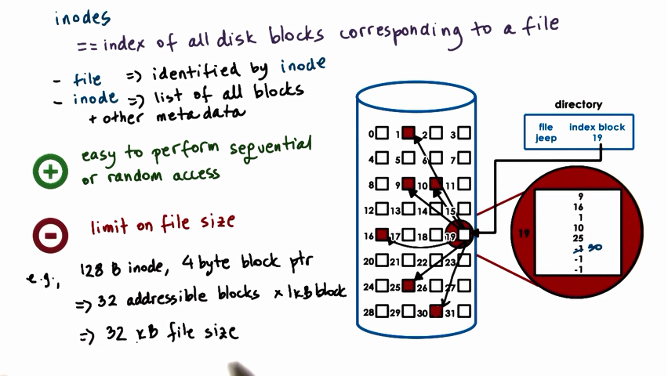

The bit length of inode will limit the size of file.

#### *Inodes with Indirect Pointers

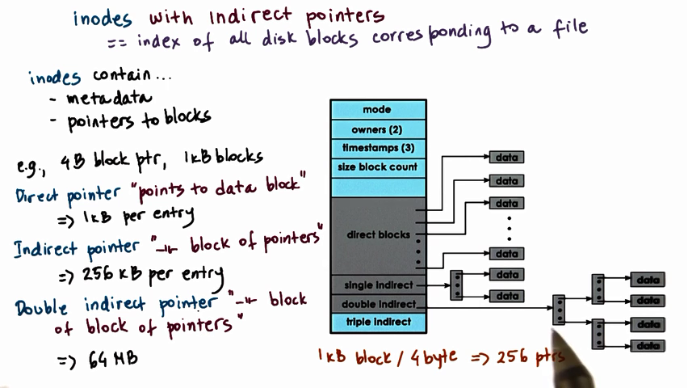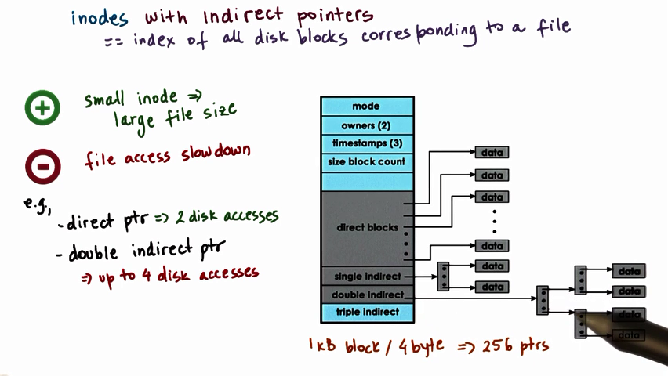

Inode points to another block, which stores pointers to the actual data block.

If a block is 1kb and each block ptr is 4B, a single indirect inode will pointer to another block , this block can contain 256 pointers(1kb/4B), which pointer to 256 blocks.

#### *Disk Access Optimization

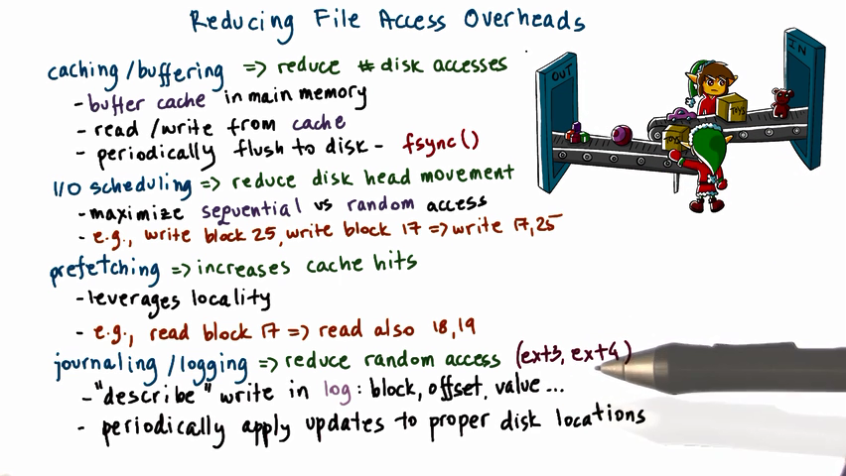

Four techniques to reduce file access overheads: by increasing the likelihood of accessing data from memory(cache hit), by not having to wait on slow disk head movement, by reducing random access and by reducing # disk access.

Sequencial access to disk is much faster than random access.

#### Lesson Summary

Keywords: I/O device feature; Device driver; CPU-Device iteraction: PIO/DMA; Block-based storage device; File system

### Virtualization

#### *What is Virtualization?

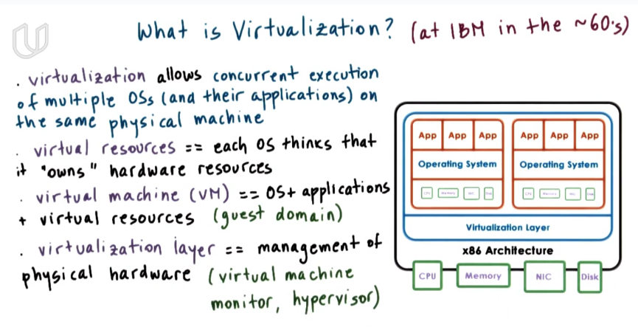

Virtualization is bottom-up method.

A few large mainframe computers are shared by many users and applications

Each VM seems like a process in the physical machine. VM often refers to as guest domain. Different VM machines share a same mainframe machine.

#### Defining Virtualization

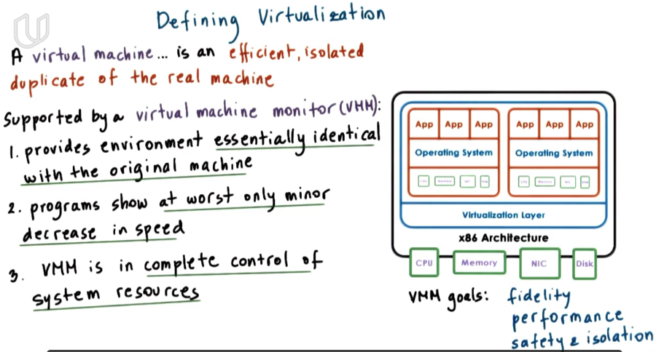

VM monitor is an abstraction level between virtual machines and real machine.

One goal of VMM is to provide **fidelity** that the representation of the hardware that’s visible to VM matches the hardware that’s available on the real machine. VMM makes multiple kinds of apps and Oss to share the same physical platform efficiently and isolatedly.



A VM is an **efficient**, **isolated duplicate** of real machine.

The hardware that’s is visible to VM is identical to the real physical platform.

#### Benefits of Virtualization

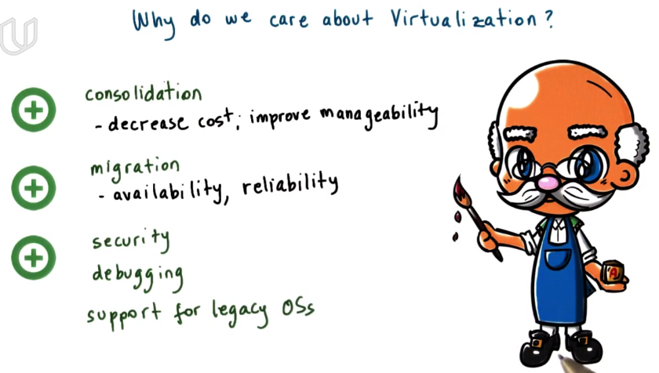

#### *Virtualization Models Bare Metal

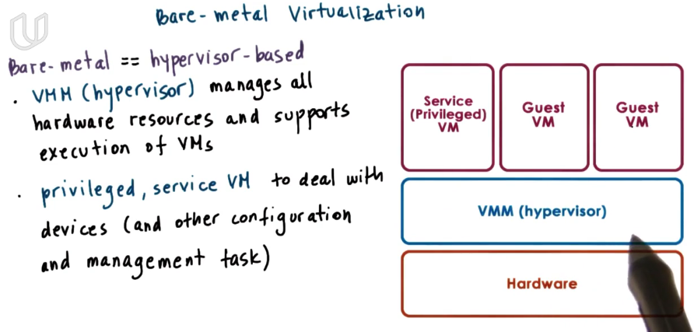

#### *Virtualization Models Host OS

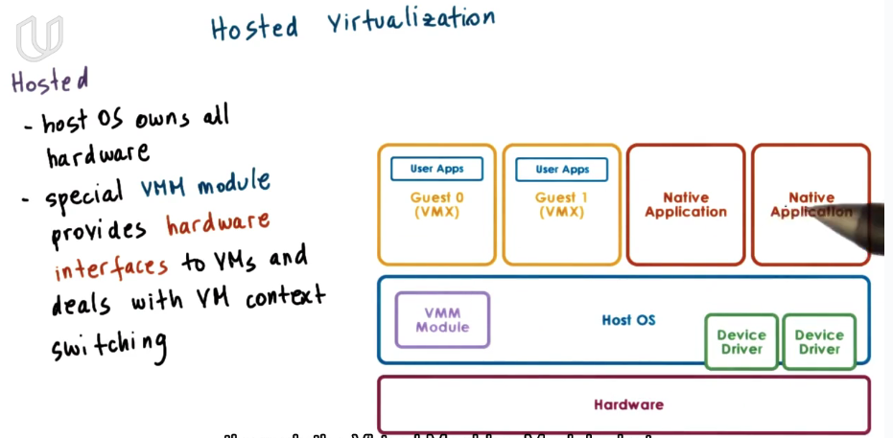

#### Virtualization Requirements Quiz

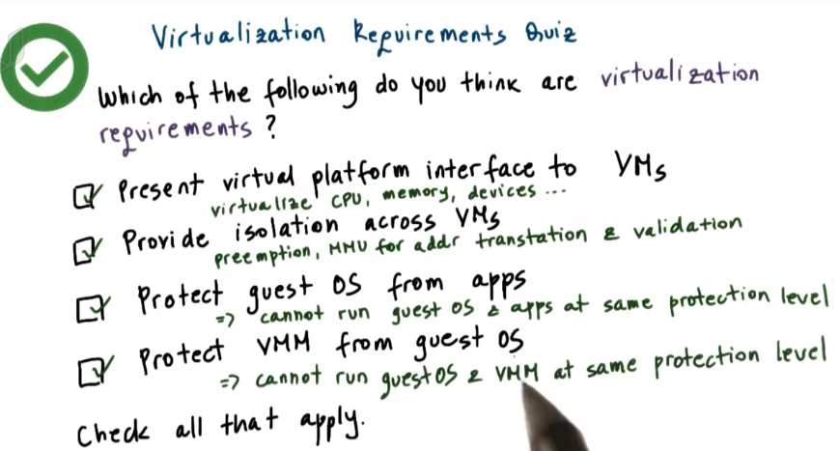

#### Hardware Protection

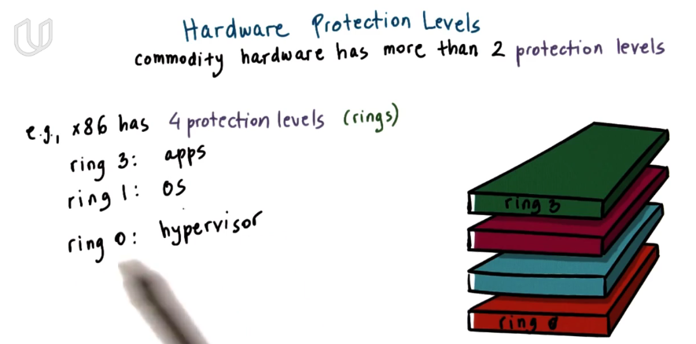

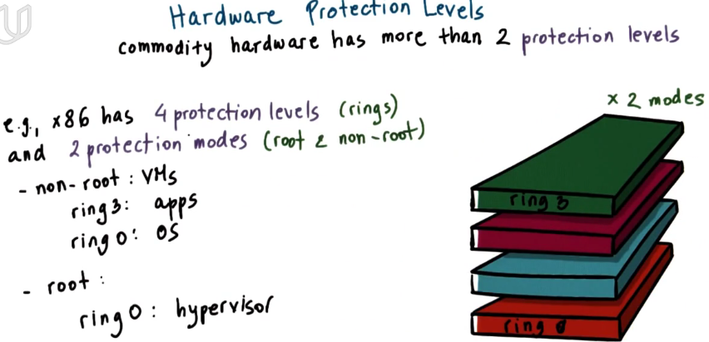

In ring0, all hardware access is available, all instructions can be executed and this is the highest priviledge level.

#### Processor Virtualization

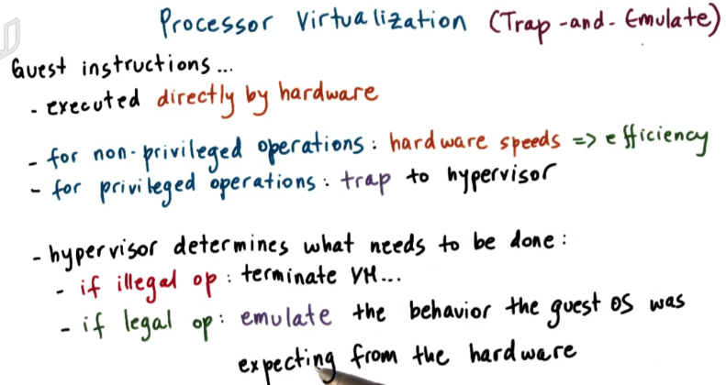

If app’s access to hardware is legal, the hypervisor should perform emulation so that the guset OS is under such an impression that it actually has control over the hardware.

#### Memory Virtualization

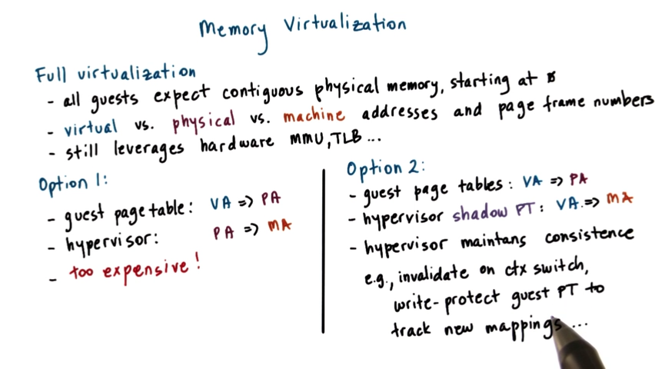

Vitual address is owned by process. Physical address is what the process thinks he owns. Machine address is actually mapped to the hardware.

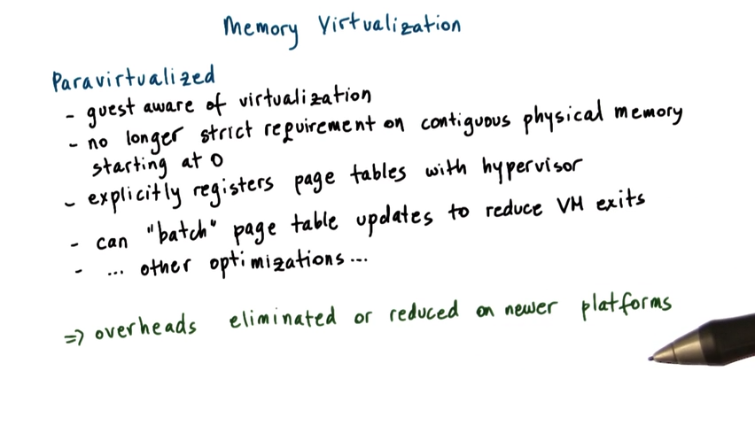

Only hypervisor has access to the physical platform. So VM cannot access to the page table which is mapped to real machine address

#### Device Virtualization

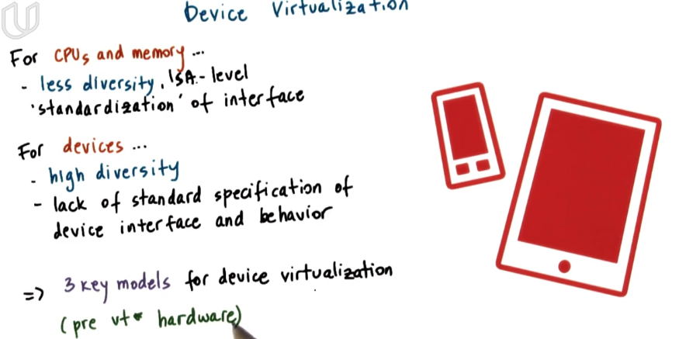

The diversity of devices is much higher than CPU.

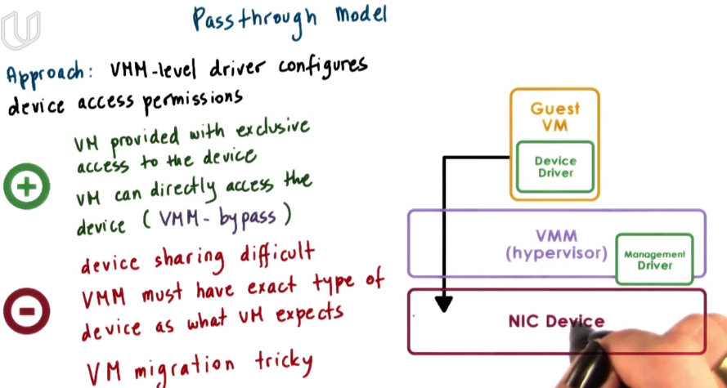

Bypass VMM violates the abstraction layer

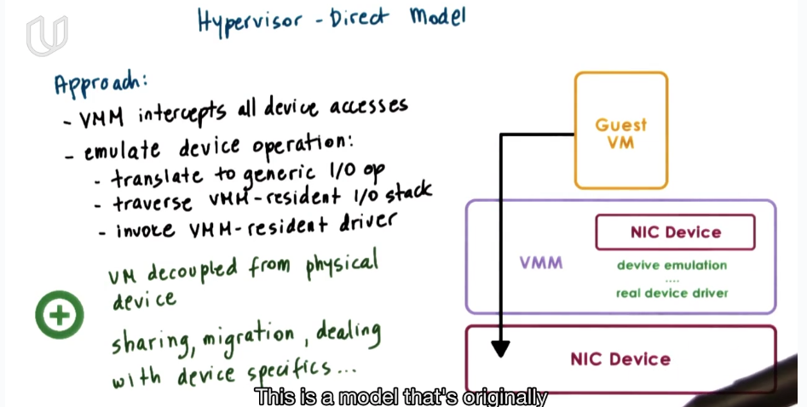

### Distributed File System

There are many storage machines in different places. The files you require may be stored in different machines. So you need well-define APIs to access those file without really visiting these machine. And different machines should maintain consistent state.

### Distributed Shared Memory

### Distributed Technologies

### About CPU

The basic job of CPU is to excuate instruction. Once the power is on, the first instruction address is 0xFFFFFFF0 in memory.

PC stores the address of next instruction.

The disk is much slower than memory and CPU. So DMA is for disk to directly send data to memory bypass CPU. Or CPU has to wait a long time.

Cache: locality.

Pipeline: mainly four stages---fetch instruction, translate, excuate, return result.

### About Function Call

Every function has its own frame. Two pointers point to the startpoint and endpoint of the frame(stack): ebp, esp. When function A called function B, the next instruction of A will be push into the frame, together with some arguments of A. Then OS will create a new frame for function B. The first item in a frame will be the returned address of its calling function. The instruction is like:

Push(ebp);

Move ebp, esp

When the called function returns, the ebp and esp will point to the original frame of the calling function.